CEDERBERG
MUNICIPALITY
COASTAL MANAGEMENT PROGRAMME
2026
3
This Report should be cited as follows: West Coast District Municipality (2019). Draft Coastal Management Programme: Second Generation.

This report was developed for the West Coast District Municipality by:


The Point, Suite 408, 4th Floor  76 Regent Road, Sea Point  CAPE TOWN  8060  www.cesnet.co.za  Also in Grahamstown, Port Elizabeth, East London, Johannesburg & Maputo | 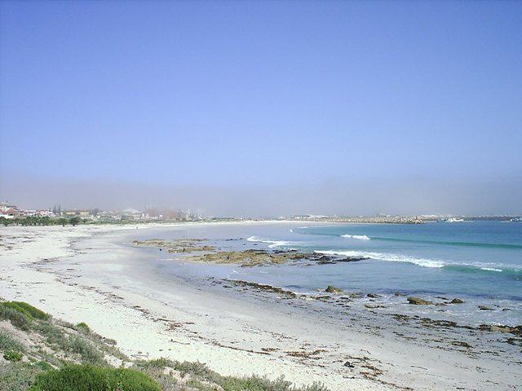  Contact:  Dr Ted Avis  Tel: 021 045 0900  Email: ted.avis@eoh.com  Amy Lindsay  Tel: 083 554 9229  Email: ahunter@live.co.a

West Coast District Municipality:
Charles Malherbe
Nick de Jongh

CES:
Ted Avis
Amy Lindsay

Acknowledgements:
Bergrivier Municipality
Cederberg Municipality
Matzikama Municipality
Saldanha Bay Municipality
Swartland Municipality

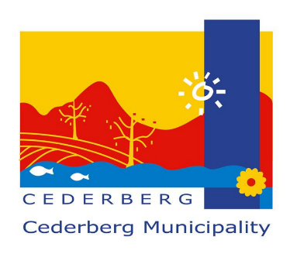
TABLE OF CONTENTS

EXECUTIVE SUMMARY viii
1 INTRODUCTION 1
1.1 Background 1
1.2 Defining the Coastal Zone 1
1.3 Value of the coast 5
1.4 Context of Coastal Management Programmes in South Africa 5
1.5 The Purpose of the Updated Cederberg Local Coastal Management Programme 6
1.6 The Cederberg Municipality Coastal Management Programme Development Process 6
1.7 Framework of this CM CMP 7
2 LEGISLATIVE OVERVIEW 10
2.1 Legislation 10
2.2 National and Provincial policies and programmes 17
2.3 West Coast District Municipality policies and programmes 18
2.4 Local Municipality policies and programmes 18
2.5 Other policies and programmes 18
3 SITUATION ASSESSMENT 19
3.1 Locality and extent of the coastline 19
3.2 Theme 1: Institutional Arrangements and Cooperative Governance 20
3.2.1. Coastal management functions at Provincial, District and Local Level 20
3.2.2. Co-operative governance 21
3.2.3. Protected Areas 21
3.2.4. WCDM Coastal Committee 21
3.3 Theme 2: Coastal access 22
3.3.1. Existing access to the coastline 22
3.3.2. National and Provincial Coastal Access Strategies 23
3.3.3. Western Cape Provincial Coastal Management Programme 2022-2027 24
3.3.4. Coastal Access Audit for the WCDM 25
3.3.5. Coastal public amenities 25
3.3.6. Working for the Coast projects 25
3.3.7. Public launch sites 26
3.3.8. Use of vehicles in the coastal zone 27
3.3.9. The use of the coastal zone for recreational activities 28
3.3.10. Facilitation of coastal access through town planning processes 29
3.4 Theme 3: Coastal Planning and Development 30
3.4.1. Western Cape Biodiversity Spatial Plan (2023) 30
3.4.2. Coastal Management Lines 32
3.4.3. West Coast District Municipality’s Climate Change Response Framework (2014) 34
3.5 Theme 4: Compliance, monitoring and enforcement 35
3.5.1. Environmental Management Inspectorate (EMI) 35
3.5.2. Fisheries Control Officers 36
3.5.3. Air Quality Compliance and Enforcement in the WCDM 37
3.6 Theme 5: Estuary management 38
3.7 Theme 6: Natural resource management 42
3.7.1. Vegetation 42
3.7.2. Formal protected Areas 43
3.7.3. Important Bird Areas 45
3.7.4. Marine resources 46
3.7.5. Mineral resources 50
3.8 Theme 7: Heritage resource management 52
3.8.1. Khoisan communities within the WCDM 52
3.8.2. Heritage resources 52
3.9 Theme 8: Pollution control and management 54
3.9.1. Existing sources of pollution in the coastal zone 54
3.9.2. Existing pollution monitoring and management activities 58
3.10 Theme 9: Socio-economic development 62
3.10.1. Contribution to Provincial GDP and demographic profile 62
3.10.2. Existing ports and harbours 63
3.10.3. Western Cape Small Harbours: Spatial and Economic Development Frameworks 63
3.10.4. Tourism assets in the CM 63
3.10.5 Aquaculture activities………………………………………………………………………...65
3.10.6. Small Scale Fisheries Policy 65
3.10.7. Renewable Energy opportunities 66
3.11 Theme 10: Awareness, education, training, capacity building and information 67
3.11.1. National Oceans and Coastal Information Management System 68
3.11.2. South African National Biodiversity Institute (SANBI) 69
3.11.3. Formalised coastal education and awareness campaigns 70
3.11.4. National and Provincial training initiatives 71
3.11.5. Signage at beaches 71
3.11.6. Coastal related forums and committees 72
3.11.7. Fisheries Community Development Workers 72
3.11.8. Public libraries 73
4 ROLES AND RESPONSIBILITIES FOR COASTAL MANAGEMENT 74
4.1 Mandatory Roles and Responsibilities in terms of the ICMA 74
4.2 Collaborative Partnerships for Coastal Management 76
4.3 Development of bylaws 76
5 VISION AND PRIORITIES 78
5.1 The Cederberg Municipality Vision for the Coastline 78
5.2 The Cederberg Municipality’s Priorities for Coastal Management 80
6 COASTAL MANAGEMENT OBJECTIVES AND ACTIONS 86
6.1 Coastal Management Objective 1: Improve Cooperative Governance and Clarify Institutional Arrangements 87
6.2 Coastal Management Objective 2: The Facilitation of Coastal Access 89
6.3 Coastal Management Objective 3: To Ensure that Coastal Planning and Development is Conducted in a Manner that ensures the Protection and Rehabilitation of the Coastal Zone 92
6.4 Coastal Management Objective 4: To Enhance Compliance Monitoring and Enforcement Efforts in the District 94
6.5 Coastal Management Objective 5: To Ensure Effective Management of Estuarine Resources in the WCDM 96
6.6 Coastal Management Objective 6: The Protection, Management and Sustainable Use of Natural Resources 98
6.7 Coastal Management Objective 7: Managing Heritage Resources within the District 101
6.8 Coastal Management Objective 8: The Effective Management and Control of Pollution in the Coastal Zone 103
6.9 Coastal Management Objective 9: Ensuring the Socio-Economic Development of Coastal Communities 107
6.10 Coastal Management Objective 10: Developing and Facilitating Awareness, Education, Training, Capacity Building and Information Gathering in the District 110
7 IMPLEMENTATION AND REVIEW 113
8 CONCLUSION 113
9 References 114
APPENDIX A: MUNICIPAL DEMARCATION BOARD MAP 117
APPENDIX B: DECLARED PROVINCIAL HERITAGE SITES ALONG THE CM COASTLINE (SAHRIS, 2019). 118

ii
LIST OF ABBREVIATIONS

CM | Cederberg Municipality
CML | Coastal Management Line
CMP | Coastal Management Programme
CSIR | Council for Scientific and Industrial Research
CWDP | Coastal Waters Discharge Permit
DFFE | Department of Forestry, Fisheries and the Environment
DPWI | Department of Public Works and Infrastructure
DFFE: O+C | Department of Forestry, Fisheries and the Environment: Oceans and Coasts
DEADP | Department of Environmental Affairs and Development Planning
DWS | Department of Water and Sanitation
DMPR | Department of Mineral and Petroleum Resources
DALRRD | Department of Agriculture, Rural Development and Land Reform
EAF | Estuary Advisory Forum
EFZ | Estuarine Functional Zone
EIA | Environmental Impact Assessment
EMP | Estuarine Management Plan
HWM | High-Water Mark
ICMA | Integrated Coastal Management Act (Act No. 24 of 2008)
IDP | Integrated Development Plan
MCC | Municipal Coastal Committee
MEC | Member of the Executive Council
Min Tech | Ministerial Technical Committee
MISA | Municipal Support Agency
MLRA | Marine Living Resources Act (Act No. 18 of 1998)
MMP | Mouth Management Plan
MPA | Marine Protected Area
MFMA | Municipal Finance Management Act No. 56 of 2003
MSA | Municipal Systems Act (Act No. 32 of 2000)
NBA | National Biodiversity Assessment 2012
NCC | National Coastal Committee
NCMP | National Coastal Management Plan (2015)
NEM: BA | National Environmental Management: Biodiversity Act (Act No. 10 of 2004)
NEM: PAA | National Environmental Management: Protected Areas Act (Act No. 57 of 2003)
NEMA | National Environmental Management Act (Act No. 107 of 1998)
NEMP | National Estuary Management Protocol (2013)
NHRA | National Heritage Resources Agency
NRF | National Research Foundation
PCC | Provincial Coastal Committee
PLS | Public Launch Sites
PPP | Public Participation Process
RMA | Relevant Management Authority
SANBI | South African National Biodiversity Institute
SDF | Spatial Development Framework
SEA | Strategic Environmental Assessment
SETA | Sector Education and Training Authority
SPLUMA | Spatial Planning and Land Use Management Act (Act No. 16 of 2013)
TNPA | Transnet National Ports Authority
WCDM | West Coast District Municipality
WC PCMP | Western Cape Provincial Coastal Management Programme (2022 – 2027)
WG8 | Working Group 8 (Oceans and Coasts) of Min Tech

iii
GLOSSARY OF TERMS

“admiralty reserve” means any strip of land adjoining the inland side of the High-Water Mark which, when the ICM Act took effect, was state land reserved or designated on an official plan, deed of grant, title deed or other document evidencing title or land-use rights as “admiralty reserve”, “government reserve”, “beach reserve, “coastal forest reserve” or other similar reserve;

“biodiversity” or “biological diversity” has the same meaning ascribed to it as in the Biodiversity Act;

“blue economy” means marine-based economic development that leads to improved human well-being and social equity, while significantly reducing environmental risks and ecological scarcities;

“coastal access land” means land designated as coastal access land in terms of section 18(1), read with section 26, of the ICM Act;

“coastal activities” means activities listed or specified in terms of Chapter 5 of the NEMA which take place –
- in the coastal zone; or
- outside the coastal zone but have, or are likely to have, a direct impact on the coastal zone;

“coastal environment” means the environment within the coastal zone;

“coastal management” includes-
- the regulation, management, protection, conservation and rehabilitation of the coastal environment;
- the regulation and management of the use and development of the coastal zone and coastal resources;
- monitoring and enforcing compliance with laws and policies that regulate human activities within the coastal zone; and
- planning in connection with the activities referred to in paragraphs (a), (b) and (c);

‘‘coastal management line” means a line determined by a MEC in accordance with section 25 of the ICM Act in order to demarcate an area within which development will be prohibited or controlled in order to achieve the objectives of the ICM Act.
iv

“coastal management objective” means a clearly defined objective established by a coastal management programme for a specific area within the coastal zone which coastal management must be directed at achieving;

“coastal protected area” means a protected area that is situated wholly or partially within the coastal zone and that is managed by, or on behalf of, an organ of state, but excludes any part of such a protected area that has been excised from the coastal zone in terms of section 22 of the ICM Act;

“coastal protection zone” means the coastal protection zone contemplated in section 16 of the ICM Act;

“coastal public property” means coastal public property referred to in section 7 of the ICM Act;

“coastal resources” means any part of-
- the cultural heritage of the Republic within the coastal zone, including shell middens and traditional fish traps; or
- the coastal environment that is of actual or potential benefit to humans;

“coastal waters” means-
- internal waters, territorial waters, exclusive economic zone and continental shelf of the Republic referred to in sections 3, 4, 7 and 8 of the Maritime Zones Act, 1994 (Act No. 15 of 1994), respectively; and
- an estuary;

“coastal zone” means the area comprising coastal public property, the coastal protection zone, coastal access land, coastal protected areas, the seashore and coastal waters, and includes any aspect of the environment on, in, under and above such area;

“competent authority” means a competent authority identified in terms of section 24C of the NEMA;

“cultural heritage” means any place or object of aesthetic, architectural, historical, scientific, social or spiritual value or significance;

“development”, in relation to a place, means any process initiated by a person to change the use, physical nature or appearance of that place, and includes-
- the construction, erection, alteration, demolition or removal of a structure or building:
- a process to rezone, subdivide or consolidate land;
- changes to the existing or natural topography of the coastal zone; and
- the destruction or removal of indigenous or protected vegetation;

“dynamic coastal processes” means all natural processes continually reshaping the shoreline and near shore seabed and includes –
- wind action;
- wave action;
- currents;
- tidal action; and
- river flows;

“effluent” means –
- any liquid discharged into the coastal environment as waste, and includes any substance dissolved or suspended in the liquid; or
- liquid which is a different temperature from the body of water into which it is being discharged;

“environment” means “environment” as defined in the NEMA;

“environmental authorisation” means an authorisation granted in respect of coastal activities by a competent authority in terms of Chapter 5 of the NEMA;

“estuary” means a body of surface water-
- that is permanently or periodically open to the sea;
- in which a rise and fall of the water level as a result of the tides is measurable at spring tides when the body of surface water is open to the sea; or
- in respect of which the salinity is higher than fresh water as a result of the inﬂuence of the sea, and where there is a salinity gradient between the tidal reach and the mouth of the body of surface water;

“Exclusive Economic Zone” means the Exclusive Economic Zone of the Republic referred to in section 7 of the Maritime Zones Act, 1994 (Act No. 15 of 1994);

v “harbour” means a harbour proclaimed in
terms of any law and managed by an organ of state;

“high-water mark” means the highest line reached by coastal waters, but excluding any line reached as a result of –
- exceptional or abnormal weather or sea conditions; or
- an estuary being closed to the sea;

“littoral active zone” means any land forming part of, or adjacent to, the seashore that is –
- unstable and dynamic as a result of natural processes; and
- characterised by dunes, beaches, sand bars and other landforms composed of unconsolidated sand, pebbles or other such material which is either unvegetated or only partially vegetated;

“low-water mark” means the lowest line to which coastal waters recede during spring tides;

“MEC” means the member of the Executive Council of a coastal province who is responsible for the designated provincial lead agency in terms of the ICM Act;

“municipality”-
- means a metropolitan, district or local municipality established in terms of the Local Government: Municipal Structures Act, 1998 (Act No. 117 of 1998); or
- in relation to the implementation of a provision of this Act in an area which falls within both a local municipality and a district municipality, means –
- the district municipality; or
- the local municipality, if the district municipality, by agreement with the local municipality, has assigned the implementation of that provision in that area of the local municipality;

“National Estuarine Management Protocol” means the national protocol concerning the management of estuaries contemplated in Section 33 of the ICM Act;

“organ of state” has the meaning assigned to it in section 239 of the Constitution;

“pollution” has the meaning assigned to it in section 1 of the NEMA;

“port” means a port as deﬁned in the National
Ports Act, 2005 (Act No. 12 of 2005);

“protected area” means a protected area referred to in section 9 of the Protected Areas Act, 2003 (Act No. 57 of 2003);

“Protected Areas Act” means the National Environmental Management: Protected Areas Act, 2003 (Act No. 57 of 2003);

“provincial lead agency” means a provincial organ of state designated by the Premier of the province in terms of section 38 of the ICM Act as the lead agency for coastal management in the province;

“public launch site” means a site listed by notice in the Gazette in terms of the Management of Public Launch Sites in the Coastal Zone Regulations, 2014, (GN. No R 497 of 27 June 2014) as a site where a vessel may be launched by members of the public in the coastal zone, but excludes a privately used launch site;

“sea” means –
- the high seas;
- all coastal waters; and
- land regularly or permanently submerged by seawater, including-
- the bed, subsoil and substrata beneath those waters; and
- land ﬂooded by seawater which subsequently becomes part of the bed of coastal waters, including the substrata beneath such land;

“seashore” subject to section 26 of the ICM Act, means the area between the Low-Water Mark and the High-Water Mark;

“small scale fishers” means persons that fish to meet food and basic livelihood needs, or are directly involved in harvesting/processing or marketing of fish, traditionally operate on or near shore fishing grounds, predominantly employ traditional low technology or passive fishing gear, usually undertake single day fishing trips, and are engaged in the sale or barter or are involved in commercial activity.

“small scale fishing community” means an established socio-cultural group of persons who are, or historically have been, fishermen and – women, including ancillary workers and their families; have shared aspirations and historical interests or rights in the harvesting, catching or processing of marine living

vi
resources; have a history of shared Small Scale

fishing activity but, because of forced removals, are not necessarily tied to particular waters or geographic area; and were or still are operating near or in the seashore or coastal waters where they previously enjoyed access to marine living resources, or continue to exercise their rights in a communal manner in terms of an agreement, custom or law; and who regard themselves as a community;

“special management area” means an area declared as such in terms of section 23 of the ICM Act;

“the Act” refers to the National Environmental Management: Integrated Coastal Management Act, 2008 (Act No. 24 of 2008 and includes any regulation made in terms of this Act);

“universal access” a system of access that accommodates the many different needs of people;

“vessel” means a waterborne craft of any kind, whether self-propelled or not, but does not include any moored floating structure that is not used as a means of transport by water;

“waste” means any substance, whether or not that substance can be re-used, recycled or recovered-
- that is surplus, unwanted, rejected, discarded, abandoned or disposed of;
- that the generator has no further use of, for the purposes of production, reprocessing or consumption; and
- that is discharged or deposited in a manner that may detrimentally impact on the environment;

“wetland” means land which is transitional between terrestrial and aquatic systems where the water table is usually at or near the surface, or the land is periodically covered with shallow water, and which land in normal circumstances supports or would support vegetation typically adapted to life in saturated soil.

EXECUTIVE SUMMARY

INTRODUCTION

The National Environmental Management: Integrated Coastal Management Act (No. 24 of 2008) (ICMA) provides for the integrated management of South Africa’s coastline to ensure the sustainable development of the coast. It was developed to promote ecologically-, socially-, and economically sustainable coastal development, as well as to prevent inappropriate development along the coastline. It is also intended to promote public awareness regarding the complexities and sensitivity of the coastal environment, which then promotes active participation in coastal management.

The ICMA highlights the benefits of cooperation and shared management responsibilities and mandates all three spheres of Government to develop Coastal Management Programmes (CMPs). These are policy and/or strategy documents that contain a system of principles and objectives to guide decisions and achieve outcomes relating to the coastal environment. These policy tools consist of three core components: a situational analysis or status quo assessment; a vision, priority and objectives setting component; and, a five-year implementation programme, which includes specific coastal management objectives and implementation strategies for each identified priority area.

The Cederberg Municipality (CM), with support from the West Coast District Municipality (WCDM), has reviewed and updated its 2013 CMP in line with the requirements of the ICMA and in support of the implementation of the National CMP and the Western Cape CMP (2022-2027). This updated CM CMP builds on its previous strengths and successes; is informed by stakeholder engagement; and, responds to the requirements of current legal mandates as well as national-, provincial- and municipal policies, strategies, programmes and workshops.

SITUATION ASSESSMENT

The Situation Assessment was structured according to ten themes that were identified during the review of the first-generation CMP as well as the outcomes of stakeholder workshops.

Theme 1: Cooperative Governance

Cooperative governance is important in the implementation of coastal management objectives and strategies within the WCDM and the CM. Effective cooperative governance requires:
- the participation of all stakeholders,
- coastal governance and co-responsibility,
- integrated, coordinated decision making,
- planning and development,
- the continued learning and practical implementation of programmes and processes, and
- ensuring compliance with international conventions, protocols and agreements.

It is important that the WCDM and the CM work closely with the National and Provincial spheres of government to ensure that the municipalities are sufficiently capacitated and financially resourced to implement coastal management strategies.

vii
Theme 2: Facilitation of Coastal Access

The provision of public access to the coast is clearly addressed in the ICMA. Within the CM, public access to the coast is compliant with the relevant provisions in the ICMA, due to public access points within the coastal zones.

Some of the challenges in terms of coastal access relate to:
- poor condition/maintenance requirements for access roads.
-ambiguity in terms of access roles and implementation as well as institutional responsibilities.

Theme 3: Coastal Planning and Development

This can be achieved by incorporating appropriate spatial principles into the CM SDF, defining and establishing urban edges for all urban nodes in the coastal zone and ensuring that climate change adaptation and mitigation measure are included in the planning processed.

The integrity of marine and coastal resources are vulnerable to a variety of impacts largely resulting from human activities, such as coastal urban and rural sprawl, uncontrolled and unmonitored development in coastal areas, and development that may pose a threat to eco-tourism through environment degradation.

There will inevitably be impacts due to the increasing development along the CM coastline. However, in order to preserve the coastline and prevent degradation, it is necessary to incorporate all existing guidelines and frameworks into town and regional planning schemes, and broader spatial planning tools such as SDFs, for with all development along the coastal zone.

Theme 4: Compliance, monitoring and enforcement

The coastal and marine environments are sensitive and are prone to exploitation and degradation because of anthropogenic activities. Various legislation has been developed to protect these coastal and marine resources and need to be effectively implemented and enforced to preserve the integrity of these systems.

Illegal activities within the CM need to be monitored and the relevant coastal and marine legislation needs to be enforced. There are a number of structures that make provision for enabling organs of state to respond to these illegal activities, and the officials who have been mandated to enforce certain legislation need to be more visible in areas that are known to be hotspots for illegal activities. The municipalities also need to build their own capacity in terms of being able to ensure compliance with coastal management objectives.

Theme 5: Estuary Management

Estuaries are sensitive unique environments and are susceptible to pollution and degradation from sources upstream and the surrounding areas. The CM does not have many estuaries along its coastline (i.e Wadrfit, Jakkalsvlei, Verlorenvlei estuaries which have estuarine management plans that have been approved. It is important that the implementation strategies outlined in these EMPs are actioned to preserve their ecological integrity.
viii
Theme 6: Natural Resource Management

The marine environment includes inshore and offshore reefs, sandy beaches and rocky shores. This area is an extremely valuable asset and resource due to its aesthetic value, ecological and biological diversity and economic potential. However, the integrity of marine resources is vulnerable to a variety of impacts largely resulting from varying levels of human induced pressure. Numerous plant and animal populations (such as abalone, limpets, mussels and lobster and other shellfish, seaweed, bait species, etc.) along the CM coastline are subject to varying degrees of exploitation for subsistence and non-subsistence purposes, both permitted and un-permitted.

Certain coastal communities along the CM coastline are dependent on harvesting various marine organisms either for food or to generate an income as well as sand mining. Sand mining and heavy mineral mining takes place in certain areas. Both mining and the harvesting of resources seem to continue unchecked. The DMPR is responsible for checking environmental compliance in the mining sector, and DFFE is responsible for monitoring marine living resource use. The unsustainable use of these resources results in over exploitation and degradation of the marine and coastal zones. Both the WCDM and CM need to engage with national departments to improve natural resource management along the West Coast.

Theme 7: Heritage resource management

The CM is home to some of the oldest population groups in southern Africa and as a result, some of the most valuable heritage and cultural assets. These assets highlight the history of the development of the South African people. It is important that these cultural groups, and the heritage and cultural assets that are associated with these groups, are acknowledged and that these important cultural and heritage assets are formally protected to ensure that future generations can better understand and appreciate the rich and diverse heritage of South Africa.

Theme 8: Pollution control and management

The community needs to become custodians of their environment by supporting the authorities’ objectives regarding waste management. This can be achieved by reporting pollution events as well as reducing household pollution through adopting a reduce-reuse-recycle culture.

Existing waste management policies and plans need to be updated and better implemented to ensure that the municipalities fulfil their required mandates in terms of waste management; and the municipalities need to continue to support organisations that undertake continual monitoring of environmental conditions within the WCDM.

The CM has a few processing facilities along the coastline that discharge into the coastal environment. The CM also supports a number of aquaculture activities that may also contribute to coastal and marine degradation if their management practices become unsustainable. It is important that all discharge and other pollution generating activities within the CM are properly authorised and that they remain compliant with their authorisation conditions.

ix

There are programmes that are being implemented by National government that afford an opportunity for the municipalities to capacitate themselves on waste management, thereby improving waste management along the coastline. These programmes are currently being underutilised by the CM, it is their responsibility to ensure that these programmes are being effectively utilised, particularly the Working for the Coast programme.

Theme 9: Socio-economic development

The CM coastal economy focusses on harbours, fisheries and processing as well as aquaculture, and it is important that the further development of these industries is achieved are developed in an environmentally sustainable manner. However, it is even more important to ensure that the coastal communities benefit from these activities, and the municipalities need to encourage that private operators to support community benefaction objectives. To assist with this, the CM should develop a list of community benefaction objectives and targets that the private sector is expected to meet.

Many coastal communities rely on the fisheries industry. Although the municipalities cannot directly control the issuing of rights and permits, they municipalities shave a responsibility to support community development. Close partnership with DFFE is essential in ensuring the sustainable of the livelihood of coastal communities that rely on marine resources, and DFFE need to be able to support the more isolated communities who cannot travel long distances to secure their permits.

Renewable energy is a rapidly growing sector in South Africa, and a number of renewable energy projects are being proposed in the WCDM. It is important that the WCDM and the CM participate in the development of the sector, but they must ensure that the renewable energy projects do not come into conflict with the Municipality’s environmental and biodiversity conservation programmes. Active involvement in the EIA process by both the WCDM and CM is required to ensure this.

Theme 10: Awareness, education, training, capacity building and information

The CM coastline has unique biodiversity and has many beaches and rocky shore environments that are in good condition. It is important to conserve and effectively manage this natural heritage through awareness and education of the coastline. This requires the coordination and cooperation of the communities, authorities and private sector.

Municipal officials also need to be able to make informed and environmentally sound decisions with regards to spatial and town planning activities. A wide variety of data is publicly available and there is easy access to up-to-date environmental planning tools that can assist decision-makers. It is important that environmental management officials are adequately capacitated to understand the management aspects and legislative tools that need to be utilised to effectively fulfil their mandates. National and Provincial government understand the need to provide training to municipal officials regarding environmental management and offer training programmes on an annual basis. The municipalities need to ensure that they are aware of these programmes and need to attend where possible.

To secure capacity in the future, it is strongly recommended that the Municipalities utilise internship programmes where graduates are afforded the opportunity to gain valuable work experience within the environmental management context. Engagement with universities and funding organisations (NRF, MISA, SETA) needs to be undertaken to facilitate this initiative.
x
Municipalities must also assist research institutions in their research objectives by facilitating access to data and potential access to resources.

VISION, PRIORITIES AND COASTAL MANAGEMENT OBJECTIVES

The vision for the first generation CMP for the CM has been carried through to the second and third generation CMP. The vision that was created for the first generation CMP still holds true and still bears relevance to the CM coastline.

We, the people of the Cederberg Municipality, celebrate the diversity, richness and uniqueness of our coast and its communities. The coastal environment will be effectively managed to ensure a balance between ecological integrity, sustainable livelihoods and cultural values.

The coast will be a safe, clean and healthy asset with equitable access and opportunities for all communities, now and in the future.

The Situational Analysis (Chapter 3) describes the state of the CMs coastal ecosystems. The Situational Analysis along with contributions from the stakeholder engagement workshops held in each coastal LM within the WCDM contributed significantly to the assessment of the status of coastal management within the CM.

The CM does not have the resources or the capacity to address every coastal issue or challenge with which it is faced. It is also good coastal management practice to focus available resources on those issues that are deemed to be significant and require urgent response and to embark on a “cycle of improvement”.

Ten priorities/objectives for coastal management in the WCDM and CM have been identified and, together with the coastal management strategies, have been summarised below.

Coastal Management Priority/Objective | Coastal Management Strategy
- Improve Cooperative Governance and Clarify Institutional Arrangements | - Clarification of institutional arrangements for coastal management and the facilitation of the generation of capacity  - The continued implementation and update the Coastal Management Programme  - The promotion of cooperative governance through engagement with all relevant coastal stakeholders
- The Facilitation of Coastal Access  xi | - The implementation of any strategic or management actions in the West Coast District Municipality Coastal Access Audit  - Engagement with the Working for the Coast Infrastructure Programmes  - Addressing Public Coastal Access Issues through Town Planning and Resource Use (Section 18(9) of ICMA)  - The facilitation of the effective management of Public Launch Sites  - Managing recreational and commercial events on beaches  - Ensuring Public safety and security
- To Ensure that Coastal Planning and Development is Conducted in a Manner that ensures the Protection and Rehabilitation of the Coastal Zone | - Incorporation of biodiversity, environmental and climate change policies into town planning processes  - Addressing Coastal Erosion within the coastal zone  - To address the high percentage of vacant plots and the low occupancy levels of residential dwellings
- To Enhance Compliance Monitoring and Enforcement Efforts in the District | - Developing Local Authority Environmental Management Inspectorate and Honorary Marine Conservation Capacity  - Facilitating and encouraging public reporting of illegal activities  - Facilitating the development and enforcement of Municipal by-laws  - Addressing the increase in illegal Off-Road Vehicle activity in partnership with DFFE and Operation Phakisa
- To Ensure Effective Management of Estuarine Resources in the WCDM | - Facilitating the designation of Responsible Managing Authorities (RMA) by the National and Provincial Departments  - Supporting the development of Estuarine Management Plans for smaller estuaries in the WCDM  - Facilitating the implementation of Estuarine Management Plans in the District
- The Protection, Management and Sustainable Use of Natural Resources | - The effective control of invasive alien plants  - is responsible for invasive species clearing on Municipal land and according to the Cederberg Municipality Invasive species monitoring, control and eradication plan  - Cooperative management of Protected Areas  - Monitoring mining activities in the coastal zone  - Facilitating the coordinated management of Marine Living Resources
- To appreciate and conserve the rich heritage and cultural resources that are found within the WCDM. | - Acknowledging Khoisan Communities and their Needs  - Facilitating the conservation of Heritage Resources
- The Effective Management and Control of Pollution in the Coastal Zone | - Managing the discharge of effluent, stormwater and other industrial-based pollutants into coastal waters in collaboration with DFFE (Coastal waters pollution management unit)  - Continue to plan, install, alter, operate, maintain, repair, replace, protect and monitor municipal WWTWs in coastal towns  - To promote the effective management of Air Quality  - To ensure the effective management of solid waste in the coastal zone  - Encouraging the Reinstatement of the Blue Flag Beach Programme
- Ensuring the Socio-Economic Development of Coastal Communities  xii | - Promotion of the Small Harbours: Spatial and Economic Development Framework  - Development of marine aquaculture within the District  - Supporting the Small-Scale Fisheries Industry  - The facilitation of coastal tourism development  - Preparing for the growth of the renewable energy sector
- Developing and Facilitating Awareness, Education, Training, Capacity Building and Information Gathering in the District | - Facilitate the training of municipal officials on coastal management and informed decision making  - Facilitating public awareness and access to information  - Supporting existing education and awareness projects  - Supporting research and development and graduate skills development

IMPLEMENTATION AND REVIEW

Implementation of this CM CMP is driven by the LM’s commitment to the requirements of the various relevant national and provincial drivers (The National Development Plan, NCMP, Operation Phakisa, Western Cape Coastal Management Programme), as well as the MLMs strategic objective of ‘ensuring environmental integrity for the West Coast”. These, together with the outcomes of the stakeholder engagement process, form the basis for the CM CMP priority areas which will enable quantifiable and measurable outcomes.

Monitoring the success of the implementation of this CM CMP is important and the five-year programme is proposed to be continually reviewed by the WCDM Municipal Coastal Committee (MCC). Indicators identified will be used to measure the success of the proposed strategies. Indicators, and the means of collecting information about them, are anticipated to be refined over time. The recently completed Western Cape State of Coast report will be a useful guide for developing district and local level indicators. The implementation and monitoring of the estuarine management plans will also play an important role in the monitoring of the success of the CM CMP as many of the priority actions are linked.

Following the adoption of the updated CM CMP by the CM, the next review/amendment is required to occur five years after the adoption of this updated CMCMP, as per the requirements of the ICMA. Review of the progress of implementation will be on-going and interim amendments to the programme may be required and undertaken in consultation with the WCDM MCC.

CONCLUSION

Managing the complex and sensitive environments that make up the coastal zone is a challenge that requires strategic and practical coastal management objective setting followed by the development of definitive and implementable goals, with on-going monitoring of indicators to ensure effective implementation.

This CM CMP is intended to function as an integrated coastal planning tool to manage the diverse range of activities that occur in the coastal zone, without compromising environmental integrity or economic development. Effective implementation of the priority strategies contained in this CM CMP should make a significant contribution towards the achievement of ICM in the West Coast as well as the Western Cape as a whole.

xiii

INTRODUCTION

  - Background

Around the world, the coastline is the most highly populated area, with many major cities being located along the coast. The concentration of the population along the coastline places pressure on coastal resources due to increasing social and economic demands.

Historically, the coast has provided communities with a rich source of resources (such as fish, seaweed, molluscs, etc.) and has therefore resulted in the coast being heavily exploited. As the population along the coastline increases, along with an increase in reliance on coastal resources, the sustainability of these coastal resources has been cast into the spotlight. The sustainability of coastal resources is primarily being threatened by increasing development along the coast, pollution and over exploitation of natural resources. For the coastline to be promoted as an asset that can be enjoyed by a variety of users, the current and future sustainability of coastal resources needs to be prioritised.

The Constitution of the Republic of South Africa (1996) has emphasised that the people of South Africa have a right to an environment that is protected for the benefit of both present and future generations. The promulgation of legislation that focuses on the conservation of the environment, and the prevention and management of pollution and ecological degradation has been highlighted within the Constitution. As a result, the National Environmental Management Act (Act No. 107 of 2008) (NEMA) was promulgated in 2008 and amended in 2014. The primary objective of NEMA is to promote an integrated and coordinated approach to the management of the environment through cooperative governance.

To establish the statutory requirements for Integrated Coastal Management, the Integrated Coastal Management Act (Act No. 24 of 2008) (ICMA) was promulgated in 2008 and amended in 2014. The ICMA was developed to provide tools to ensure that development within the coastal zone and the use of coastal resources is both socially and economically justifiable. The ICMA also aims to ensure that development in the coastal zone and the use of coastal resources is ecologically sustainable; and that transgressions within the coastal zone are dealt with using appropriate measures.

  - Defining the Coastal Zone

The ICMA provides a uniform national definition of the coastal zone that clearly outlines the boundaries and spatial aspects of the coastal zone. To effectively manage coastal resources, the boundaries of the coastal zone must be well defined and understood. In terms of the ICMA, the coastal zone is made up of the following:

- coastal waters;
- coastal public property;
- the coastal protection zone;
- coastal access land;
- coastal protected areas; and
- special management areas.

The various features of the coastal zone, their constituents and the responsible authority is detailed in Figure 1 and Table 1.

1
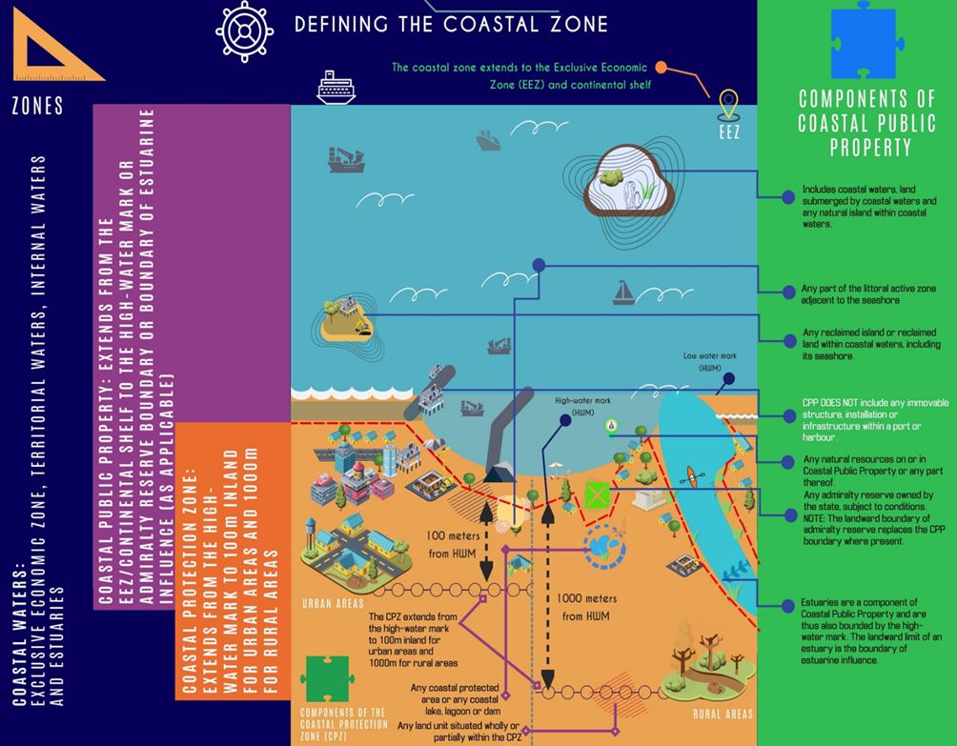
Figure 1: The coastal zone as defined by the ICMA (As provided by DFFE, 2024)

Table 1: Definition of the coastal zone in terms of the ICMA

FEATURE | CONSITUENTS | CHARACTERISTICS | RESPONSIBLE AUTHROITY
Coastal Public Property  2 | - Coastal waters;  - Land submerged by coastal waters, including:  - Land flooded by coastal waters that subsequently becomes part of the bed of coastal waters; and  - The substrate beneath such land;  - Any Natural island within coastal waters;  - The seashore, including:  - The seashore of a natural or reclaimed island; and  - The seashore of reclaimed land;  - Subject to Section 66A, any admiralty reserve owned by the State;  - Any land owned by the State declared under Section 8 to be coastal public property;  - Land reclaimed in terms of Section 7C; or  - Any natural resources on or in any coastal public property of a category mentioned above. | - Marks the shift away from resource centered management to a people centered approach; and  - Aims to improve access to coastal resources, protect sensitive coastal ecosystems and to promote the functioning of natural coastal processes. | The State, which includes all three spheres of government.
Coastal Protection Zone | - Sensitive coastal areas, as defined in the Environment Conservation Act (no. 73 of 1989);  - Any part of the littoral active zone that is not coastal public property;  - Any coastal protected area, or part of such an area, that is not coastal public property;  - A rural land unit that is situated within 1000m of the high water mark (HWM) that is zoned as agricultural or undetermined;  - Any urban land unit that is completely or partly within 100m of the HWM;  - Any coastal wetland, lake, lagoon or dam that is situated completely or partially within a land unit situated within 1000m of the HWM that was zoned for agricultural or undetermined use, or is within 100m of the HWM in urban areas;  - Any part of the seashore that is not coastal public property (including all privately owned land below the HWM);  - Any Admiralty Reserve that is not coastal public property; and  - Any land that would be inundated (submerged or covered) by a 1:50 year flood or storm event (this includes flooding caused by both rain storms and rough seas). | - To protect the ecological integrity, natural character and the economic, social and aesthetic value of the neighbouring coastal public property;  - To avoid increasing the effect or severity of natural hazards;  - To protect people, property and economic activities from the risks and threats that may arise from dynamic coastal processes such as wave and wind erosion, coastal storm surges, flooding and sea-level rise;  - To maintain natural functioning of the littoral active zone;  - To maintain the productivity of the coastal zone; and  - To allow authorities to perform rescue and clean-up operations | The State, which includes all three spheres of government.
Coastal Access Land | - Land designated as such in terms of Section 18(1) of the ICMA. | - Intention of coastal access land is to ensure that the public can gain access to coastal public property via public access servitudes. | Municipality, in accordance with Section 29 of the ICMA by notice in the Gazette.
Coastal Waters  3 | - The internal waters, territorial waters, exclusive economic zone and continental shelf of the Republic referred to in Sections 3, 4, 7 and 8 of the Maritime Zones Act (No 15 of 1994), respectively, and, an estuary. | - Intention is for the State to control activities in coastal waters in the interests of all South African citizens. | National Government.
Coastal Protected Areas | - A protected area that is situated wholly or partially within the coastal zone and that is managed by, or on behalf of, an organ of state, but excludes any part of such a protected area that has been excised from the coastal zone in terms of Section 22 of the ICMA. | - Coastal protected areas are managed through the Protected Areas Act; and  - Intended to augment the coastal protection zone. | National or Provincial conservation agencies.
Special Management Areas | - An area declared as such in terms of Section 23 of the ICMA. | - May prohibit certain activities from taking place within such a management area in order to:  - Achieve the objectives of a coastal management programme;  - Facilitate the management of coastal resources by local communities;  - Promote sustainable livelihoods; or  - Conserve, protect or enhance coastal ecosystems and biodiversity. | National Government (may adopt a manager).
Estuaries  4 | - Estuarine Functional Zone (EFZ) as defined in the NBA and the NEMA EIA, regulations 2014.  - The EFZ is by default approximated as the 5m topographical contour (i.e. 5m above mean sea level) but should be confirmed by on-site verification, especially in smaller estuaries. The EFZ includes open water area, estuarine habitat (sand and mudflats, rock and plant communities) and floodplain area. | - Estuaries are rich in resources, biodiversity and habitat provision;  - They provide the link to the hinterland and the catchment;  - Their state is often referred to as the report card for the catchment as a whole;  - They require integrated and dedicated management tools; and  - Local input in an advisory capacity. | National, Provincial, Local Government or conservation agencies.

  - Value of the coast

South Africa has a coastline that is both ecologically diverse and rich in natural resources. The National Coastal Management Programme of South Africa (2014) (NCMP) identifies South Africa’s coastline as a national asset. The West Coast District Municipality’s (WCDM) coastline is equally diverse and rich in resources and as a result, many coastal communities depend heavily on these coastal resources for both subsistence needs (food, etc.) and as a source of income (e.g. tourism). The NCMP describes the coastal environment as:

- An economic place where commercial, recreational and subsistence activities take place;
- A social place where people can enjoy themselves and come to relax and find spiritual peace; and
- A biophysical place where land, sea and air meet and interact, and where beaches, sand dunes, rocky headlands and estuaries support a wide range of coastal biodiversity.

The WC PCMP (2022 -2027) strives to:

- to provide a uniform approach to coastal management within the province, ensuring consistency with the NCMP and National Estuarine Management Protocol;
- maintains synergy with national goals and objectives in the provincial outcomes, provide guidance on the alignment of municipal outcomes;
- collate provincial needs and issues to formulate priorities, action plans and strategies.

The description of the coastal environment, as described by the NCMP is encompassing of the CMs diverse and resource rich coastline. These aspects of the coastline (economic aspect, social aspect and biophysical aspect) are interlinked, and each aspect needs to be effectively managed to ensure coastal resource sustainability.

The contribution of coastal resources to the South African economy is estimated to be approximately R 57 billion per annum (UNOPS, 2011) where the direct economic benefits of coastal resources in South Africa are approximately 35% of the country’s GDP. Within the CM, the primary direct economic benefits of coastal resources include harbour activities within the Lamberts Bay harbour, small scale fisheries, recreational fishing and coastal tourism. The CM coastline also provides a valuable source of educational and scientific opportunities that cannot be quantified in monetary value.

  - Context of Coastal Management Programmes in South Africa

In terms of the ICMA, CMPs are considered to be an important tool for effective integrated coastal management in South Africa. Section 48 of the ICMA requires that coastal district and local municipalities develop CMPs that are in alignment with both the NCMP and the provincial CMP (Western Cape Coastal Management Programme 2022-2027). While the NCMP and the provincial CMPs are required to address strategic planning and implementation issues in the coastal zone, whereas municipal CMPs are required to address more operational and more focused planning and implementation issues in the coastal zone.

5
  - The Purpose of the Updated Cederberg Local Coastal Management Programme

The first generation CM CMP was finalised and adopted in 2019. However, the priorities identified in this CM CMP, like the coastal zone, are dynamic and must be periodically re-examined to revise strategies. For this reason, Section 48 of the ICMA requires that the CM review the CMP at least once every five years, and if necessary, amend the CMP.

In order to ensure that all the requirements of a CMP as per Section 49 of the ICMA are met, the CMP must –

- Be a coherent municipal policy directive for the management of the coastal zone within the jurisdiction of the municipality;
- Be consistent with –
- The national and provincial coastal management programmes; and
- The national estuarine management protocol.

More specifically, the ICMA (Section 49) states that the updated CM CMP must include the following components:

- A municipal vision for the management of the coastal zone, including the sustainable use of coastal resources;
- Municipal coastal management objectives;
- Priorities and strategies that achieve the following:
- Coastal management objectives of the WCDM,
- Applicable coastal management objectives stipulated within the NCMP and Western Cape CMP,
- Address the issue of high percentage of vacant plots and the low occupancy levels of residential dwellings,
- The designation of areas for the purposes of mixed cost housing and taking into account the needs of previously disadvantaged individuals,
- Addressing coastal erosion and accretion,
- Strategies to deal with issues pertaining to coastal access,
- Performance indicators to measure progress with the achievement of the objectives.

Section 29 of the ICMA also states that the CM CMP may include a programme of projected expenditure and investment to be made by the CM to implement the CMP, and a description of specific areas within the coastal zone that may require special management strategies or estuary management plans.

  - The Cederberg Municipality Coastal Management Programme Development Process

An integrated approach was adopted for the development of this CM CMP whereby each of the coastal LMs were engaged separately to form part of the larger WCDM CMP development process. The coastal LMs within the WCDM (see Figure 2) are:

- Swartland;
- Saldanha Bay;
- Bergrivier;
- Cederberg; and
- Matzikama.

6

The development of this CM CMP followed the following general process:

- Firstly, an initial framework for coastal management in the CM was developed, which outlined the key components of an integrated CMP. This formed the structure of the CMP.
- A draft situation analysis of the coastal zone and coastal management along the CM coastline was prepared.
- Through a series of stakeholder workshops, coastal issues and potential future needs were identified.
- A preliminary list of indicators for coastal management was derived from the issues identified as well as consultation with the existing CM CMP (2013) and the Western Cape Provincial CMP (2016). This was done in order to monitor the progress of the implementation of the CMP to achieve management objectives.
- Finally, specific coastal management actions for the CM CMP were identified, from which implementation plans were developed.

  - Framework of this CM CMP

The framework for this CM CMP is based on the first generation CMP, the Western Cape CMP as well as the NCMP. It is important that this CM CMP aligns closely with the Provincial and National CMP.

The framework aims to provide a holistic and structured guideline as to how to undertake the situation analysis, and to identify coastal issues and future needs:

- The vision of the CM CMP was developed to not only reflect the ecological aspects of the coastal zone, but to also reflect its social, economic and cultural aspects.

- The objectives of the CM CMP were formulated in order to achieve the CM vision for coastal management.

- The strategies and associated actions in this CM CMP were grouped into the following themes:

- Institutional arrangements;
- Natural resource management;
- Heritage resource management;
- Pollution control and management;
- Facilitation of coastal access;
- Safety and security;
- Socio-economic development; and
- Institutional, human and financial resource capacity.

However, after reviewing the first generation CMP, the Provincial CMP and the outcomes of the stakeholder engagement process for this CM CMP, the need to reorganise the themes became evident. They have been reorganised as follows, and these 10 themes (listed in order of importance) will be carried through into the development of implementation strategies for coastal management in the CM:

- Cooperative governance and institutional arrangements: This theme has overarching importance for the effective implementation of coastal management objectives and strategies.

7

Effective cooperative governance requires the participation of all public sector agencies and departments with responsibility for coastal management, from national through to local government levels. There is a need for co-responsibility, and integrated and coordinated decision making and planning. In addition, ongoing skills transfer and capacity building, especially related to practical implementation of programmes and processes is required. This will assist in ensuring compliance with international conventions, protocols and agreements. In reference to the Provincial coastal management programme 2022-2027.

- Facilitation of coastal access: The ICMA (Section 49) identifies the facilitation of coastal access as a key issue, and this is particularly applicable to the CM CMP. Emphasis needs to be placed on the promotion and management of reasonable access to coastal public property, the promotion and facilitation of equitable access to coastal resources and coastal public property, and the need to meet the objective of ensuring access, whilst promoting custodianship and stewardship of the coastal zone.

- Coastal planning and development: Due to the ever-increasing demand for ocean and coastal space, appropriate coastal planning is required to ensure that all forms of development align with ICMA principles. This requires that measures which emphasise local economic development opportunities are put in place. But planning and spatial development must focus on sustainable and equitable development, and the approval process must take this into consideration.

- Compliance, monitoring and enforcement: In order to ensure that coastal management objectives are being implemented and that coastal legislation is being complied with, compliance, monitoring and enforcement strategies need to be developed. Ensuring compliance with applicable coastal legislation requires the promotion of the Environmental Management Inspectorate, including facilitation, training and designation of Environmental Management Inspectors by the WCDM. This will contribute to ensuring that the coastal zone is managed effectively. The selection of indicators and the implementation of monitoring programmes are required in order to assess progress towards achieving the CMP vision and objectives. In order to evaluate the findings of these monitoring programmes, Section 93 of the ICMA requires that State of the Coast Reporting be carried out. State of the Coast Reporting will inform the subsequent reviews of the CM CMP and future coastal planning processes.

- Estuary management: Estuaries within the CM are heavily impacted and of high value. These estuaries require the establishment and implementation of strategies to improve the management and protection of estuarine resources, as well as the need to secure sufficient financial resources to fund and implement the identified actions, research projects, other initiatives and the advisory forums. The Verlorenvlei Estuary provided important fishing, bird watching and tourism benefits for the local community and tourists within the coastal town of Eland’s bay and is very important to the local and regional economy.

8

- Natural resource management: The effective management of natural resources needs to include the maintenance of ecosystem integrity and health, the assessment and effective management of coastal protected areas, including marine protected areas, as well as the identification and rehabilitation of damaged and degraded coastal ecosystems and habitats.

- Heritage resource management: The CM coastline has a wealth of heritage resources that require protection and management in order to preserve them for the benefit of future generations. Heritage resource management in the coastal zone is an important aspect of coastal management in the WCDM.

- Pollution control and management: This requires both effective management and effective prevention strategies, with an emphasis on reducing and responding to both land based and marine based sources of pollution in the coastal zone. Ensuring adherence to the waste management hierarchy of “reduce, reuse, recycle”, will help reduce solid waste in particular. The effective management of waste within the coastal zone requires cooperation between various departments within the local and district municipalities, provincial and national government departments, as well as coastal communities.

- Socio-economic development: The coastal zone is important to society, and to the economic development of all coastal communities. It is important that the socio-economic environment along the coastline is well managed and supported to ensure that all coastal communities receive the full benefit of the resources that the coastal zone provides. The identification and exploitation of sustainable livelihood opportunities is equally important to capitalise on the benefits offered by the coastline.

- Awareness, education, training, capacity building and information: These are important actions to implement, as this will help to facilitate the cooperative management of the coastal zone, which is required to successfully implement an integrated coastal management strategy. The generation of internal capacity within the CM, to effectively manage the coast is also vital in ensuring that the objectives and strategies set out in the CMP are implemented. Awareness of the coastal zone among various key stakeholder can be achieved through the facilitation of knowledge production and exchange, the promotion of knowledge sharing of coastal issues, and instilling a sense of ownership of the coastal zone amongst all stakeholders.

9

LEGISLATIVE OVERVIEW

Coastal management is an integrated process and as a result the coastline is governed by a number of laws and policies. Due to the complexities of the legislative framework that is applicable to coastal management in South Africa, many legal requirements pertaining to coastal management are either implemented ineffectively or not at all. This section provides a brief description of the relevant legislation, policies and plans that are important to integrate into coastal management activities.

  - Legislation

The South African Constitution

Schedule 4b and 5b of the Constitution indicates that the management of the following matters are assigned to local government:

- Beaches and amusement facilities;
- Cleansing;
- Control of public nuisances;
- Local amenities;
- Local sport facilities;
- Local tourism;
- Municipal parks and recreation;
- Municipal planning;
- Municipal roads;
- Noise pollution;
- Pontoons, ferries, jetties, piers and harbours, excluding the regulation of international and national shipping activities and related matters;
- Public places;
- Refuse removal, refuse dumps and solid waste disposal;
- Stormwater management systems in built up areas;
- Traffic and parking; and
- Water and sanitation services limited to potable water supply systems and domestic waste-water and sewage disposal systems.

Local Government: Municipal Systems Act (No. 32 of 2000, as amended by Act No. 44 of 2003).

The following aspects of this Act relate specifically to coastal management and need to be incorporated into the CM CMP:

- The creation and adoption of by-laws;
- Chapter 5 provides for Integrated Development Planning (IDP) wherein a municipal CMP can be incorporated. Section 26 states that each Local, Metropolitan and District Municipality is required to develop an IDP, which must reflect a municipality’s vision and objectives. The IDP is seen as the primary planning instrument that informs and guides all planning and development in a municipality;
- Section 11(3) highlights the need for municipalities to exercise their legislative authority. The Act states that municipalities must exercise their executive and legislative authority within the constitutional systems of co-operative government envisaged in terms of Section 41 of the Constitution; and

10

- Section 25 states that: “each municipal council must, within a prescribed period after the start of its election term, adopt a single, inclusive and strategic plan for the development of the municipality”.

Local Government: Municipal Structures Act (Act No. 117 of 1998, as amended by Act No. 1 of 2003)

The functions of a District and Local Municipality that relate specifically to coastal management are identified in this Act as:

- Integrated development planning for the Municipality, including a framework for IDPs of all municipalities in the area of the WCDM;
- Potable water supply systems;
- Domestic waste-water and sewage disposal systems;
- Solid waste disposal sites, as it relates to:
- The determination of a waste disposal strategy;
- The regulation of waste disposal; and
- The establishment, operation and control of waste disposal sites, bulk waste transfer facilities and waste disposal facilities for more than one LM in the district;
- Municipal roads, which form an integral part of a road transport system for the area of a WCDM as a whole;
- Promotion of tourism for the area of the WCDM;
- Municipal public works relating to any of the above functions or any other function assigned to the WCDM;
- The receipt, allocation and, if applicable, the distribution of grants made to the WCDM; and
- The imposition and collection of taxes, levies and duties related to the above functions or as may be assigned to the WCDM in terms of national legislation.

Local Government Municipal Finance Management Act (No. 56 of 2003)

The objective of the Municipal Finance Management Act (2003) (MFMA) is to modernise municipal financial management in South Africa, so as to lay a sound financial base for the sustainable delivery of services.

Municipal financial management involves managing a range of interrelated components: planning and budgeting, revenue, cash and expenditure management, procurement, asset management, reporting and oversight. Each component contributes to ensuring that
expenditure is developmental, effective and efficient and that municipalities can be held accountable.

The MFMA, together with the Municipal Structures Act (1998), the Municipal Systems Act (2000), the Municipal Property Rates Act (2004) and the Municipal Fiscal Powers and Functions Act (2007), sets out frameworks and key requirements for municipal operations, planning, budgeting, governance and accountability.

National Environmental Management Act (No. 107 of 1998) (NEMA)

NEMA serves as framework legislation for South Africa because it provides for overarching and generic principles that should inform South Africa’s environmental management and governance. NEMA is mainly regarded as a requirement from State, in order to fulfil

11
obligations imposed upon it, by the constitutional environmental right to protect the environment, through reasonable legislative measures and other measures. Furthermore, NEMA is intended to give effect to the cooperative governance imperative contained in the Constitution.

It is important that the CM incorporates the sustainable development principles outlined in NEMA into their municipal planning procedures.

National Environmental Management: Integrated Coastal Management Act (Act No. 28 of 2008) Amended in 2014 (ICMA)

The ICMA (Amended in 2014) is the key legislative framework that regulates the use of coastal resources. The Objectives of the ICMA include the following:

- Sets out a new and integrated approach to managing the nation’s coastal resources in order to promote social equity and to make best economic use of coastal resources, whilst protecting the natural environment. Specifically, the Act seeks to:
  - Provide a legal and administrative framework that will promote cooperative, coordinated and integrated coastal management;
  - Preserve, protect and enhance the status of the coastal environment as the heritage of all;
  - Ensure that coastal resources are managed in the interest of the whole community;
  - Ensure that there is equitable access to the opportunities and benefits derived from the coast; and
  - Give effect to South Africa’s international law obligations.

It is important that the CM CMP fully aligns with the requirements of the ICMA.

NEM ICMA: Dumping at Sea Regulations (2016)

The Dumping at Sea Regulations have been developed to enable the DEFF to implement Sections 70 and 71 of the ICMA. The Regulations outline the specific requirements that must be met when applying for a dumping permit as well as an emergency dumping permit.

All Dumping at Sea permits are issued by DEFF, but the CM has a responsibility to report any illegal activities to DEFF to ensure that all dumping at sea activities are properly authorised and monitored.

NEM ICMA: Coastal Waters Discharge Permit Regulations (2018) (CWDP)

The CWDP Regulations aim to provide an administrative framework for the implementation of Section 69 of the ICMA. The ICMA empowers the DEFF to manage the discharge of effluent into coastal waters in a manner that ensures that users of coastal waters are not adversely affected, and that the environmental integrity of the coast is not compromised.

National Estuarine Management Protocol (NEMP)

The ICMA requires that estuaries in South Africa be managed in a co-ordinated manner. As a result, the NEMP was developed to guide the management of estuaries through the development and implementation of individual Estuarine Management Plans (EMPs). The EMPs aim to achieve harmony between ecological processes and human activities while accommodating sustainable estuarine resource utilisation.

12
The NEMP was reviewed and updated by the DFFE to address matters relating to legal questions regarding Responsible Management Authority allocated in the NEMP 2013. The reviewed NEMP was completed and published in 2021 for implementation. Clearly defined roles are now in place. A guideline which unpacks the NEMP has been developed by the DFFE and assists with the implementation of the NEMP.

NEM: Environmental Impact Assessment (EIA) Regulation, as amended in 2017

The EIA Regulations, as amended in 2017, make provision for the protection of the coastal zone by incorporating a number of listed activities that are specifically aimed at protecting the coastline. Any proposed activities listed in the EIA Regulations that relate to the coastal zone may not proceed without undergoing an EIA process and having been issued an Environmental Authorisation.

The National DFFE and Provincial Department of Environmental Affairs and Development Planning (DEA&DP) are the relevant Authorities that are mandated to issue Environmental Authorisations (EAs) as well as to monitor compliance with the conditions of the EAs. However, it is the Municipality’s responsibility to ensure that they participate in the EIA process to ensure that municipal planning schemes are taken into consideration. This will prevent conflicts with the Municipality’s development goals and objectives.

NEM: Control of Use of Vehicles in Coastal Areas Regulations (2014)

The NEM: Control of Use of vehicles in Coastal Areas Regulations aim to minimise the impact of vehicles driving in the sensitive coastal environment. The Regulations stipulate prohibitions as well as defines permissible uses of vehicles within the coastal area. The Regulations allow for permits to be issued for the use of vehicles in coastal areas.

The DFFE are mandated to issue permits for vehicles in the coastal zone as well as enforcing the Regulations. However, the Municipalities are responsible for reporting any illegal driving activities in the coastal zone to DFFE.

NEM: Management of Public Launch Sites in the Coastal Zone Regulations (2014)

The NEM: Management of Public Launch Sites in the Coastal Zone Regulations provides a formal process when registering new or existing public launch sites. The Regulations provide a framework from which the provincial Department of Environmental Affairs is able to assess and authorise public launch sites.

The CM has one public launch site at Elands Bay (Old Crayfish Factory) that has been listed in the Provincial Gazette (2015). The CM has been identified as the management authority responsible for the operation and maintenance of this launch sites.

However, the Management Bodies can request that registered PLS can be delisted or a new PLS can be added to the list.

Marine Living Resources Act (Act No. 18 of 1998) (MLRA)

The purpose of the MRLA is to provide for the conservation of the marine ecosystems, the long-term sustainable utilisation of marine living resources and the orderly access to the

13
exploitation, utilisation and protection of certain marine living resources; and for these purposes to provide for the exercise of control over marine living resources in a fair and equitable manner to the benefit of all the citizens of South Africa.

The CM has a strong small-scale fishing presence and the small-scale fisheries in the district need to be managed through the MLRA. However, the MLRA does not make provision for local authorities to implement and enforce the Act unless representatives of the local authority are designated as Fisheries Control Officers in terms of Section 9 of the MLRA.

National Ports Act (No. 12 of 2005) (NPA)

The NPA seeks primarily to give effect to the Government's Policy on commercial ports that outlines the role of ports in the South African economy. The largest harbour in the CM is the Lamberts Bay harbour.

National Environmental Management: Protected Areas Act (No. 57 of 2003) (NEM: PAA)

NEM: PAA mainly provides for the following:

- Declaration of nature reserves and determination of the type of reserve declared;
- Cooperative governance in the declaration and management of nature reserves;
- A system of protected areas in order to manage and conserve biodiversity; and
- Utilization and participation of local communities in the management of protected areas.

A few protected areas exist within the coastal areas of the CM. Some of the protected areas that have been proclaimed under the NEM: PAA include:

- Penguin (Bird) Island Nature Reserve Complex;
- Elands bay Dune Reserve; and
- Dassen Coastal Complex Protected Area.

National Environmental Management: Biodiversity Act (No. 10 of 2004) (NEM:BA) and the Western Cape Biodiversity Act (No. 6 of 2021)

The objectives of the Biodiversity Act include the following:

- Management and conservation of biological diversity;
- Use of biological resources in a sustainable manner;
- Equitable sharing of benefits arising from bio-prospecting; and
- Cooperative governance in biodiversity management and conservation.

The Biodiversity Act requires that the state must manage, conserve and sustain South Africa's biodiversity and its components and genetic resources; and must implement this Act to achieve the progressive realization of those rights.

National Environmental Management: Air Quality Act (No. 39 of 2004) (NEM: AQA)

The purpose of the NEM: AQA is to provide a legislative platform for regulating air quality. This is done by providing reasonable measures for the prevention of pollution and ecological degradation, as well as securing ecologically sustainable development while

14
promoting justifiable economic and social development. The AQA also aims to provide for national norms and standards regulating air quality monitoring, management and control by all spheres of government.

The WCDM and CM have an Air Quality Management Plan that is currently being updated and the WCDM, together with the CM, are responsible for implementing the strategies outlined in the Air Quality Management Plan. The WCDM is also responsible for issuing Air Emissions Licenses and monitoring the conditions stipulated in the licenses.

National Environmental Management: Waste Management Act (No. 59 of 2008) – (NEM:WMA)

The NEM: WMA outlines roles and responsibilities of the three spheres of government with respect to waste management within a waste avoidance and minimisation framework. It establishes a national framework for waste management and provides for identification of waste management activities that require licensing. The NEM:WMA sets out measures for the storage, collection, transportation, recovery, re-use, recycling, treatment and disposal of waste and outlines requirements for the licensing of waste management activities.

The WCDM has developed and is implementing their Integrated Waste Management Plan.

National Water Act (No. 36 of 1998) (NWA)

The NWA is the legislative framework that guides the development of a number of programmes that aim to understand the state of and effectively manage water resources in South Africa. Examples of programmes and projects include the classification of water resources and setting the Reserve and Resource Quality Objectives (RQOs), the prevention of the pollution of water resources due to land based activities, the authorisation and management of various water use activities, as well as the establishment and management of catchment management agencies which manage water resources within their water management area.

The water management area within the CM is the Berg -Olifants Water Management area.

Conservation of Agricultural Resources Act (No. 43 of 1983) (CARA)

CARA is the chief statute that deals with agricultural resources. The objective of CARA is to provide for the conservation of the natural agricultural resources of South Africa through maintenance of the production potential of the land. In order to maintain production potential of land, CARA provides for the following mechanisms:

- Combating and preventing erosion and the weakening and destruction of water sources;
- Protection of vegetation; and
- Combating and control of weeds and invader plants.

It is important that the CM CMP captures the objectives of CARA though the management of coastal erosion as well as the management of alien invasive vegetation within the coastal zone.

15
National Heritage Resources Act (No. 25 of 1999) (NHRA)

The NHRA governs natural heritage resources and the management thereof. It creates Heritage Authorities, namely the South African Heritage Resource Agency (SAHRA), with the responsibility to protect and manage certain categories of heritage resources. The CM has a number of heritage resources that are formally protected though the NHRA. In terms of the Act, the local authorities are responsible for managing all Grade III registered heritage resources. A detailed discussion regarding the heritage resources within the CM has been provided in the Situational Analysis.

Spatial Planning and Land Use Management Act (No. 16 of 2013) (SPLUMA)

SPLUMA aims to provide a framework for spatial planning and land use management in South Africa and informs the development of Spatial Development Frameworks (SDFs) at Provincial and local government levels. All the Local Municipalities, District Municipalities and Provinces require the development of Spatial Development Frameworks (SDFs) to inform the Integrated Development Plans (IDPs). These SDFs must incorporate all coastal management aspects so ensure that the integrity of the coastline is maintained when development in the coastal zone is proposed.

Western Cape Land Use Planning Act (Act No. 3 of 2014) (WCLUPA)

The WCLUPA provides a legislative framework for effective provincial planning, regional planning and development, pertaining to urban and rural development, regulation, support and monitoring of municipal planning and regulation of public places and municipal roads arising from subdivisions. WCLUPA also makes provision for provincial spatial development frameworks as well as provides for minimum standards for, and the efficient coordination of, spatial development frameworks. The WCLUPA aims to provide for the minimum norms and standards of effective municipal development management and regulates provincial development management, as well as the effect of land development on agriculture and also aims to provide for land use planning principles.

The Promulgation of this Act is important for future planning for development in the coastal zone, and the CM needs to ensure that this legislation is incorporated into the municipal IDP and SDF.

Criminal Procedures Act (No. 51 of 1977)

The Criminal Procedures Act provides the basis for the procedure for the arrest and prosecution of people found to be in contempt of the law. The Criminal Procedures Act needs to be applied when conducting any enforcement activities relating to any of the environmental and coastal legislation.

  - National and Provincial policies and programmes

This section lists the various National and Provincial policies and programmes that have informed the development of the CM CMP:

- National Coastal Management Programme (2015)(NCMP);
- National Estuarine Management Protocol (2013) and (2021)(NEMP);
- State of Oceans and Coasts around South Africa Report (2014);
16
- 2nd South Africa Environment Outlook (2016);
- Africa Environmental Education and Training Strategy Action Plan (2015);
- White Paper for Sustainable Coastal Development (2000);
- Blue Flag South Africa;
- National Biodiversity Strategy and Action Plan (NBSAP);
- National Climate Change Response Strategy (NCCRS);
- South African Water Quality Guidelines for Coastal Marine Waters (2012, currently being updated);
- National Guideline for the Discharge of Effluent from Land-based Sources into the Marine Environment (2014);
- Policy for the Small-Scale Fisheries Sector in South Africa (2012);
- Western Cape Provincial Coastal Management Programme (2022-2027) (WCPCMP);
- Western Cape Biodiversity Spatial Plan (2017) (WCBSP);
- Western Cape State of the Coast Report (2019) (WCSoCR);
- Western Cape Green Economy Strategic Framework (2017) (WCGESF);
- Western Cape Climate Change Response Strategy (2023) (WCCCRS); and
- Breede-Gouritz Catchment Management Strategy (2017).

  - West Coast District Municipality policies and programmes

This section lists the various WCDM policies and programmes that have informed the development of the CM CMP:

- West Coast District Municipality Integrated Development Framework (2017-2022) (IDP);
- West Coast District Spatial Development Framework (2014) (SDF);
- West Coast District Air Quality Management Plan (currently being reviewed and updated);
- West Coast District Disaster Manager Plan (2015);
- West Coast District Municipality Sea Level Rise & Flood Hazard Risk Assessment;
- Coastal Management/Set Back lines for the West Coast District Municipality;
- West Coast District Climate Change Response Framework (2014);
- Treated Effluent By-law and Amended By-law (2015); and
- Stormwater Management By-law (2005).

  - Local Municipality policies and programmes

The following polices, programmes and by-laws for each of the Local Municipalities (LMs) were assessed as part of the CM CMP development process:

- Cederberg LM IDP;
- Cederberg LM SDF;
- Cederberg By-law for the Control of the Seashore and the Sea situated within or adjoining the Area of Jurisdiction of the Municipality of Cederberg;
- Cederberg By-law relating to Camping Areas; and
- Cederberg By-law relating to Nature Reserves.
- Cederberg Coastal management By-law
- Cederberg Municipality Climate Change plan
- Cederberg Air Quality Management By-law

17
  - Other policies and programmes

Coastal zone management requires an integrated approach. Therefore, the following policies, programmes and plans that have been developed outside of local government and provincial government levels, forms part of the CM CMP development process:

- Dassen Coastal Complex Protected Area Management Plan (2019–2029).

Dassen-Complex-PAMP_board-approved.pdf

18

SITUATION ASSESSMENT

This chapter provides an updated Situation Assessment of the CM that was developed for the first generation CM CMP in 2013. A brief outline of the coastal environment and the status of coastal ecosystems along the CM coastline is provided. The status of coastal management along the CM coastline has been assessed using the framework for coastal management as set out in Section 1.7. Section 1.7 identifies ten themes for inclusion in this updated CMP and the current status of the CM coastline has been described according to these ten themes. Current coastal issues and existing responses to address these issues have also been described.

  - Locality and extent of the coastline

Cederberg Municipality (CM) is located on the West Coast of the Western Cape Province and forms part of the WCDM. The municipal area is eight thousand square kilometres (8,007 km²) in extent, constituting 25.7% of the West Coast District. The CM area stretches from the Atlantic seaboard on the west to the Cederberg on the east. Figure 2 below indicates the boundaries of the CM.

A map indicating the municipal boundaries according to the Municipal Demarcation Board is attached in Appendix A.

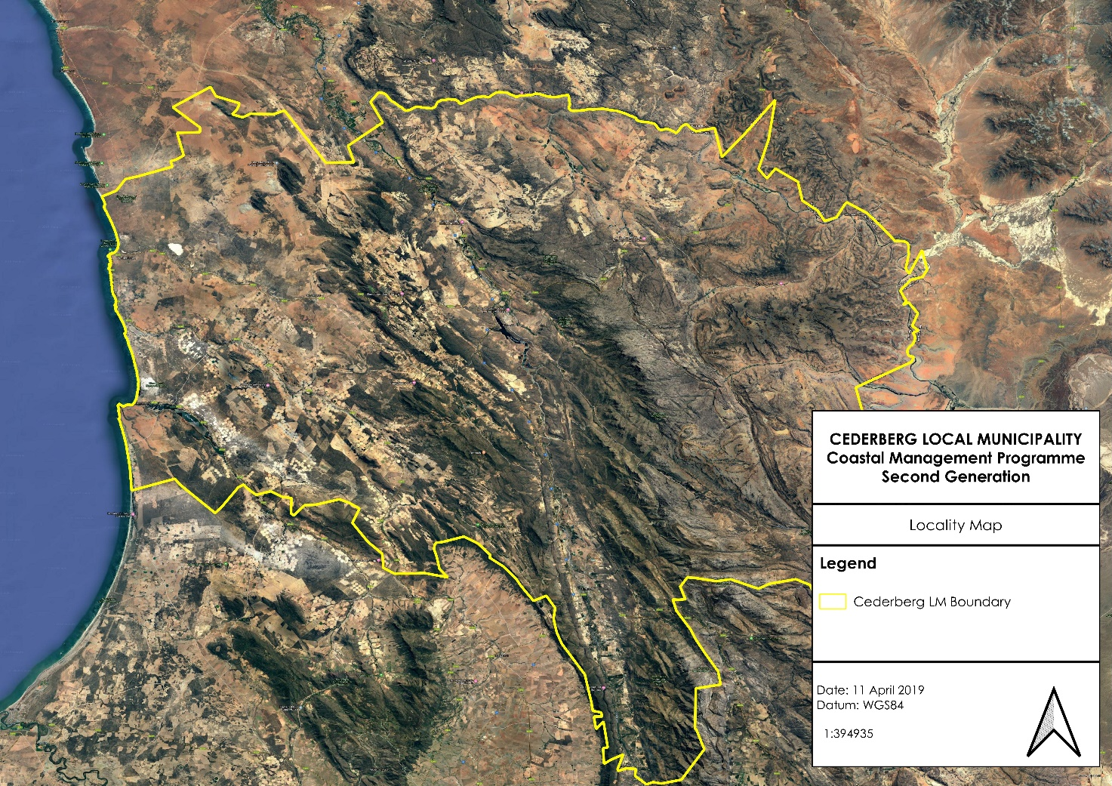
Figure 2: Boundaries of the CM

An important aspect of coastal management is understanding of the extent of the coastline. According to the Demarcation Board of South Africa, the extent of the CM coastline is 62km.
19
  - Theme 1: Institutional Arrangements and Cooperative Governance

This theme has overarching importance for the effective implementation of coastal management objectives and strategies. Effective cooperative governance requires the participation of all public sector agencies and departments with responsibility for coastal management, from national through to local government levels. There is a need for co-responsibility, and integrated and coordinated decision making and planning. In addition, ongoing skills transfer and capacity building, especially related to practical implementation of programmes and processes is required. This will assist in ensuring compliance with international conventions, protocols and agreements.

3.2.1. Coastal management functions at Provincial, District and Local Level

At a provincial level, the DEA&DP Coastal Management Unit have several coastal management functions within the CM. These functions include the following:

- Assisting municipalities with the registering and/or deregistering of PLS;
- Supporting the Municipal Coastal Committee (MCC);
- Facilitating the Provincial Coastal Committee (PCC);
- Supporting estuary management;
- Advisory and support services with regards to the provision of access to the coast;
- Commenting on Environmental Impact Assessment (EIA) applications as well as providing advisory and support services;
- Assistance with the delineation of coastal management lines; and
- Coastal education and awareness.

Effective coastal management efforts are also reliant on a wide range of stakeholders that have an interest in the coast and the management thereof. These stakeholders encompass other government organisations such as, but not limited to:

- Department of Mineral and Petroleum Resources (DMPR).
- Department of Agriculture
- Department of Land Reform and Rural Development
- Department of Cooperative Governance and Traditional Affairs (CoGTA); and
- Department of Forestry, Fisheries and the Environment (DFFE).

Other relevant coastal stakeholders include local government, NGOs and civil society.

Most environmental and coastal aspects within the WCDM still falls to the District to manage. The reason for this appears to be that there is still a lack of resources and capacity at LM level to administer environmental and coastal management tasks. This situation does not seem to have changed much since the first-generation CMP was developed.

At WCDM level, there is also limited capacity, resources and knowledge to fulfil their coastal management role. The WCDM has an Environmental Management Unit, which falls within the Administration and Community Services Department. The WCDM only has one designated environmental management officer who is responsible for environmental management in the District.

However, the effective management of the coastal zone also requires cooperation from numerous units within the WCDMs organisational structure. These include, but are not limited to the following units:

20

- Tourism;
- Disaster management; and
- Technical services (roads, planning and development and water supply),

At an LM level, the CM has a fulltime and dedicated environmental officer to support coastal management in the CM.

Local Municipalities are under capacitated to effectively carry out coastal management objectives within their areas of their jurisdiction. It is therefore imperative that the WCDM and Provincial and National Departments provide a supporting role to the local municipalities and to assist and drive coastal management programmes and projects.

3.2.2. Co-operative governance

In terms of the current legislation, such as the Intergovernmental Relations Framework Act (Act 13 of 2005) and the Local Government: Municipal Structures Act (Act 117 of 1998), government departments are obliged to act in a co-operative manner. Co-operative governance can be described as consisting of two main components: ‘vertical’ and ‘lateral’ cooperative governance.

- ‘Vertical’ co-operative governance relies on integration between the coastal management bodies of the Local Municipalities, WCDM and with the Provincial and National authorities. Currently there appears to be some level of co-ordination between the various levels of government with respect to decision-making around issues impacting on the stakeholders and the coastal assets of the WCDM. Key to this has been the establishment of the Municipal Coastal Management Committee;
- ‘Lateral’ cooperative governance relies on inter-departmental integration, coordination and communication between the WCDM and other governmental departments/parastatals, for example, DEA&DP, DFFE, Cape Nature, DALRRD, DMPR, DPWI, SAPS. To a large extent this seems to be lacking in the province, although there is good lateral cooperation in estuary management. Other platforms that facilitate “lateral” cooperative governance include the PCC as well as the National Committee (Working Group 8) that specifically deals with coastal management issues in South Africa.

3.2.3. Protected Areas

Co-operative governance is also important with respect to the management of protected areas. SANParks and CapeNature are responsible for the management of many of these conservation areas, but there needs to be cooperation and a focus on the management of the interface with other land uses. It should also be noted that all spheres of Government (National, Provincial, District and Local Municipalities), and traditional authorities, have an obligation to practice Duty of Care on the natural environment in terms of Section 28 of the National Environmental Management Act 1998 (NEMA).

3.2.4. WCDM Coastal Committee

The WCDM has established a Coastal Committee that meets on a quarterly basis. A variety of stakeholders are invited and encouraged to attend these meetings. These stakeholders include:

- Representatives from the Department of Forestry, Fisheries and the Environment.
21
- Representatives from the CapeNature;
- Representatives from the Department of Environmental Affairs and Development Planning;
- Transnet;
- Local municipal officials;
- Residents and rate payers’ associations;
- Chairpersons of various Estuary Advisory Forums;
- Local conservancies; and
- Various NGO’s.

The WCDM also participates in the Provincial Coastal Committee where priority issues highlighted at the WCDM Coastal Committee meetings are raised at a provincial platform.

Based on the above as well as feed-back from stakeholders, the future needs in terms of facilitating and improving institutional arrangements and cooperative governance are as follows:

- The CM needs to show commitment to the CMP by providing input, resulting in buy-in to the CM CMP objectives and implementation strategies.
- An improvement in lateral cooperation through closer collaboration between all relevant spheres of government as well as public-private partnerships for effective coastal management.
- Clear mandates for all spheres of government with regards to coastal management needs to be defined. These mandates require funding to enable them to be effectively fulfilled.

  - Theme 2: Coastal access

Section 49 and section 18(9) of the ICMA specifically identifies the facilitation of coastal access as a key component of the CM CMP. Emphasis needs to be placed on the promotion and management of access to coastal public property, the promotion and facilitation of equitable access to coastal resources and coastal public property, and the need to meet the objective of ensuring access whilst promoting custodianship and stewardship of the coastal zone.

3.3.1. Existing access to the coastline

The processes required to identify and formalise access points in areas that may not be considered priority areas, as required by the ICMA, is a laborious one. To determine whether coastal access has been appropriately designated in an area or not, the need for coastal access based on the number of people living in the area, the total length of coastline and the number of existing coastal towns and access points located along that length of coastline must be determined.

The CM has a population of 60 790 people living within its borders (WCSEP, 2022) This means that the CM in not a highly populated municipality with small sized settlements scattered throughout the region. Along the CM coastline, there are two towns. Table 2 below provides an indication of the population density and number of coastal towns located within the CM.

22
Table 2: A description of the number of coastal towns and population densities within the CM
Local Municipality | Length of coastline | Population (WC Socio- economic profile 2022) | Coastal towns
Cederberg | 62km | 60 790 | Lamberts Bay  Elands Bay

Physical access to many sections of the CM coastline is restricted by large tracks of private land, private development and conservation areas, especially further north. There is also limited formalised public road infrastructure that facilitates access to the coastline, with the majority of the road network being informal sand tracks through private land as well as the Transnet service road that run parallel to the Sishen-Saldanha railway line. The Transnet service road is not a public road, and users require a permit issued by Transnet.

There is also controversy surrounding the facilitation of access to marine resources and that the benefits of those resources could be distributed on a more equitable manner. Due to the isolated nature of the CM coastline, issues such as ribbon development along the coastline is not a current threat to coastal access. Within the CM, many of the existing coastal access points are located at the settlements that occur along the coastline.

3.3.2. National and Provincial Coastal Access Strategies

The National Strategy for the Facilitation of Coastal Access in South Africa was developed in 2014 and it states that the goal of coastal access is, “to ensure, protect and manage, in perpetuity, public right of physical access to and along the coastal zone”.

Section 18 of the ICMA requires each metro and district municipality, (unless assigned to local municipalities by agreement) whose area includes coastal public property to, within four years of the commencement of the Act, promulgate a by-law that designates coastal access land, in order to secure public access to coastal public property. The Cederberg Municipality Coastal Management By-law has been promulgated in November 2022. However, the ICMA does not provide any guidance on how many of what type of access should be provided. The National Strategy, together with the Provincial Coastal Access Strategy, needs to be used as a benchmark, and states the following two objectives:
- Objective 1: Opportunities for public access must be provided at appropriate coastal locations in context of the environmental, financial and social opportunities and constraints.
- Objective 2: Public access must be maintained, managed and monitored to minimize adverse impacts on the environment and public safety, and to resolve incompatible uses.
The National Strategy for the Facilitation of Coastal Access describes the various types of access as follows:
- Existing access to the coast;
- with facilities provided by the local municipality;
- informal access provided over private land;
- may be indicated in zoning schemes of municipality as “public open space” or similar; or
- Public launch sites (Western Cape public launch sites listed in the provincial gazette (P.N. 193/2015) dated 26 June 2015);
23
- Seasonal coastal access; i.e. popular camping spots along the coast over festive periods;
- Coastal access land designated under section 18 of the ICMA by a municipality;
- Coastal public property declared under sections 8 and 9 of the ICMA by the national Minister; and
- Private land may be acquired for the purpose of declaring as coastal public property to improve public access by:
- purchasing the land;
- exchanging that land; or
- if no agreement, by expropriation.
The minimum requirements for coastal access so designated is described in section 20 of the ICMA:
- signpost entry points to coastal access land;
- control the use of, and activities on, that land;
- protect and enforce the rights of the public to use that land to gain access to coastal public property;
- maintain that land to ensure that the public has access to the relevant coastal public property;
- where appropriate and within its available resources, provide facilities that promote access to coastal public property, including parking areas, toilets, boardwalks and other amenities, considering the needs of physically disabled persons;
- ensure that the provision and use of coastal access land and associated infrastructure do not cause adverse effects to the environment;
- remove any public access servitude that is causing or contributing to adverse effects that the municipality is unable to prevent or to mitigate adequately; and
- describe or otherwise indicate all coastal access land in any municipal coastal management programme and in any municipal spatial development framework prepared in terms of the Municipal Systems Act.

3.3.3. Western Cape Provincial Coastal Management Programme 2022-2027

The Western Cape Provincial Coastal Management Programme 2022-2027 (WC CMP) identified nine priority areas with accompanying goals and coastal management objectives and implementation strategies. The Facilitation of Coastal Access is Priority Area 3 with specific goals and objectives. The Western Cape Government is a key role-player in building commitment and providing guidance and support to municipalities to allow them to effectively implement, maintain and monitor coastal access. This priority area includes ensuring that the public has an equitable and reasonable right of access to the coast and its resources, as well as the appropriate management of such access. Two implementation strategies were highlighted:
- Develop a Western Cape Coastal Access Strategy and Plan (This strategy proposes to ensure provincial consistency, entrenches the municipal responsibility and supports municipal implementation); and
- Assist Local Government in implementing the Western Cape Coastal Access Strategy.
To date, the Western Cape Province has developed a Western Cape Provincial Coastal Access Audit: West Coast Municipal District, October 2019 of existing coastal access points along the WCDM coastline.

24
In order to assist the WCDM and the CM with the implementation of the Provincial Coastal Access Strategy, the WC CMP proposes the following actions:
- Assist with the inclusion of coastal access land designated by Local Governments in reviewed SDFs;
- Produce a consolidated report on status of coastal access land designation and management;
- Develop a framework operational plan for each listed Public Launch Site (PLS); and
- Monitor the implementation of operational plans for PLS.

3.3.4. Coastal Access Audit for the WCDM

Section 18 of the ICMA states that each metro and district municipality, (unless assigned to local municipalities by agreement) whose area includes coastal public property, are to promulgate a by-law that designates coastal access land in order to secure public access to coastal public property within four years of the commencement of the ICMA. Coastal Management By-law has been promulgated in November 2022 by Cederberg Municipality.

The 2014 amendments to the ICMA allow the Provincial Member of the Executive Council (MEC), followed by the National Minister, to intervene and designate coastal access land should a municipality fail to do so. However, the Coastal Access Audit for the WCDM will assess existing and historic coastal access land and admiralty reserve and will include recommendations in respect of land that could be designated as coastal access land.

To date (May, 2019), a desktop assessment and a ground-truthing exercise has been undertaken where these coastal access points were verified. The Western Cape Provincial Coastal access audit: West coast municipal district main report was completed in November 2019. The outcomes and recommendations of the Coastal Access Audit for the WCDM is incorporated in the CM CMP and well as the CM IDP and SDF.

3.3.5. Coastal public amenities

Many of the beaches and coastal access points along the CM have public amenities such as parking areas, toilets, braai areas, walkways and rubbish bins and educational signage. The provision and maintenance of these amenities falls to the CM in terms of their constitutional mandate to manage beaches within their area of jurisdiction.

The WCDM Coastal access audit gives a detailed assessment of these public amenities within the CM.

3.3.6. Working for the Coast projects

Since the 1999/2000 financial year, the DFFE has been implementing programmes aimed at conserving natural assets and protecting the environment. These programmes are called the Environmental Protection and Infrastructure Programmes (EPIP).

The purpose of EPIP is to manage the identification, planning and implementation of programmes that mirror and support the mandate of the DFFE, while creating job opportunities under the banner of the Expanded Public Works Programme (EPWP) using labour intensive methods targeting the unemployed, youth, women, people with disabilities and Small, Medium and Micro-sized Enterprises (SMMEs).
25

The main goal of the EPIP is to alleviate poverty through a number of interventions that are implemented in communities, to uplift households, especially those headed by women, while empowering beneficiaries to participate in the mainstream economy in a manner that addresses the environmental management challenges facing the country.

The EPIP implements its projects through a number of focus areas that include the following:

- Greening and Open Space Management;
- People & Parks;
- Working for Land;
- Working for the Coast;
- Working on Waste;
- Wildlife Economy; and
- Youth Environmental Service.

The Working for the Coast (WftC) focus area is the area where the WCDM and its LMs can benefit the most in terms of facilitating coastal management in the district. The WftC focus area is responsible for the implementation of the following in coastal areas:

- Rehabilitation of coastal environment, including but not limited to, dunes, estuaries, etc.;
- Cleaning up of coastlines in general and the beaches in particular;
- Upgrading and maintaining of facilities and infrastructure along the coast; and
- Facilitation of access to the coastline without compromising the environment.

Coastal Management Objective: Promote and support advisory bodies, inclusive of civil society, to enable effective co-operative governance
Implementation Strategy: | Output Indicators: | Timeframe:
Ensure provincial representation and support to advisory bodies | Deployment and support of provincial representatives at these committees e.g., Biosphere Reserves, Water Quality Trusts, Estuary Advisory Forums, Protected Areas Advisory Committees, Working for the Coast Project Advisory Committees, newly identified bodies | Ongoing
Figure 3: Partnerships, Cooperative governance and local government support

3.3.7. Public launch sites

A public launch site (PLS) is a site that has been listed by notice in the Gazette in terms of the Management of Public Launch Sites in the Coastal Zone Regulations 2014 (GN. No R 497 of 27 June 2014). The intention of these regulations is to manage public launch sites in the Coastal Zone as indicated in Section 83(1)(d)(i) and (o) of the ICMA, as amended. Members of the public may only launch a vessel from an official site. A vessel excludes non-motorised waterborne craft which do not require a vehicle or any other equipment to launch into the water.

26
Previously, the ORV Regulations used an application based system where applicants could submit an application for boat launch site license or exemption to DEA&DP. The new PLS regulations state that members of the public may only launch vessels from a public launch site. However, if managed PLS are not available, it is likely that many members of the public will continue to use un-listed launch sites, which will have negative ecological impacts in environmentally sensitive areas (Tunley et al., 2010).

Public launch sites are those listed in the Western Cape Provincial Gazette 7410, 26 June 2015. It is illegal to launch vessels from any other launch site, including those that were previously licensed or identifies in any launch site audits.

The CM has one launch site that has been listed in the Provincial Gazette (2015), which is located in Elands Bay. The CM has been identified as the management authority responsible for the operation and maintenance of the launch sites. It is recommended that illegal use of unregistered launch sites be monitored and the Municipalities must determine whether there is a need to list additional launch sites as a result.

3.3.8. Use of vehicles in the coastal zone

Inadequate control of vehicle use in the coastal zone has led to the degradation of dunes, loss of habitat and natural coastal defences and overall damage of coastal ecosystems. It also poses a threat to the safety of people enjoying coastal recreation.

The regulation of the use of vehicles in the coastal zone is conducted through the Control of Use of Vehicles in the Coastal Zone Regulations (ORV Regulations) that came into effect on the 11th of May 2015.

The ORV regulations prescribe permissible uses that are described as activities in the coastal area that do not require a permit. These permissible uses include the following:

- The use of a vehicle:
- on a public road;
- on private land by the owner or with the written permission of the owner or lawful occupier of that land;
- on a road within a coastal protected area where written permission has been granted by the management authority of that coastal protected area, or provided that such use is authorised in the protected area management plan or integrated management plan compiled by the management authority;
- within a mining area as defined in section 1 of the Minerals and Petroleum Resources Development Act (No. 28 of 2002)
- in coastal public property within an operational harbour area that has already been physically modified from its original natural state; or
- in an emergency in order to safeguard human life or health, property or any aspect of the environment;
- the use of a vehicle within a public launch site or privately used launch site;
- the use by a physically disabled person of an electrically propelled wheelchair that is specifically designed and manufactured for this particular function;
- the use of a vehicle by an employee or agent of an organ of state acting in the course and scope of their employment or mandate, or by any person contracted by an organ of state, for the purposes of performing the public duties of that organ of state mandated by law; or

27
- the use of a vehicle by members of the National Sea Rescue Institute (NSRI) for the purpose of performing the public duties of that organisation including authorised training exercises.

According to the ORV regulations, the following activities where a vehicle may be required to be operated within the coastal zone will require a permit:

- Carrying out a non-recreational activity in terms of a right, permit or exemption granted under the ICMA, the Marine Living Resources Act (No. 18 of 1998) (MLRA) or the Sea Fishery Act (No. 12 of 1988);
- Conducting scientific research;
- Operating a tourism business;
- Accessing private property provided there is no reasonable alternative access to the property;
- Producing an advertisement, film, still photograph or a television programme;
- Access by a physically disabled person;
- Hosting a fishing competition; or
- The construction or maintenance of infrastructure within the coastal zone as authorised by a law.

The WCDM and the LMs are not mandated to receive and process ORV permits. This responsibility resides with DFFE: O+C and is seen as a major drawback to achieving effective integrated Coastal Zone Management (CZM). However, it is important that the DM and LMs are aware of permitted ORV activities taking place in the coastal zone within their relevant areas, in order to fulfil their mandates with regards to maintenance of beaches. It is assumed that DFFE:O+C do engage with the LMs with regards to permitting ORV activities.

In the CM, there is an increase in illegal driving of vehicles within the coastal zone and while the WCDM and the LMs do not have a mandate to enforce the ORV regulations, they have a responsibility to report illegal activities to DFFE. Contacts where the public can report illegal activities along the coastal zone need to be made easily available so that members of the public, as well as the municipalities know where to report illegal activities that have been observed.

Since the LMs have a mandate to manage beaches, they also have the ability to physically block off illegal access points. The outcomes of the WCDM coastal access audit informs the identification of priority areas for coastal access and problem areas that can potentially be addressed through the installation of physical barriers.

3.3.9. The use of the coastal zone for recreational activities

The WCDM and the LMs often received requests from the public to undertake various recreational and small-scale commercial activities in the coastal zone, in particular on beaches. Some of these requests include the following:

- Wedding ceremonies;
- Sporting tournaments;
- Corporate functions on beaches;
- Filming on beaches for commercial and advertisement purposes; and
- Photo shoots (non-commercial. I.e. family photo shoots).

28
The CM has a mandate to maintain beaches within their respective areas. The Coastal Management By-law was promulgated in 2022 in order to manage the coastal areas within the Cederberg Municipal jurisdiction. The ORV Regulations are also implemented and enforced for the coastal areas.

Swartland Municipality has developed their own “Policy Guidelines on Filming in the Jurisdictional Area of Swartland Municipality”. This policy describes the process to be undertaken to apply for a permit for filming in the coastal zone and prescribes permitting fees. This policy also clearly outlines the code of conduct and obligations of the applicant in terms of carrying out filming activities in the coastal zone. This policy is very clear in terms of what is expected from the applicant before, during and after filming activities, and serves as a good example of a policy that could be developed for the CM.

It is suggested that a similar policy be drafted for the CM. This policy will function as a management tool for the LMs by providing clarity on the process to be followed to address and manage requests for these types of activities within the coastal zone. However, in order to simplify the management of activities in the coastal zone, an “umbrella policy” should be developed that incorporates all the activities that are frequently requested, e.g.: Wedding and other religious and cultural ceremonies, sporting tournaments, corporate functions (team building exercises, functions such as dinners or lunches, etc.), filming and photoshoots. The policy will also prescribe fees that will be required to be paid by the applicant. These fees must then be used to perform the LM function of maintaining the coastal areas within their own respective areas.

However, should a policy of this nature be developed, other gazetted regulations must be taken into consideration when an application is submitted. These include, but are not limited to, the following:

- The ORV Regulations – vehicles entering the coastal zone for setting up, operating and breaking down of events; and
- The EIA Regulations – the temporary installation of dune stabilisation infrastructure, the removal of 5m³ or more of beach sand, the clearing of 5m² of vegetation etc.

If any of the activities listed in the above-mentioned regulations are triggered, the applicant must be referred to the relevant Managing Authority.

In terms of determining the fee structure for this permit, the Municipality will need to follow the process for determining the fee structure prescribed by National Treasury.

3.3.10. Facilitation of coastal access through town planning processes

During the stakeholder workshops, an important issue was raised regarding the municipal approval of plans for new developments along the coast, such as aquaculture facilities, housing developments and mines, which result in access to coastal areas being restricted. While these types of developments may be subject to Environmental Impact Assessments, it is important that the LMs take into consideration and provide comment on all potential impacts of new development proposals, particularly with regards to the impact on public access to the coast. It would be possible for the CM to include a set of conditions in the town planning approvals to address restricted coastal access should it be deemed as serious impact. It is suggested that the CM engages more closely with applicants during the town planning approval process in order to address issues such as coastal access in an amenable and practical manner.

29
Based on the above as well as feed-back from stakeholders, the future needs in terms of addressing coastal access are as follows:

- The outcomes and recommendations of the Western Cape Provincial Coastal Access Audit will be implemented.
- The CM is responsible for maintaining coastal access points and infrastructure, and signage needs to be either developed or upgraded at most of the coastal access points.
- The CM can use their town planning processes to address coastal access issues related to applications for new developments along the coastline.
- The WftC Programme is an important resource for providing coastal access and funding of infrastructure and must be better utilised by the LMs.
- The Cederberg Municipal Coastal Management By-law was compiled in order to effectively manage coastal access.
- The CM needs to engage more closely with DFFE with regards to the issuing of permits in terms of the MLRA. Permits are currently issued in areas where there is no public launch sites and no formal access.
- The CM is responsible for the management and maintenance of Public Launch Sites and if they do not have capacity to fulfil their mandate, a service provider must be appointed.
- Illegal ORVs are an issue and the enforcement of illegal ORVs is a National DFFE mandate. The LMs can potentially construct physical barriers at these sites that will prevent vehicle access. However, it is important that any illegal ORV activities are reported to the DFFE.
- A standardised policy is required for the management of recreational and commercial events taking place on beaches where the roles and responsibilities of the DM and LMs are clearly defined.
- Ensuring the safety and security of the public at beaches is important in terms of promoting beaches as a safe recreational space, as well as tourism destinations. Public safety needs to be improved along all sections along the coastline, particularly around popular coastal resorts and villages.

  - Theme 3: Coastal Planning and Development

Due to the ever-increasing demand for ocean and coastal space, appropriate coastal planning is required to ensure that all forms of development are aligned with ICMA and NEMA principles. This requires that measures which emphasise local economic development opportunities and approval procedures are put in place. But planning and spatial development must focus on sustainable and equitable development that also increases resilience to the impacts of climate change.

A number of spatial planning tools have been developed that assist decision makers in making informed and sustainable decisions. These spatial planning tools are aligned with the NEMA Principles and ensure that development is conducted in an environmentally responsible manner. This section provides a summary of the existing spatial planning tools that are currently being incorporated into the WCDM and the CM planning processes. These tools aim to conserve the unique biodiversity of the district as well as to aid in the planning, adaptation and mitigation of climate change related impacts, particularly within the coastal zone.

3.4.1. Western Cape Biodiversity Spatial Plan (2023)

The Western Cape Biodiversity Spatial Plan (WCBSP) is the product of a systematic biodiversity planning assessment that delineates, on a map (via a Geographic Information System (GIS)), Critical Biodiversity Areas (CBAs) and Ecological Support Areas (ESAs) which

30
require safeguarding to ensure the continued existence and functioning of species and ecosystems, including the delivery of ecosystem services, across terrestrial and freshwater realms. These spatial priorities are used to inform sustainable development in the Western Cape Province, including the WCDM and the LMs.

The CM IDP and Budget Process plan (2023/27) has identified the importance of including CBAs and ESAs into their SDF in order to increase the areas resilience to climate change. The CM has updated the SDF to include the WCBSP.

Figure 4 below provides a map indicating the spatial extent of the CBAs and ESAs within the CM. It is evident from this data that the incorporation of the WCBSP into all planning along the entire coastline is critical, as almost half the area is defined as a CBA1, and large stretches fall into CBA2 and ESA categories.

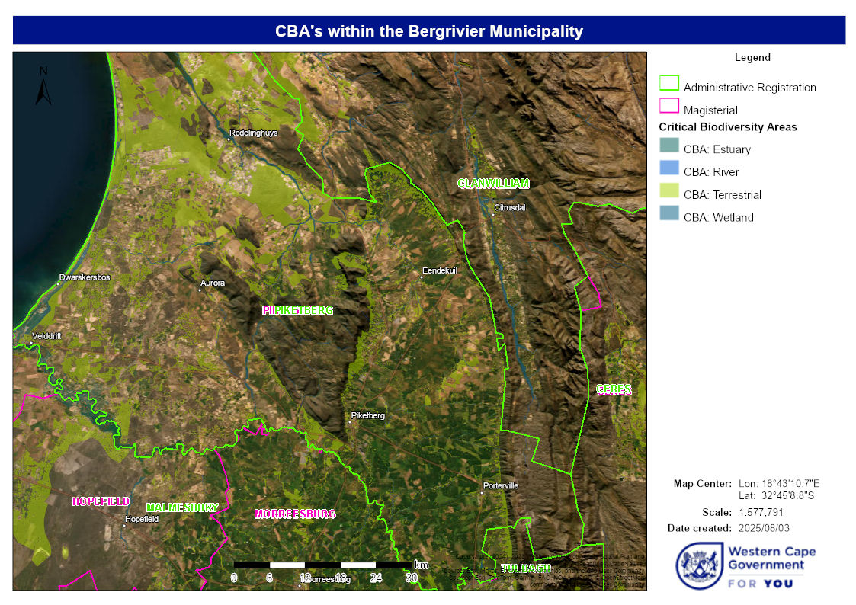
Figure 4: Critical Biodiversity Areas within the Cederberg LM (WCBSP, 2023)

31

3.4.2. Coastal Management Lines

Climate change has been highlighted as a current and future threat to coastal environments and infrastructure. The dynamic nature of coastal zones makes the prediction of sea level changes and calculation of the related risk to coastal communities challenging but essential in the face of the potentially extensive impacts from sea level rise-related storms and storm surges on the coastal zone.

The establishment of Coastal Management Lines (CMLs) are a provincial responsibility, as legislated by the ICMA. In terms of section 25 of the ICMA, the development and establishment of CMLs, is the obligation of the Provincial MEC responsible for the environment supported by the Provincial Lead Agency for Coastal Management (DEA&DP). CMLs are prescribed boundaries that may limit development in ecologically sensitive or vulnerable areas, or areas where dynamic natural processes pose a hazard or risk to humans. The ICMA allows CMLs to demarcate areas where authorities can prohibit or restrict the building, alteration or extension of structures that are either entirely or partly seaward of the CML. It is noted that the location of immovable property and the ownership and zonation of vacant land must be taken into consideration when delineating coastal management lines. The ultimate intentions of the CMLs are to:
- protect coastal public property and private property;
- contribute to public safety;
- determine features that should be protected under the coastal protection zone; and
- preserve the aesthetic values of the coastal zone.
To determine the CML, coastal features are considered alongside coastal risk zones, based on observed and available information. In developing a CML the following are considered:
- Environmental buffers required inland from the HWM to maintain a functional coastal ecosystem under future sea level rise scenarios;
- Social buffers required along the coast, for example, allowance for public beach access through and along the coastal frontage, areas which have cultural significance and will need to be preserved from development, or heritage resources and historically sensitive locations that require specific management; and
- Economic requirements for the coast, for example, allowance for new beach facilities that will need to be placed closer than would normally be the case. Economic demands often require a trade-off against environmental aspects at a particular site.
According to the Provincial Circular: DEA&DP 0004/2021 The consideration of Coastal risk in land use decisions reference to the following:
Where land use decisions are made that did/do not consider or did/do not adequately consider available information pertaining to coastal processes and the associated risk(s), such development may be impacted by coastal processes (e.g., impact of erosion and / or moving sand on private property) and there is the risk that a Municipality could be held liable for damages suffered. In this respect it is important to take heed of Section 15(1) of the NEM: ICMA that states:
“…15(1) No person, owner or occupier of land adjacent to the seashore or other coastal public property capable of erosion or accretion may require any organ of state or any other person to take measures to prevent the erosion or accretion of the seashore or such other

32
coastal public property, or of land adjacent to coastal public property, unless the erosion is caused by an intentional act or omission of that organ of state or other person…”
It is imperative that any development that is proposed along the coast, be scrutinised and that caution is applied when considering such proposals. Any further development that is at risk from coastal processes within both the high and medium risk areas, unless warranted, should therefore be discouraged and/or prohibited. Where development already exist in high-risk areas, strategic management options, including retreat or land swops, may need to be considered by the municipality.
Demarcation of the actual CML is different for developed and undeveloped areas and is a combination of the two around estuaries.

In rural areas, the CML follows the landward boundary of the long-term risk projections. Where necessary, a separate line can be drawn around existing development and development rights within the risk zone in order to recognise the development rights within a ‘development island’. In urban areas, the CML is drawn seaward of properties adjacent to the shoreline with existing development or development rights, as the intention is not to use the coastal management/set-back line to impact on existing development rights.

The CML also extends along estuaries, and in developed areas it is aligned with the lower (water side) boundary of properties with existing development or development rights. In rural areas, the CML runs along the 5m amsl (above mean sea level) contour or along the 1:100 year floodline around estuaries.

Overlay Zones are a universal mechanism for administration of CMLs within the extent of town planning regulations and management in the Western Cape. The overlay zones refer to areas designated as subject to short term (1:20 year), medium term (1:50 year) or long term (1:100 year) risk emanating from coastal processes such as coastal erosion, storm surges, sea level rise and storm wave run-up, based on risk modelling. In rural areas, the risk grading from low to high is not necessary, and hence only a default ‘risk’ zone is indicated as the entire area between the 0m amsl and landward boundary of the low risk (long term risk) zone (Figure 10).

When the CML and coastal management overlay zones are combined, a management scheme along the shore that guides where development should and shouldn’t take place and how it needs to be undertaken in order to protect property, lives and the integrity of the coast (overlay zones) is produced. Figure 5 below provides an example of what the final combined management scheme looks like in a developed or urban area in the West Coast District Municipality (WCG 2014). With the CML in place, development can be prevented from encroaching onto coastal public property, whilst the risk-based overlay zones will determine the nature of development in close proximity to the shoreline.

33
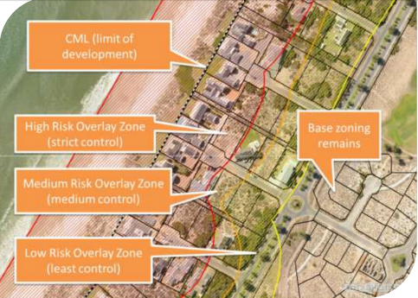
Figure 5: An example of the combined coastal management line and overlay zones (urban or developed area) in the West Coast District Municipality (WCG, 2014).

CMLs have been determined for the entire WCDM coastline. However, the CMLs are in the process of being formalised and adopted by the MEC. In the meantime, it is important that the CMLs are incorporated into all municipal zoning schemes and considered in all planning decisions. The CM has already incorporated the CMLs into their planning processes.

3.4.3. West Coast District Municipality’s Climate Change Response Framework (2014)

Climate change has become a reality in South Africa and is considered to be one of our largest economic and environmental challenges. A lack of resilience to climate change manifestations, and an inability to adapt will increase the susceptibility of human and natural systems to the impacts of climate change. It is anticipated that local government will play an important role in improving climate change resilience through the effective execution of its mandated duties. Local government will be required to plan and respond appropriately if it is to fulfil its objectives of sustainable and equitable service provision, enabling socio-economic development and providing a safe and healthy environment for all.

This WCDM’s Climate Change Response Framework was developed in 2014 and is aimed at decision makers and technical personnel from local through to national government, development agencies, NGO’s and civil society organisations in order to serve as a guide to improve adaptive capacity within the WCDM. The framework recognises that responding to, adapting to and mitigating climate change impacts needs to be a coordinated effort between the WCDM and the LMs.

The WCDM Climate Change Response framework identified the following climate change-related risks to the coastal zone:
- Increased coastal erosion and inundation;
34
- Increased or permanent inundation of infrastructure and utilities;
- Impacts on private and public harbours and boat ramps;
- Increased erosion or deterioration of coastal defences;
- Loss of private property and community assets;
- Loss of beach width; and
- Changes to wetland and estuary ecosystems due to sea level rise, erosion and saline intrusion.
The CM has infrastructure and settlements located within the coastal zone. Based on sea-level rise scenarios combined with the risk posed by coastal erosion, the majority of the CMs coastal infrastructure is at risk. This includes the following:
- Recreational facilities;
- Water management infrastructure; and
- Transportation infrastructure such as ports and road networks.
The WCDM Climate Change Response Framework reports that most of the LMs in the WCDM have implemented a reactive approach towards infrastructure management. In order to provide reliable levels of service, municipalities will have to review how they plan, design and manage their infrastructure to incorporate climate change considerations.

Based on the above as well as feed-back from stakeholders, the future needs in terms of coastal planning and development are as follows:

- The WCDM and the CM must ensure that all biodiversity planning tools are incorporated into the Municipal SDFs as well as in town planning approvals.
- Impacts of climate change, such as sea level rise and coastal erosion due to storm surges and inundation, need to be considered prior to approving applications for new development within the coastal zone.
- To address the high percentage of vacant plots and the low occupancy levels of residential dwellings, and to equitably designate zones for the purposes of mixed cost housing and taking into account the needs of previously disadvantaged individuals a key priority would be to rezone certain portions of these areas.
- Coastal Management Lines must be incorporated into the SDFs once they have been approved by the MEC but must in any event be considered in all coastal plans and proposed coastal developments.

  - Theme 4: Compliance, monitoring and enforcement

3.5.1. Environmental Management Inspectorate (EMI)

EMIs represent the environmental compliance and enforcement capacity in respect of NEMA and Specific Environmental Management Acts as defined in NEMA (SEMAs). There are also officials appointed in terms of provincial legislation and local authority by-laws who also carry out environmental compliance and enforcement functions in terms of that legislation. In many instances, officials may carry both the EMI designation in terms of national environmental legislation, as well as a separate provincial or municipal designation in respect of ordinances or by-laws.

35

The following relevant government organisations in the Western Cape have designated EMIs to carry out environmental compliance and enforcements functions:
- DFFE;
- SANParks;
- DWS;
- SANBI;
- DEA&DP; and
- CapeNature.
DFFE initiated an EMI Local Authority Project in 2011 that aimed to capacitate local authorities by providing them with the relevant mandate to enforce certain environmental issues in terms of Schedules 4 and 5 of the Constitution, by providing the legislative tools to do so. In the 2024-25 financial year, DFFE reported that 233 local authority EMIs had been designated in the Western Cape, of which five EMI’s designated within the WCDM.

In terms of Section 31B and C of NEMA, the Minister of the DFFE and MECs are empowered to designate EMIs at their discretion. The Minister and MECs can further delegate this power to designate EMIs to other organs of state. Examples of this include SANParks and the Head of DEA&DP.

Various grades of EMIs exist that are capacitated to enforce a variety of functions in terms of NEMA, with Grade 1 EMIs holding the greatest amount of power in terms of enforcement. Table 3 below provides a description of the powers that are granted to the different grades of EMIs in terms of enforcing NEMA.
Table 3: Powers granted to the various grades of EMIs in terms of NEMA
Grade | Powers that may be conferred in terms of Section 31D(3) of the NEMA
5 | Powers in terms of section 31H, section 31I (3) and section 31J of the Act.
4 | All the powers given to environmental management inspectors under the Act, except for the power under sections 31H(1)(b), 31H(5), 31I(3) 31J, 31L and 34G(2) of the Act.
3 | All the powers given to environmental management inspectors under the Act, except for the power under sections 31H (5) and 31L of the Act.
2 | All the powers given to environmental management inspectors under the Act, except for the power under section 31L of the Act.
1 | All the powers given to environmental management inspectors under the Act.

To be eligible for EMI designation, an official must complete a relevant training course approved by the Director-General. Currently, DFFE offer an EMI Basic Training Course. DFFE normally host two EMI training courses per year. Officials who wish to undergo the EMI training are required to submit an application form to DFFE, which will be evaluated to ensure that the applicant meets the minimum requirements to attend the course. The organisation who has designated the applicant is responsible for financing the training of the applicant.

3.5.2. Fisheries Control Officers

Fisheries Control Officers (FCOs) are appointed by the DFFE in terms of Chapter 6 of the Marine Living Resources Act (No. 18 of 1998) and are responsible for ensuring that the provisions of the MRLA are being complied with. The CM has one fisheries office along the coastline and is located in Eland’s bay.

36

Another mechanism that can be used to enforce the MLRA is through the appointment of Honorary Marine Conservation Officers. These Officers are appointed in terms of Section 9 of the MLRA and the position is entirely voluntary. These officers work closely with the FCO and act as the “on-the-ground” eyes and ears of the DFFE compliance directorate. The Officers can be members of the community or employees of the municipality, and do not have to be employed by DFFE.

It is important that the WCMD, CM and communities engage closely with the local FCOs with regards to reporting illegal activities in terms of the MLRA and that Honorary Marine Conservation Officers be appointed to assist in this role. These illegal activities include, but are not limited to, abalone poaching, suspicious vessels at sea and illegal fishing activities.

3.5.3. Air Quality Compliance and Enforcement in the WCDM

A dedicated air quality management section has been established in the WCDM and has been properly capacitated through the appointment of trained staff, mandated to do compliance monitoring and enforcement. Currently, two WCDM staff members have been designated as EMIs. The process of designation of these officials must, however, first be clarified at national and provincial level since municipalities do not have the authority in terms of NEMA to do such designations. It is hoped that an implementation protocol will soon be entered into between the MEC and Council. Until such time as the legal issues regulating the designation of EMIs have been resolved, it is recommended that municipal staff be appointed by the MEC and report to provincial officials. This will create an opportunity for municipal EMIs to gain valuable experience from
provincial staff until such time as the legal issues relating to designation by municipalities have been concluded.

Compliance and enforcement actions have been implemented at various industries with assistance from DEA&DP as well as DFFE.

Based on the above as well as feed-back from stakeholders, the future needs in terms of compliance, monitoring and enforcement are as follows:

- There is a need for EMIs at a local level. One Grade 2 EMI has been appointed and designated in the CM.
- The WCDM EMIs must be continually supported through training and provision of resources.
- Contact details of the relevant EMIs and FCOs in the CM must be publicly displayed at known infringement sites so that members of the public know who to report illegal activities to.
- The implementation of the CMP must be monitored through the WCDM Coastal Committee.
- SAPS, EMIs and FCOs need to be more visible in coastal areas to deter illegal activities from taking place.
- Municipal by-laws need to be better enforced.

37
  - Theme 5: Estuary management

Although the CM does not have a high number of estuaries, almost all the estuaries in the Municipality are heavily impacted. These estuaries require the establishment and implementation of strategies to improve the management and protection of estuarine resources, and the need to secure sufficient financial resources to fund and implement identified actions, research projects, initiatives and advisory forums. This is done through the development of Estuarine Management Plans (EMPs) as per the NEMP. The following adopted EMPs for the CM are the Verlorenvlei and Jakkalsvlei EMPs with CapeNature as the RMA (Responsible management authority) and DEA&DP the RMA for the Wadrift EMP.

Verlorenvlei Estuary EMP_Final_January 2023.pdf

Jakkalsvlei Estuary EMP_Final_Janaury 2023.pdf

Wadrift River Estuary EMP_2022 - Approved.pdf

The updated National Biodiversity Assessment (2019) identifies three estuaries within the CM. The locality of these estuaries is indicated in Figure 6 below and a brief description of each has been provided in Table 4.

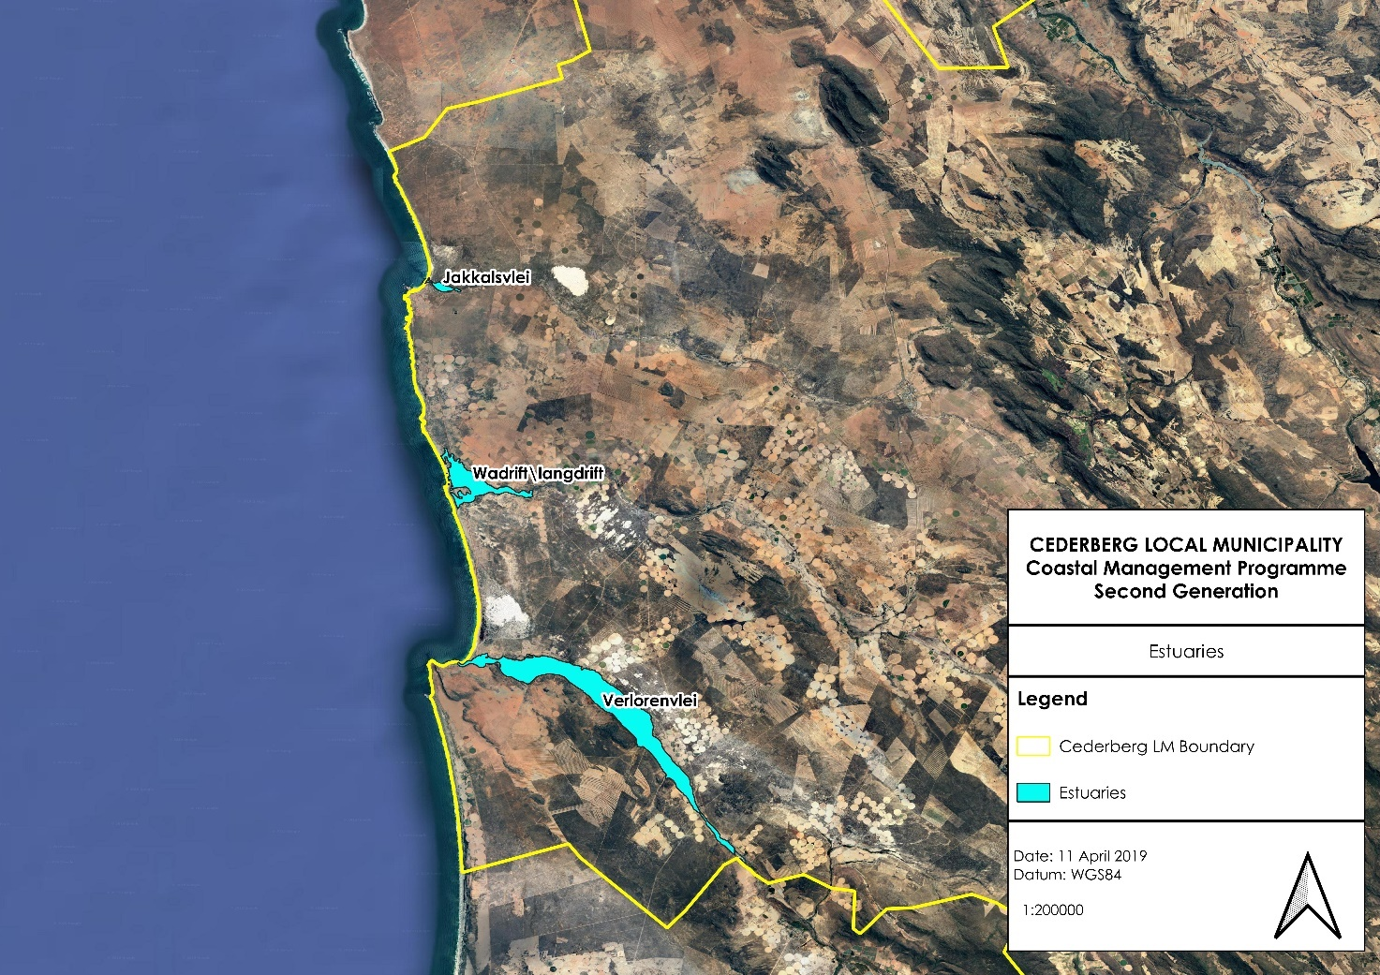
Figure 6: Estuaries in the CM including the Verlorenvlei estuary (National Biodiversity Assessment, 2019).
38
Estuaries are recognised as particularly sensitive and dynamic ecosystems, and as such require a more integrated and holistic approach in the planning and control of activities related to their use and management. As a result, the ICMA, via the prescriptions of the National Estuarine Management Protocol (the Protocol), require Estuarine Management Plans to be prepared for estuaries in order to create informed platforms for efficient and coordinated estuarine management. Table 4 below provides a brief summary of the characteristics of each estuary within the WCDM as well as whether an Estuarine Management Plan is being developed or not.

The RMAs for the estuaries in the WCDM were identified.
The Estuary Management Framework and Implementation Strategy project was developed by DEA&DP. The strategy provides some guidance on how and what kind of management will be implemented in the smaller estuary systems and assist in clarifying the roles and responsibilities of the municipalities with regards to the management of the estuaries in the WCDM.

39

Table 4: A summary of the characteristics of each of the estuaries located within the WCDM
Estuary name | Municipal Area | Biogeographical Region | Estuary Class | Estuary Type | EMP developed? | Unique Characteristics
Jakkalsvlei | Cederberg LM | Cool Temperate | Estuary | Large Temporarily Closed | Yes – The EMP was developed and approved in 2022 | Jakkalsvlei estuary and its catchment falls within the very rural, and largely undeveloped areas.  It is a relatively small estuary and has an average importance with regards to its biodiversity value.  The main form of social dependency associated with the Jakkalsvlei estuary relates to recreational/ aesthetic value from a tourism and landownership perspective. Above the estuary, the Jakkals River is vitally important in terms of regional water supply, particularly for irrigation.  While the estuary falls just outside of the Greater Cederberg Biodiversity Corridor, the catchment area of the Jakkals River would benefit from the implementation of the agriculture best practise guidelines produced under the initiative.
Wadrift | Cederberg LM | Cool Temperate | Estuary | Arid Predominantly Closed | The EMP was developed and approved in 2022 | The Wadrift estuary is known as an important site for its rich bird diversity.  The Wadrift estuary has not been identified as a national priority estuary in need of formal protection, however, it does fall within the Greater Cederberg Biodiversity Corridor and as a result, some level of sustainable management is required.
Verlorenvlei  40 | Cederberg LM | Cool Temperate | Estuary | Estuarine Lake | Yes, the EMP was updated and approved in 2022 | Verlorenvlei is one of the largest estuarine lakes in South Africa but is also one of the country’s few coastal freshwater lakes.  It predominantly functions as a freshwater system where the mouth is perched and only allows occasional seawater inflow during high spring tides and stormy conditions at sea.  Designated as a Ramsar site in 1991, and also identified as an Important Bird Area, Verlorenvlei is regarded as one of the ten most important wetlands for wading birds in the South-Western Cape.  It has been listed as one of the estuaries with minimal development and in a good state to be conserved so as to control further developments.  Despite the importance of this estuary in South Africa, it has no official conservation status.

41

An Estuary Advisory Forum (EAF) is a platform that is established to provide an advisory service to the RMA on issues specific to the management and implementation of the EMP. Additionally, it can be used as the entity that links all stakeholders, which serves to foster stakeholder engagement and to facilitate the implementation of the project plans identified in the EMP. It is envisioned that the broader community is also able to voice concerns and raise issues via the EAF. This includes Ratepayers’ Associations, NGO’s, community groups, conservancies, etc., as well as representatives from surrounding industry and agriculture.
While the establishment of an EAF for each estuary is no longer a requirement in the NEMP, the Western Cape Government still supports their establishment and recommends that private entities and non-government organisations continue to play a supporting role in the implementation of the EMPs. While an individual EAF is not necessarily always recommended, the establishment of a regional EAF can be proposed. The EAF should be chaired by the RMA and should aim to meet on a quarterly basis (Jakkalsvlei EMP; DEA&DP, 2018).
The following Estuary Advisory Forum (EAFs) have been established, on which the CM are represented:
- Verlorenvlei EAF.
Based on the above as well as feed-back from stakeholders, the future needs in terms of estuary management are as follows:

- The EMPs need to be implemented and implementation must be monitored through the EAFs and the WCDM Coastal Committee.
- The Verlorenvlei Intergovernmental Task team (VGITT) meetings takes place on a quarterly basis involving relevant stakeholders and departments to engage on task team strategies for the Verlorenvlei estuary.

  - Theme 6: Natural resource management

The effective management of natural resources needs to include the maintenance of ecosystem integrity and health, the assessment and effective management of coastal protected areas, including marine protected areas, as well as the identification and rehabilitation of damaged and degraded coastal ecosystems and habitats.

3.7.1. Vegetation

The CM is located within the Cape Floristic Kingdom consisting of the Fynbos Biome, which is predominant towards the south of the region, and the Succulent Karoo Biome, which extends along the north-westerly margin of the region. Both of these biomes have been identified as global biodiversity hotspots with high levels of diversity and endemism for plants and animals. The Succulent Karoo is one of only two semi-arid biodiversity hotspots in the world, and exhibits the highest plant diversity for a semi-arid ecosystem globally. The region contains about 9000 plant species, of which over 6000 are endemic. The diverse soil types and variation in rainfall distribution are key to this diversity. The region also has high animal diversity, including both vertebrates and invertebrates and is especially rich in lizard, amphibian and insect species (WCDM SDF, 2013).

42
A significant portion of the low-lying vegetation has already been lost due to agricultural activities, and resort and urban settlements have also had a large impact on the biodiversity of coastal regions. Other significant threats to biodiversity within the coastal zone include port land management and invasive alien plant infestation, soil erosion, overgrazing and inappropriate fire regimes. When practices are unsustainable, land uses such as mining, potato farming and 4x4 trails pose threats to the West Coast’s biodiversity (WCDM SDF, 2013)).

3.7.2. Formal protected Areas

There are a number of terrestrial protected areas within the CM. This protected area network comprises of privately managed protected areas and areas managed by DFFE. Figure 7 below indicates the location of the protected areas located along the coast of the CM.

It is important that the CM engage with the private nature reserves to ensure that their spatial planning processes to not conflict with the objectives and management practices of these reserves.

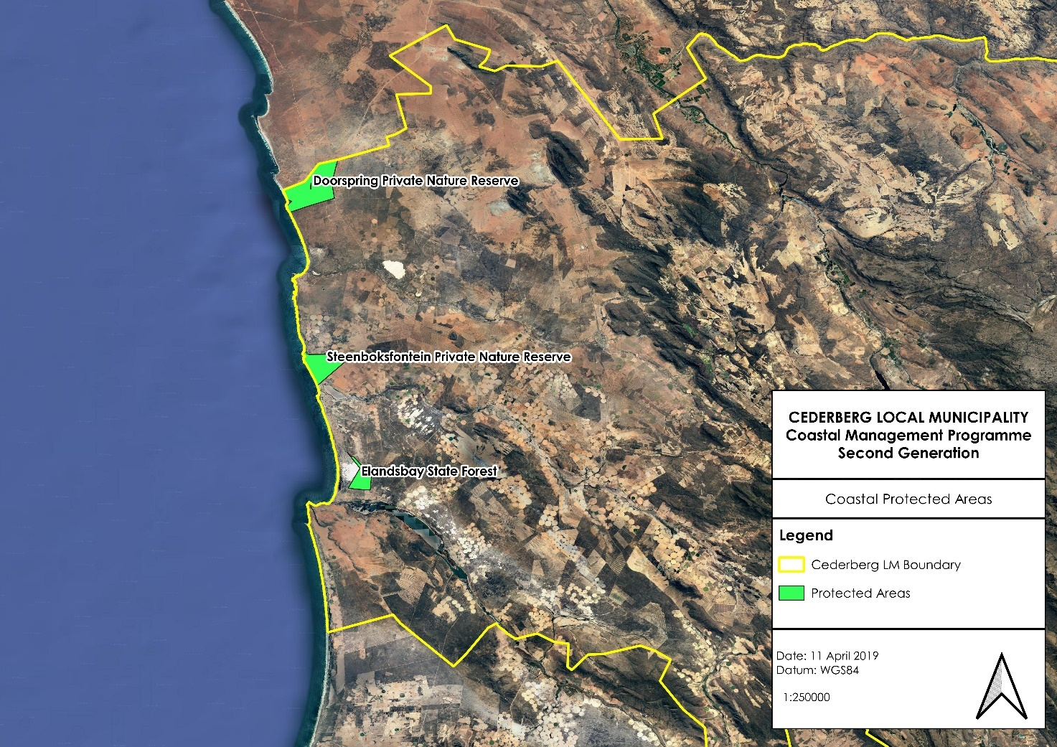
Figure 7: Formal protected areas within the coastal zone of the WCDM (WCBSP, 2017)

Offshore Marine Protected Areas

Operation Phakisa, which is a presidential project to fast-track the development of South Africa’s Ocean Economy, identified the need to protect off shore ocean habitats within South Africa’s Exclusive Economic Zone (EEZ). Though Operation Phakisa, a number of offshore sites were identified as a potential Marine Protected Areas (MPAs) network. MPAs

43
are increasingly being used as a tool for the achievement of biodiversity, fisheries management, tourism and research objectives. This MPA network represents the full spectrum of biodiversity, secures ocean benefits and provides important reference areas to understand and manage change in our oceans (DEA, 2016). It was approved by Cabinet on the 24th of October 2018. Figure 8 shows the location of these 20 new MPAs, with the Benguela Muds and the Cape Canyon MPAs being located offshore of the WCDM coastline.

While the WCDM and the CM do not have any direct responsibility in terms of management of these offshore MPAs, it does provide an opportunity for the WCDM and the CM to use these MPAs as an opportunity to educate and inform communities of the importance of the offshore marine environment to the coastal and marine economy.

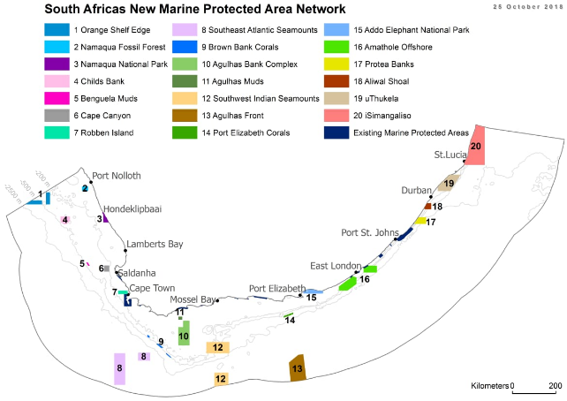
Figure 8: the location of the 20 new MPAs (www.saambr.org.za/marine-protected-areas-mpas/)

RAMSAR Convention

The Convention on Wetlands, signed in Ramsar, Iran, in 1971, is an intergovernmental treaty which provides the framework for national action and international cooperation for the conservation and wise use of wetlands and their resources. There is one official Ramsar site located within the CM, namely Verlorenvlei.

The Verlorenvlei Ramsar site was designated in 1988 and is situated approximately 100 km northwest of Cape Town. The Verlorenvlei is one of the largest lakes (and one of the country’s few coastal freshwater lakes), with associated scrub, shrubland, dune systems,

44

marshland and reedbeds representing a transition zone between two plant communities. The site is an important feeding area for rare pelicans and fish, for molting and breeding birds, as well as for staging wading birds. During dry periods, large numbers of flamingos gather. The site also supports notable plant species. Water is pumped for irrigation purposes, and the marshland is used for cattle grazing.

Provincial Nature Reserves

A number of provincial nature reserves can be found within the CM that are managed by CapeNature. The Provincial nature reserves are described below.
- Lamberts Bay Bird Island Nature Reserve
Bird Island lies approximately 100 m off the shore of Lambert’s Bay in the Cederberg LM. The reserve allows visitors an opportunity to observe the blue-eyed Cape gannet up close. Bird Island is one of only six sites world-wide where Cape gannets breed, and it is the only breeding site easily accessible to the public.

The island, which is almost three hectares in size, is connected to the mainland via a breakwater. It is an important breeding and roosting site for seabirds, particularly Cape gannets and cormorants. Cape fur seals can also be observed on the island.

Private Nature Reserves

A number of private nature reserves are also located within the CMs coastline and include the following:
- Doorspring (Matzikama and Cederberg LMs); and
- Steenboksfontein (Cederberg LM);
It is important that the CM engage with the private nature reserves to ensure that their spatial planning processes do not conflict with the objectives and management practices of the private nature reserves.

3.7.3. Important Bird Areas

Important Bird and Biodiversity Areas (IBAs) are sites of international significance for the conservation of the world's birds and other biodiversity. By conserving IBAs, the ecosystem goods and services they provide are protected and, in turn, support a component of the South African economy (such as water management and agriculture).

The CM has two IBAs located within its boundaries. These IBAs have been indicated in Figure 9 below and include the following areas:

- Verlorenvlei estuary; and
- Cederberg - Koue Bokkeveld Complex.

45

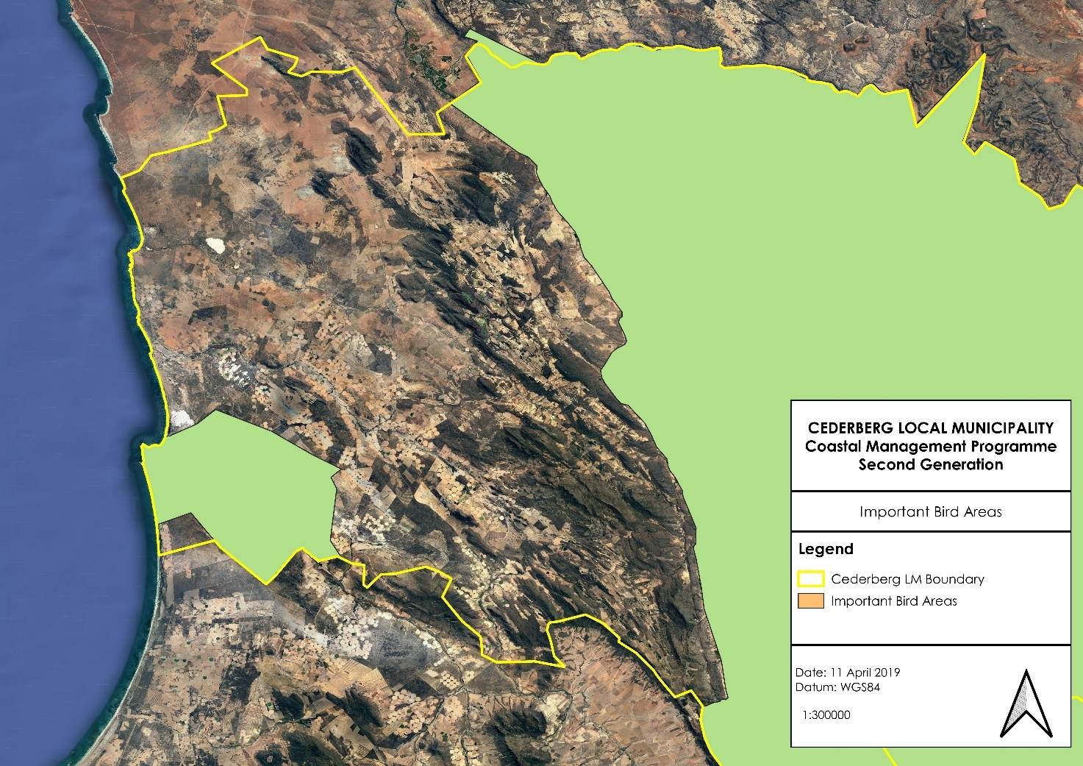
Figure 9: The location of the IBAs in the CM

3.7.4. Marine resources

The West Coast is characterised by its cold water upwellings that are nutrient rich waters, which result in the presence of a substantial fishing industry, with approximately 90% of South Africa’s fish being caught off the West Coast. This makes the offshore regions of the West Coast one of the world’s richest fishing grounds. The CM falls within the Namaqua Marine Bioregion situated from Cape Columbine northwards.

The Namaqua bioregion is dominated by the cold Benguela Current and is characterized by large-scale intensive upwelling and nutrient rich water. Low oxygen events are a feature of this region. Extensive mud banks are an important characteristic of the Namaqua bioregion. This productive bioregion supports major commercial fisheries including hake trawl and longline fisheries. A significant proportion of the commercial linefish effort occurs within this bioregion (Sink, et al., 2004).

Despite commercial fishing being an important economic along the CM coastline, there are various factors threating existing stocks. These factors are derived from anthropogenic activities and include the following:
- Pollution of coastal waters;
- Increased coastal development in sensitive coastal habitats; and
- Overfishing.
46
While the CM does not hold responsibility in terms of activities that occur in the inshore and offshore environment, the CM has an obligation to alert the responsible authorities should any suspicious or illegal activities be observed.
Marine mammal strandings

A number of marine mammals are commonly found along the CM. These species include southern right whales, humpback whales, Bryde’s whales, Heaviside dolphins, dusky dolphins and common dolphins.

Although a relatively rare occurrence, the CM does occasionally experience strandings of large marine animals. These stranding events require a collective, coordinated and organised response by various authorities and agencies for the effective management of the following scenarios:
- Rescue attempts for live animals;
- Public control and management;
- Volunteer control and management;
- Environmental protection; and
- Carcass removal and disposal.
Currently there is confusion within the local government structures in the WCDM as to whose responsibility it is to respond to these events and the protocol to be followed should stranded marine mammals be reported.

Oil and Gas

Currently, South Africa does not have significant proven oil and gas reserves and produces oil and gas from coal and imported crude oil. Due to abundant coal resources that have been available in South Africa that has allowed the country to produce petroleum and by-products, as well as electricity cheaply from coal, gas is an underutilised resource. However, as coal resources in South Africa are declining and the relative cost of coal-produced electricity and petroleum increases, gas will become a more exploited resource.

Offshore and onshore gas exploration has begun in South Africa with 20 exploration licences having been issued to date (SAOGA, 2017). Figure 10 indicates the exploration rights that have been granted offshore of the CM coastline. It is important that the WCDM and the LMs are aware of offshore oil and gas exploration activities that are taking place offshore of the West Coast coastline, due to the potential for oil spills and contamination of coastal waters and beaches. Both the WCDM and the CM have a role to play in managing oil spills along the coastline and these roles and responsibilities are discussed further in Section 3.9.

47
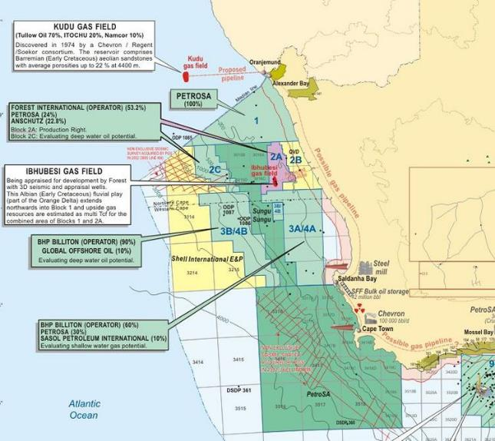
Figure 10: Offshore gas and oil exploration rights that have been granted along the West Coast of South Africa (www.energy-pedia.com/news/south-africa/bhp-set-to-drill-offshore-south-africa)

Strategic Environmental Assessment (SEA) for a phased gas pipeline network and expansion of the electricity grid infrastructure in South Africa

The Operation Phakisa Offshore Oil and Gas Lab (August 2014) has set a target of achieving 30 exploration wells in the next 10 years in order to exploit the potential of gas reserves in South Africa and contribute to the transition to a low carbon economy. In addition, the need to accelerate the planning for gas to power as part of the Governments Integrated Resource Plan (IRP) and for State Owned Entities to pre-plan for the logical development of gas transmission servitudes within South Africa has been identified. The phased development of an onshore gas pipeline network forms part of the infrastructure that is proposed as an enabler for the offshore oil and gas exploration and has the potential to unlock further possibilities for the growth of the gas industry in South Africa (CSIR, 2018).

To support the objectives of the Operation Phakisa Oceans Economy Oil and Gas Lab and to ensure that when required, environmental authorisations are not a cause for delay, a Strategic Environmental Assessment has been undertaken.
48
In April 2017, the Council for Scientific and Industrial Research (CSIR) was appointed to undertake a SEA for a Phased Gas Pipeline Network and for the expansion of the electricity grid infrastructure (EGI) corridors that were assessed as part of a separate SEA Process (in response to the Government’s Strategic Infrastructure Build Program, Strategic Integrated
Project SIP 10: Electricity transmission and distribution for all) which concluded in 2016 (CSIR, 2018).

The SEA will be focussed on nine corridors identified as part of Operation Phakisa as key areas where gas transmission pipelines are required in order to meet future energy requirements. SEA will assess the environmental, social and economic constraints and opportunities for gas pipeline and EGI development within these corridors. The results of the assessment will serve to inform suitable routing options for gas pipelines and EGI expansion.

The proposed gas pipeline corridors that will directly affect the CM are as follows (refer to Figure 11):
- From Saldanha Bay to Abraham Villiers Bay (landing point for the Ibhubesi field).
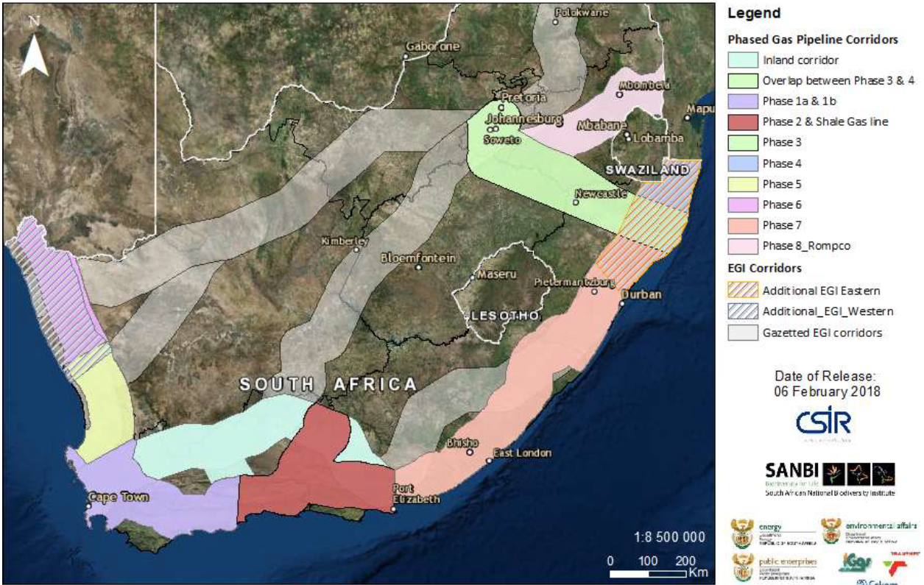
Figure 11: The gas pipeline corridors that were assessed as part of the SEA (CSIR, 2018; https://gasnetwork.csir.co.za/wp-content/uploads/2019/04/PART-1_Background_Gas-Pipeline_FINAL_110419.pdf)

Algal blooms

Harmful algal blooms (HABs) are a fairly common occurrence along the CM coastline and can have a significant impact of natural coastal resources such lobster, commercial fisheries and aquaculture operations. These algal blooms are caused by south-easterly

49
winds bringing nutrients from the sea bottom to the surface. This event is known as an upwelling and results in a rapid increase in plankton populations. The density of the algal bloom turns the ocean’s surface red to brown.

Over time algal blooms naturally die off and get dispersed. When calm and relatively warm oceanic conditions occur, this could further result in a proliferation and congregation of decomposing bacteria that have, through the breakdown of dead algae, depleted the available oxygen in the water.

The National Oceans and Coastal Information Management System (OCIMS) has developed a HAB Decision Support Tool (DeST) and provides capability for monitoring and assessing risk of HAB events for the South African coastal area to approximately 50km offshore. Maps of sea surface temperature, ocean winds and ocean colour-derived phytoplankton biomass proxies are used to provide information on the presence and movement of blooms, and the HAB viewer provides real time information on the spatial extent of the HAB risk along the coast.

The WCDM does have a HAB Contingency Plan as part of the Disaster Management Plan to monitor and manage HAB event. With regards to removing and disposing of mortalities that wash up on beaches as a result of HAB events, the WCDM has a mandate to manage municipal health services, which is defined in the Minmec Resolution in July 2002, as environmental health services. The responsibility thus falls to the WCDM to remove and dispose of mortalities. However, the CM has been designated the responsibility of managing beaches, which also includes an environmental health component, and it is suggested that the removal and disposal of mortalities becomes a joint effort between the WCDM and the CM. The WCDM HAB Contingency Plan needs to be updated to incorporate a joint function between the WCDM and CM with regards to removal and disposal of mortalities.

3.7.5. Mineral resources

The South African Code for the Reporting of Exploration Results, Mineral Resources and Mineral Reserves (SAMREC) defines mineral resources as any solid mineral of potential economic interest in any concentration found in bedrock or as afloat, especially a valuable or potentially valuable mineral in sufficient concentration to suggest further exploration. In the WCDM region, these mineral resources include the following:
- Diamonds;
- Limestone;
- Dolomite;
- Dimension stone;
- Gypsum;
- Salt;
- Silica sand;
- Brentonite;
- Phosphate;
- Kaolin;
- Heavy minerals;
- Sepiolite;
- Brick clay; and
- Building sand

50
Mining activities that occur in the CM are minimal. The main commodities that are mined in the Cederberg region are building sand and phosphate. However, diamond mining activities are taking place off shore from Lamberts Bay to the north of the LM (Cederberg SDF, 2023-2027).

SANBI Mining Guidelines

Most mining operations, past, in operation, proposed and possibly in future, comprise either of quarrying or open cast mining. This results in total surface destruction. This is further worsened if there is no proper rehabilitation, as happened with Foskor near the West Coast Fossil Park. SANBI has produced spatial data that indicates where such habitat destruction should not be contemplated and areas where it could.

Mining is already prohibited in legally protected areas and should also be prohibited in ‘highest risk’ areas. It should be permitted in medium risk and no risk areas only, but with the most stringent rehabilitation plans whose implementation is strongly monitored with regular reporting to the Municipality which is responsible for land use management (SANBI, 2012).

It is important that these mining guidelines are incorporated into all municipal planning processes.

Based on the above as well as feed-back from stakeholders, the future needs in terms of natural resource management are as follows:

- Alien vegetation needs to be better managed in the CM, particularly within open areas of coastal towns.
- The WCDM and CM need to continue to work closely with CapeNature and Private nature reserves to ensure that the unique biodiversity of the CM is conserved.
- The WCDM and CM must be in the position to assist members of the public to alert the relevant authorities of suspicious or illegal activities that are taking place in terms of NEMA and MLRA.
- A Marine Mammal Stranding Policy must be developed for the WCDM where the roles and responsibilities of each organ of state, as well as a protocol to be followed in terms of responding to a stranding report, are clearly defined. The CoCT Policy should be used as an example.
- The WCDM and the CM must ensure that they are aware of offshore oil and gas and mining activities taking place as oil spills and other contaminant leaks could potentially impact the coastline. The relevant authorities will then need to respond appropriately.
- The WCDM needs to revise the HAB Contingency Plan to incorporate the cleaning up of mortalities that result from a HAB event. The cleaning up of mortalities along beaches is a LM responsibility and this needs to be carried through into the Contingency Plan.
- The WCDM and CM must take into consideration the cumulative impact of existing and proposed mining activities along the coastline in order to ensure that the integrity and sustainability of the ecological functioning of the coastline is not severely impacted. The SANBI Mining Guidelines must inform the development of the mining industry along the West Coast.

51
  - Theme 7: Heritage resource management

The West Coast has a wealth of heritage resources as well a cultural history. The coastal regions of the south-western Cape were densely occupied by pastoralists, or herders, known as the Khoikhoi or Khoi-San. The West Coast region was the land of the CochoQua, which included Saldanha Bay to Vredenburg. The ChariGuriQua or GuriQua occupied the lower Berg River area, St Helena Bay and points around Piketberg (SAWestcoast.com).

3.8.1. Khoisan communities within the WCDM

Archaeological sites on the West Coast, like Kasteelberg, show occupation by herders between 1800 and 1600 years ago. It is well recorded that whale meat was used by the Khoikhoi. Places where whales often strand themselves along the shore are known as 'cetacean traps', which are areas where minima in the earth's magnetic field cross the shoreline, and where there are offshore reefs. St Helena Bay, or more specifically, Slipper Bay appears to be one of these 'cetacean traps', approximately 12km from Kasteelberg.

The GuriQua and the SonQua (Bushmen) are forgotten in the history of the West Coast. They were here to witness the arrival and departure of Vasco da Gama. The history of the Khoikhoi and the SonQua after 1652 is well documented, but it is important to mention that the 1713 small-pox epidemic was one of the main causes for the virtual disappearance of the Khoikhoi from the south-western Cape.

The remnants of the ChariGuriQua of the West Coast followed Adam Kok, the founder of the Bastaard (later Griqua) group. The Bastaards or Baster group were descendants of mixed unions between European settler farmers and Khoikhoi women. After the 1950's many descendants of the Khoikhoi were classified as "Coloured". There are no written records by the indigenous peoples for the pre-colonial period. Anthropological and archaeological research are the only tools we can use to give us a picture of a people and culture lost in time. The only other sources of information we have are ships journals and the diaries of visitors written from 1488 to 1652 (www.sawestcoast.com).

Today the ancestors of the Khoisan people along the West Coast are active members of the broader community. However, the local Khoisan people still feel the effects of being severely marginalised during the Apartheid Era. A Draft Khoisan Bill is being reviewed, which aims to support the Khoisan people in providing opportunities for cultural, social and economic upliftment.

3.8.2. Heritage resources

South Africa has a wealth of important heritage sites located along the coastline. Coastal heritage sites provide proof of human presence in, and associations with, the coastal zone. Therefore, the safe-guarding of these heritage resources is important for the understanding of the history of humankind and the definition of our cultural identify. The management of heritage resources in South Africa takes place within a legal and administrative framework in terms of the National Heritage Resources Act (Act No. 25 of 1999, NHRA). The parastatal responsible for the implementation of this legislation is the South African Heritage Resources

52
Agency (SAHRA). SAHRA has developed policies, guidelines and regulations for the management of heritage sites. In terms of the NHRA, archaeological heritage material of relevance for the West Coast coastal zone includes the following:
- Material remains resulting from human activities that are in a state of disuse older than 100 years, including human and hominid remains as well as artificial features and structures;
- Wrecks of vessels or aircraft wrecks, whether on land or within our maritime zones or water, and any other associated artefacts or cargo; and
- Features, structures and artefacts associated with military history that is older than 75 years, as well as the sites in which they are found.
In terms of Section 8 of the NHRA, the management of heritage resources is prescribed as follows:
- Tier 1: SAHRA is responsible for the identification and management of Grade I heritage resources and heritage resources in accordance with the applicable provisions of the NHRA and co-ordinates and monitors the management of the national estate in the Republic;
- Tier 2: A provincial heritage resources authority is responsible for the identification and management of Grade II heritage resources, and heritage resources which are deemed to be a provincial competence in terms of the NHRA; and
- Tier 3: A local authority is responsible for the identification and management of Grade III heritage resources, and heritage resources which are deemed to be a provincial competence in terms of the NHRA.
Shorelines were an attractive landscape for early people to exploit, and the West Coast coastline has thousands of shell middens scattered along its coastline. Shell middens result from people visiting the shore, collecting shellfish and consuming the flesh in sheltered areas such as dunes, hollows or caves. Some of these middens date back to the Middle Stone Age (MSA), and are often associated with stone tools, hearths (fireplaces), animal bones, ostrich eggshell water containers and beads. Occasionally human burials have been found in these middens. The most significant of these networks of shell middens are found between Britannia Bay to Stompneusbaai. Other areas where significant shell middens have been observed include Elands Bay, Paternoster, Namakwa Mining area and areas around Saldanha Bay.

More recent agricultural colonisation of the West Coast and the development of the fishing industry are reflected in the cultural landscapes of the District. The West Coast contains a variety of modified landscapes (cultural landscapes) which contribute significantly to the character of the region. Fishing villages, harbours, lighthouses, farms and farmsteads all contribute to the cultural landscape of the Districts coastal zone and its rich heritage resources. Some examples of these culturally significant resources within the CML include the following:
- World War II structures that have been converted to labourer camps at Elands Bay;
- Archaeologial and rock art sites at Mussel Point Midden and Baboon Point; and
- Shell middens within the Doorspring Private Nature Reserve.

Declared Provincial Heritage sites along the CM coastline (SAHRIS, 2019). are provided in Appendix B.

53
  - Theme 8: Pollution control and management

Pollution requires effective management and prevention strategies, with emphasis on reducing and responding to land based and marine based sources of pollution in the coastal zone. Ensuring adherences to the waste management hierarchy of “reduce, reuse, recycle”, will help reduce solid waste in particular. The effective management of waste within the coastal zone requires cooperation between various departments within the local and district municipalities, government departments as well as coastal communities.

3.9.1. Existing sources of pollution in the coastal zone

A few point and non-point sources of pollution within the CM have an impact on the coastal zone. These sources of pollution can result from activities taking place directly within the coastal zone as well as further up in the catchment areas. Pollution sources can be derived from industrial, domestic and agricultural activities. This section aims to identify as far as possible the know sources of pollution that impact the coastal zone within the CM.

Effluent discharges into the coastal zone

Several direct discharges into the coastal zone can be found along the CM coast. These outfalls discharge effluents that are derived from a number of activities, including aquaculture, fish processing and Wastewater Treatment Works (WWTW). Discharges into the coastal zone require authorisation in terms of the ICMA, which makes provision for the allocation of Coastal Waters Discharge Permits (CWDP). A CWDP must specify the volume and type of effluent that is authorised to be discharged, as well as water quality conditions that are required to be met. These water quality conditions are specified by the “South African Water Quality guidelines for Coastal Marine Waters”.

The table below provides information on the coastal discharges along the CM where authorisation in terms of the ICMA is currently being applied for (WCSoCR, 2019).

Table 5: Coastal discharges along the CM

Outfall name | Location | Effluent Type
Lamberts Bay Foods Limited | Lamberts Bay | Food Processing Effluent
Ocean Lobster Elands Bay | Elands Bay | Aquaculture

The responsibility to monitor the quality of effluent and the impacts on the receiving environment is that of the CWDP holder. Monitoring reports are required to be submitted to DFFE on an annual basis and any non-compliances will be acted on by the Department. However, as custodians of the coastline, it also becomes the responsibility of the communities and municipalities to report any non-compliances (e.g. sewage spills) that may be observed.

Food and fish processing facilities

There are a number for food and fish processing facilities located within the WCDM coastal zone that produce various waste streams that require careful management. Effluent discharges, as well solid waste such as offcuts are produced by these facilities. The inappropriate management of these waste streams can have knock on effects that directly impact the surrounding environment as well as the behaviour of animals.

54
An example of this is the situation taking place at Lamberts Bay. Lamberts Bay Foods Limited is a food processing facility that is located at the Lamberts Bay harbour. One of the waste streams that are generated by this facility are off-cut potato chips. The offcuts are loaded into transport vehicles and disposed of. However, the transport vehicles are not covered, and this provides an opportunity for birds to scavenge on these off cuts. The local environmental manager for the nearby Bird Island Protected Area has indicated that the seagulls have started feeding exclusively of these off-cuts and have started breeding on the roof of the factory. The Crowned cormorant (endangered species), which is found on Bird Island, is not nesting on the island anymore but on the factory roof and in the trees around town. The guano from the birds nesting on the potato factory roof also poses a health risk. There is insufficient monitoring of the activities taking place at this facility and the CM together with the WCDM need address this as a matter of urgency.

Wastewater Treatment Works (WWTW) within the coastal zone

In the CML, there is one WWTW that is located in close proximity to the coastal zone that may impact the health and safety of the nearby beaches and coastal waters. This WWTW is located in Lamberts Bay and is managed by the CM. Figure 11 indicates the location of the Lamberts Bay WWTW within the CM.

It is the CMs responsibility to maintain the infrastructure associated with the WWTW to minimise the risk of contamination from untreated sewage. The CM is also responsible for monitoring the quality of the treated effluent generated by the WWTW and are required to report to the DWS.

One of the regulatory approaches that was introduced in South Africa in 2008 was the Green Drop Certification Programme for Wastewater Quality Management Regulation. The Green Drop process measures and compares the results of the performance of water service authorities and their service providers via a standardised scorecard, and subsequently rewards (or penalises) the municipality upon evidence of their excellence (or failures) according to the defined minimum standards or requirements.

55
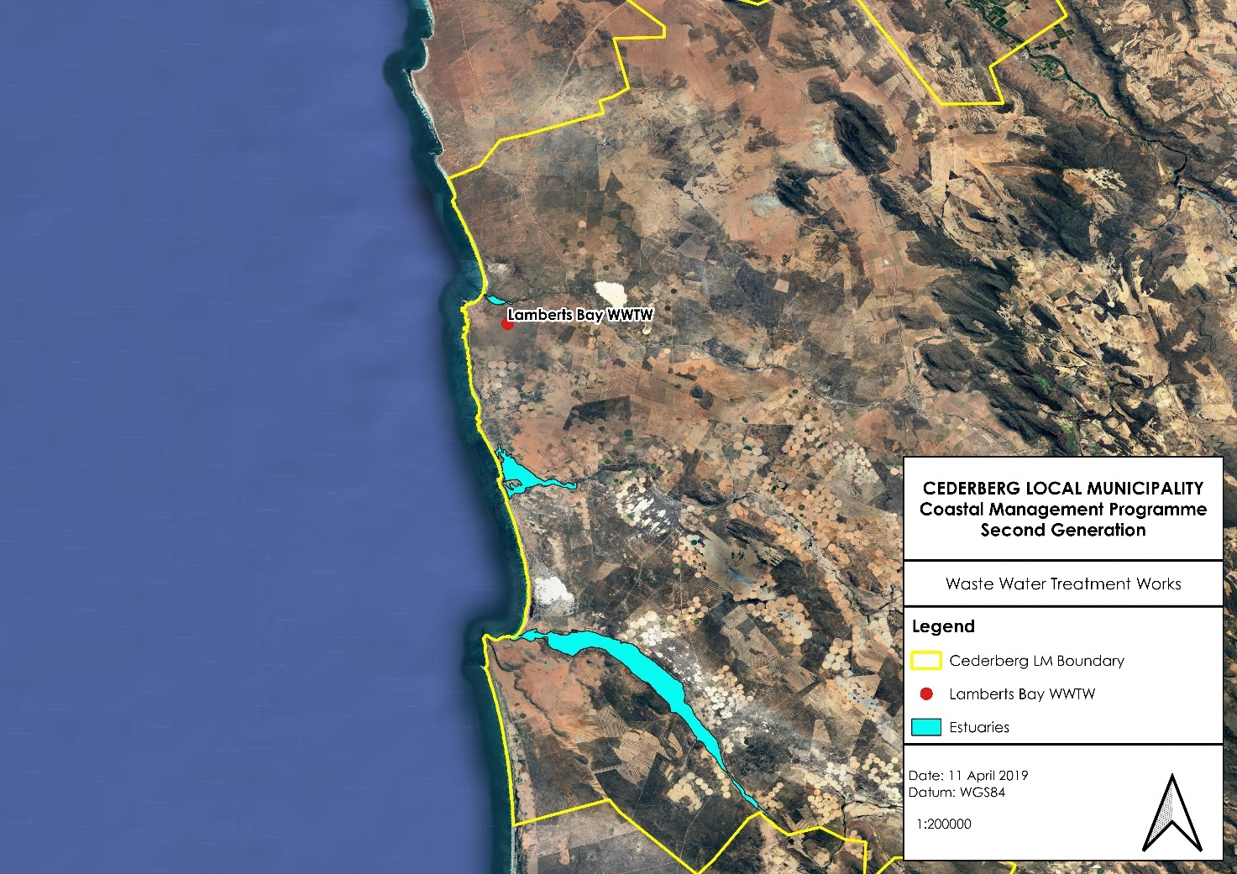
Figure 12: The location of WWTWs near coastal zones along the CM coastline

It is important that the CM continues to maintain WWTW infrastructure and to ensure that the quality of the treated effluent meets the required norms and standards.

Air emissions within the coastal zone

A number of air emissions that are generated through the greater CM area can impact on coastal areas. The primary sources of air emission are derived from the following activities within the CM (Integrated second generation of the West coast district municipality inclusive of the five local municipalities Air quality management plan 2019-2024) include the following:
- Domestic fuel burning
- Agricultural activities; and
- Biomass burning.
DFFE published legislation and established an online national atmospheric emissions inventory system that requires that industry and local government report to the system on an annual basis. The WCDM is required to develop a detailed Emissions inventory that needs to be updated on an annual basis. This air emissions inventory is based on licensed activities within the WCDM. Currently there are no facilities within the CM that have been issued Air Emissions Licenses.

56
Solid waste within the coastal zone

Solid waste, in particular plastic waste is becoming more evident on beaches and in coastal waters. The Ocean Conservancy’s International Coastal Clean-up initiative, which has become an annual feature on the South African environmental calendar, reports that over 8 million kg of waste was cleaned up off approximately 24 000km of coastline around the word in 2016 (WCSoCR, 2019).
The CM has a mandate to ensure that beaches are maintained and kept clean but communities along the coastline also need to take responsibility of their coastal environments and dispose of solid waste in a more responsible manner.
Oil spills off the WCDM coastline

The WCDM has a number or small harbours as well as the larger Saldanha Bay port. The presence of these ports and harbours within the WCDM increase the risk of the occurrence of oil spills due to increased shipping traffic. In South Africa there have been a total of five major oil spills:
- two off Cape Town (1983 and 2000);
- one in the vicinity of Dassen Island (1994);
- one close to the St. Lucia estuary in KwaZulu-Natal (2002);
- one in the Goukamma Nature Reserve (2013); and
- Treasure oil spill occurred on 23 June 2000 when the ship sank six miles off the West Coast.
No comparable oil spills have occurred in the CM to date, but minor spills do occur, which have the potential to severely impact the surrounding environment.

Stormwater

Storm water runoff occurs when rain flows over impermeable surfaces into waterways and can become a major source of non-point pollution into the coastal zone. Surfaces such as paved driveways, tarred roads and pavement are impermeable and do not allow rainwater to soak into the ground. Stormwater runoff accumulates contaminants that may be found on these surfaces and stormwater runoff does not get pre-treated before entering coastal waters (Anchor Environmental, 2018a). It is an important emerging issue in coastal zone management, and a particularly difficult one to manage.

Stormwater runoff is difficult to characterise and treat prior to it entering the coastal zone due to the variation of the composition of the discharge as well as the large number of discharge points. However, in order to address the issue of contaminated stormwater, the source of the contaminants needs to be identified and managed. This will aid in preventing these contaminants from entering into the stormwater systems. In order to do this, a coordinated effort needs to be made between various public and private sector groups within the coastal communities.

57

3.9.2. Existing pollution monitoring and management activities

Several existing pollution monitoring and management programmes are being implemented within the CM and greater WCDM area. This section briefly identifies these programmes and highlights the CMs role in terms of the implementation of these programmes.

Department of Water and Sanitation

The Department of Water and Sanitation established the National Estuarine Management Protocol, NEMP and this was revised in 2021. The purpose of NEMP is the monitoring of water quality, physico-chemical and biological aspects for determining long-term trends and changes in the condition of South African estuaries. The NEMP coordinates national monitoring efforts and provides support in the form of sampling equipment, training, data management and information dissemination, while collaborating institutions collect physico-chemical data and water samples.

Through the NEMP, basic water quality monitoring is currently undertaken on a monthly basis by the WCDM. However, monitoring is limited to the EFZ. The data that is obtained from this monitoring are important as they contribute to a long-term data repository for the system to detect long term trends and to assist in decision making. The existing estuary fora also play a valuable role in monitoring activities in and around the estuaries and the facilitating the appointment of designated monitoring officer.

Department of Forestry, Fisheries and the Environment: Oceans and Coasts

The Department of Forestry, Fisheries and the Environment: Oceans and Coasts branch (DFFE: O+C) completed the Water Quality Guidelines for Coastal Marine Waters. The Water Quality Guidelines for Coastal Marine Waters is an important source of information with regards to norms and standards required for discharges into coastal waters. DFFE required that all authorised discharges are compliant with the limits outlined in these guidelines, and holders of discharge authorisations are required to submit annual monitoring reports to DFFE in order for DFFE to track compliance with these guidelines.

DFFE: O+C have also begun to appoint regional representatives that form part of their newly established coastal monitoring unit. This unit will be monitoring a variety of coastal and oceanographic parameters, particularly focused on climate change. These parameters will include wave data, sea surface temperature as well as pollution monitoring. The regional representative will be the primary link between the local authorities and the national DEFF and it is important that the WCDM and CM work closely with the regional representative, particularly with regards to coastal pollution monitoring.

Air Quality monitoring and management

Within the WCDM area of jurisdiction, ambient air quality monitoring is done by Saldanha Bay Municipality, comprising of full ambient monitoring stations, with one located in Saldanha and one in Vredenburg. A total of seven dust fall buckets have also been placed in strategic positions within the Saldanha/Vredenburg area. Ambient air quality monitoring stations are also operational at an industrial level, particularly in the more densely developed industrial area of Saldanha Bay. The following industrial plants currently undertake ambient air quality monitoring:

58
- Transnet Port Terminals (TPT): Two stations measuring PM10 and PM2.5;
- ArcelorMittal steel plant: One station measuring PM10 , SO2 and H2S. This station has been vandalised and is not operational;
- EXXARO Namakwa Sands: One station measuring PM10. Not operational due to vandalism.
Monitoring results from these industrial stations (TPT) are reported on a quarterly basis to the WCDM as well as to the West Coast Air Quality Working Group established to coordinate air quality matters in the WCDM area of jurisdiction. This working group is chaired by the WCDM.

The National Environmental Management: Air Quality Act 39 of 2004 (AQA) requires Municipalities to develop Air Quality Management Plans (AQMP) that set out implementation strategies to achieve the prescribed air quality standards. The WCDM and CM have Air Quality Management Plans that are currently being reviewed and updated.

AQMP Steering Committee and Working Groups

Communication with CM and the appointment of Air Quality Officers (AQOs) at this level have been identified as shortcomings for the effective management of the air quality function in the WCDM. It has been suggested that a Memorandum of Understanding be entered into with the CM in order to coordinate this function properly. Air Quality Officers have now been designated at all five LMs.

A West Coast Air Quality Working Group (WCAQWG) has been established by the WCDM. The relevant working groups for air quality management meet on a quarterly basis prior to meetings by the WCAQWR. Issues such as air quality management, education and raising awareness and compliance monitoring and enforcement can receive the required attention at these meetings and be reported to the provincial structure. Within the WCDM area of jurisdiction, a Joint Municipal Air Quality Working Group was established in February 2015 between the WCDM and five LMS. The working group meet quarterly and items of mutual interest are discussed.

Oil Spill Contingency Plans

A number of Oil Spill Contingency Plans have been developed by various organs of state within the CM. Oil Spill Contingency Plans for the West Coast Zone was developed by DFFE in 2012.

The oils spill contingency plan outlines the roles and responsibilities of each sphere of government with regards to managing an oil spill incident. The primary responsibility for managing oil spills lies with the South African Maritime Safety Authority (SAMSA) with support from DFFE, DEA&DP and local government. According to the West Coast Zone Oil Spill Contingency Plans, local government, and in this case the CM, is responsible for:
- taking specified measures to prevent or remedy adverse effects of the spill on the coastal environment;
- providing assistance in the form of supervision, labour, transport and equipment for the protection and clean-up of their beaches, estuaries and other areas under their jurisdiction; and
- making arrangements with local Traffic and Police Officers to ensure traffic and crowd control in the vicinity of the impacted area.
59
It is the responsibility of the WCDM to provide support and resources to the CM where required.
Estuary Management Plans

As part of the EMPs that have been developed for the three estuaries within the CM, resource monitoring protocols have been developed to monitor both abiotic and biotic components of the estuaries. The water quality monitoring activities associated with the EMPs are supported by the WCDM as well as DWS.

Blue Flag for beaches

Blue Flag for beaches is an international annual award which focuses on the environmental management of our coastline and coastal waters to help tourism growth and development. Although it is a voluntary eco-label, it has become an international symbol of quality for beaches and marinas that achieve a standard of excellence in the areas of safety, amenities, cleanliness, environmental information and environmental management. South Africa was the first country outside Europe to be granted Blue Flag accreditation for its beaches, and the programme has been locally managed by WESSA since 2001 in partnership with participating coastal local municipalities. The strict criteria of the programme are set by the international coordinators of the Blue Flag campaign in Europe, the FEE (the Foundation for Environmental Education) (WESSA, 2018).

The Blue Flag Programme requires that beaches achieve excellent bathing water quality. The bathing water quality standards have been based on the most appropriate international and national standards and legislation.

Blue Flag has one minimum global standard for water quality, and these standards must be adopted unless stricter national standards are already in existence, e.g. testing for total coliform bacteria. In that case, the beach must comply with the more demanding national standards for bathing water quality.

In the WCDM, there used to be 2 beaches that had been awarded Blue Flag status, namely Yzerfontein (2009-2011) and Strandfontein (2012-2015). Currently there are no Blue Flag beaches in the CM.

Working for the Coast

Waste, in this case litter/rubbish, along the CM coastline is managed through the Working for the Coast (WftC) initiative, which is a national programme. WftC are responsible for collecting waste from the coastal environment and maintaining facilities at all the accessible beaches. It is important that the CM uses the WftC as a tool to aid them in ensuring that beaches are kept clean.

Operation Phakisa

Operation Phakisa was launched in 2014 as a programme aimed at accelerating government’s development targets. The Oceans Economy programme anticipates that the oceans have the potential to contribute up to 177 billion rand to the gross domestic product (GDP) of South Africa and create just over one million jobs by 2033 (Operation Phakisa, 2018). These projects, aimed at maximising economic benefits from the coastal and marine

60
environments, plans on establishing Marine Water Quality Laboratories to analyse samples and create an environmental monitoring network along the 3 900 km of South African coastline (Caren George, 2018).

As one of the enablers, the Minister launched the South African Marine Research and Exploration Forum (SAMREF) to facilitate new collaborative offshore studies to increase knowledge of the offshore marine environment related to renewable energy potential, marine biodiversity and ecology, climate change and ecosystem functioning (DEA, 2018).

The National Pollution Laboratory (NPL) located at Walter Sisulu University (WSU) has been established and work will soon be commencing. The laboratory will monitor water quality along the South African coast (DEA, 2018).

Based on the above as well as feed-back from stakeholders, the future needs in terms of coastal pollution monitoring and management are as follows:

- The CM needs to monitor the quality of the effluent from WWTW more carefully and ensure that the infrastructure is appropriately maintained to prevent contamination of the coastal environment by untreated sewage.
- The WWTW effluent water quality data must be made publicly available in order to ensure transparency.
- DFFE need to complete their Coastal Waters Discharge audit and make decisions on the CWDPs that have been applied for. DFFE then need to ensure that they monitor the permit holders on an annual basis to ensure compliance with the permit conditions.
- DFFE need to address the potato offcut issue at Lamberts Bay. Engagement with CapeNature is needed to ensure that the birds return to their natural behaviours.
- The WCDM and CM must finalise their updated Air Quality Management Plans and implement the plans.
- WCDM and the CM must, where possible, engage with the communities in the municipality to assist with monitoring non-compliances to permits and authorisations. Essentially, engage the community as “environmental watch dogs”.
- WCDM must continue to monitor AEL holders to ensure compliance with the license conditions and must consider the cumulative impact of air emissions when approving an AEL application.
- The WCDM and CM must include the tribal authorities in their various environmental and coastal monitoring forums.
- The CM must implement recycling programmes in all coastal towns and must ensure that separated waste is collected regularly.
- WCDM must continue to implement the Oil Spill Contingency Plan when required, and must have these plans developed for the CM.
- WCDM must improve stormwater management by developing a stormwater bylaw that restricts the discharge of certain substances into the general stormwater system. The Buffalo City Metropolitan Municipality in the Eastern Cape have developed a Trade Effluent By-law that could be used as an example.
- All dredging activities must receive the appropriate authorisations prior to dredging activities commencing.
- Reinstate the Blue Flag beach programme by obtaining Blue Flag Beach status at least at one of the beaches in the WCDM (e.g. Strandfontein).
- CM must ensure that they utilise the WftC programme to obtain support and capacity to clean up beaches. A CM official must be able to monitor the effectiveness of the beach clean-up activities by supervising the WftC team.
- CM needs to move away from allowing the use of septic tank systems and move towards the installation of conservancy tanks instead.
- The CM are responsible for cleaning organic matter as well as litter off of beaches and must respond to washed up kelp/seaweed and animals before it becomes a health hazard due to decay.
61

  - Theme 9: Socio-economic development

The coastal zone is important to society, and the economic development of all coastal communities. It is important that the socio-economic environment along the coastline is well managed and supported to ensure that all coastal communities receive the full benefit of the resources that the coastal zone provides. The identification and exploitation of sustainable livelihood opportunities is equally important to capitalise on the benefits offered by the coastline.

The Cederberg is located on the West Coast of the Western Cape Province. The total area of the Cederberg Municipality is eight thousand square kilometres (8,007 km²) which represents 25.7% of the West Coast District. The Cederberg Municipal area stretches from the Atlantic coast in the west to the Cederberg on the east, the Hantam and Matzikama in the north and Witzenberg and Bergrivier in the south.

3.10.1. Contribution to Provincial GDP and demographic profile

In 2018, the coastal municipalities of the CM contributed 0.68 % to the Provincial Gross Domestic Profit (GDP). The CM has a population of 60 790 people (Socio economic profile, 2022) and there is a total of two coastal settlements. Each coastal settlement has its own key socio-economic drivers that contribute towards the CMs overall Gross Domestic Profit (GDP) (WCSoCR, 2019). The CM has several socio-economic characteristics that contribute to the WCDM and Provincial GDP that are discussed in Table 6 below.
Table 6: The socio-economic characteristics of each of the CM
Population (Socio economic profile, 2022)) | Unemployment rate (Socio-economic profile, 2022) | Average household income (IDP, 2024/2025) | Coastal settlements | % Contribution to Provincial GDP for 2018 (WCSoCR, 2019) | Key socio-economic drivers along the coastline
60 790 | 11.1% (Quantec Research, 2022) | A significant proportion (almost 79%) of the population earns less than R76 401 per annum i.e. less than R5200 per month according to Census 2011. | Elands Bay (coastal village)  Lamberts Bay (coastal town) | 0,68% | Eland’s Bay functions as a low order service town and holiday town.  The fishing industry forms the main economic activity in the LM.  The Saldanha-Sishen railway divides Elands Bay, restricting access between the northern and southern sections of the town.  The harbour at Lamberts Bay plays an important role in the fishing industry in the LM.

62

3.10.2. Existing ports and harbours

Within the CM, Lamberts Bay Harbour is now home to only a limited number of small fishing vessels. Fishing activities are mostly centred on line fish, West Coast Rock Lobster and small volumes of pelagic species and hake. Subsistence fishing remains important due to the socio-economic profile of the region. Both recreational and commercial West Coast Rock Lobster fisheries are still very active at the harbour, albeit not to the same extent as it was in the past due to the heavily depleted status of West Coast Rock Lobster (Aurecon, 2017c).

3.10.3. Western Cape Small Harbours: Spatial and Economic Development Frameworks

There are five fishing harbours in the WCDM that are owned by the Department of Public Works (DPW) and administered by DFFE. The following harbours in the WCDM have been earmarked to benefit from this project:
- Saldanha Bay;
- Pepper Bay;
- St Helena Bay;
- Laaiplek; and
- Lamberts Bay.
This study identified that these harbours have four main functions which are:
- Marine Access Points (inter-modal exchange points);
- Key point in Fish Produce Value Chain (farms and fresh produce markets);
- Public Space and Amenities (parks, beaches, community recreational facilities, etc.); and
- Business/Commercial Nodes (shopping centres and industrial business parks).
To date, Spatial and Economic Development Frameworks (SEDF’s) for the five Fishing Harbours within the WCDM have been completed and the report was finalised in 2014. To date, all bathymetry surveys of the identified harbours have been completed as well as a condition assessment for each harbour.

3.10.4. Tourism assets in the CM

Tourism in Cederberg is the fastest growing industry in the LM. The natural environment and assets place Cederberg in a favourable position to become one of the leading destinations for adventure tourism. In recent years the Pakhuys region has distinguished itself as one of the best bouldering destinations in the world, drawing predominantly overseas visitors who stay in the area for longer periods.

The Cederberg LM aims to mainstream community-based tourism initiatives by implementing a portfolio of marketable tourism products and services in marginalized, rural communities of the Cederberg (e.g. Elands Bay).

These tourism assets need to be managed effectively in order to increase the number of people visiting these areas. The IDP for the CM also identifies projects to be implemented to attract more visitors. These projects within coastal areas must be pulled through into this CMP.

63

WESSA Green Coast

The National Development Plan (NDP) outlines South Africa’s strategy to tackle socio-economic development in the country. It provides a framework for Government, private sector and citizens to work together to stimulate and accelerate economic growth and provide solutions to the challenge of unemployment, poverty and inequality. In an attempt to fast track the objectives of the NDP, Operation Phakisa was developed in 2014 as a “fast results delivery programme to help implement the National Development Plan”. The South African coastline has been identified as a crucial starting point for this strategy as Government aims to realise the potential that the coastline offers as an untapped resource. Operation Phakisa states that the oceans have the potential to contribute up to 177 billion Rand to the Gross Domestic Product (GDP) and create approximately 1 million jobs by 2030.

The Green Coast award has been developed to recognise those coastal sites which are managed according to standardised criteria and able to maintain a consistent improvement of conditions at the site. Green Coast sites aim to protect one of three main coastal themes namely; sensitive habitats, species and cultural heritage. The Green Coast award allows local municipalities to sustainably manage those coastal sites outside of traditionally developed swimming beaches. The award has been developed in a way that will allow for adequate monitoring and protection of the site, whilst also allowing for the development of low impact coastal tourism, should there be potential for this. A Green Coast site is not just another stretch of protected coastline but rather a platform for collaboration, innovation and local public participation.

The Green Coast criteria include aspects of basic ecological monitoring which allow for the setup of exciting new citizen science initiatives. The Green Coast sites with their unique habitat, species and cultural heritage also provide ideal locations for outdoor learning and exemplary environmental education activities. The objectives of Green Coast are two-fold. Firstly, it aims to provide a system for sustainable management of sensitive coastal spaces and secondly, to engage local citizens to become involved in management of these unique sites.

In an attempt to now extend this positive influence along the coastline to non-swimming beaches, WESSA will work closely with existing municipal partners to identify new coastal sites to manage under the Green Coast guidelines. The main themes covered by the Green Coast award include: Environmental management; ecological monitoring; tourism management and environmental education. A local Green Coast site committee will oversee the management of each site and this committee should ideally have representatives of all stakeholders involved in the management of the site.

64

Other WESSA Green initiatives include the following:

Eco-Schools programme: This programme is aimed at creating awareness and action projects around environmental sustainability at schools and in their surrounding communities. The programme improves education through curriculum-aligned environmental learning which helps learners develop practical, useful classroom and outdoor everyday skills, equipping them to live sustainably in the future.

The Green Key award: This initiative is a leading standard of excellence in the field of environmental responsibility and sustainable operations within the tourism industry. This prestigious eco-label requires that sites adhere to the strict criteria stipulated by the international Foundation for Environmental Education (FEE), regarding water, waste, energy, food and beverage, and other areas of operation. A Green Key is an establishment’s promise to its guests that by opting to support such an establishment, they are helping to make a difference on an environmental and sustainability level.

It is strongly suggested that the WCDM, together with CapeNature and the coastal LMs, support this initiative by identifying areas that meet the criteria stipulated in order for a section of coast to receive the Tourism Green Coast eco-label. Suitable sites include unspoilt beaches and non-urban, wild spaces with minimal infrastructure. To achieve Green Coast status, locations will have to comply with a set of site-specific requirements and inspection criteria. LMs will be responsible for upholding the criteria, assisted by WESSA members who will provide specific support with the collection and monitoring of baseline ecological info.

3.10.5. Aquaculture activities

Land-based aquaculture is a coastal dependent activity with direct impacts on the coastline in terms of water quality and land use change.

Currently there are no aquaculture operations within the BLM. However, the potential for the development of aquaculture within the BLM needs to be investigated to facilitate the creation of job opportunities for coastal communities.

3.10.6. Small Scale Fisheries Policy

Many communities along the Western Cape coast rely on the coastline for subsistence purposes. The recommended definition of subsistence fishers according to the Policy for the Small-Scale Fisheries Sector in South Africa are poor people who:
  - personally harvest marine resources as a source of food or to sell it to meet the basic needs of food security;
  - operate on or near to the shore or in estuaries,
  - live in close proximity to the resource,
  - consume or sell the resources locally,
  - use low technology gear (often as part of a long-standing community-based or cultural practice), and
  - the types of resources they harvest generate only sufficient returns to meet the basic needs of food security (Branch, et. al. 2002).

65
The first democratic election in South Africa in 1994 was followed by a revision of many policies and laws, with the aim of correcting past political and social inequalities. One change that was made was the promulgation of the Marine Living Resources Act (MLRA), which recognised the previously marginalized subsistence fisheries as a formal fishing sector for the first time (Harris, et. al. 2002).

Interim Relief Measures (IRM) have been in place since an equality court order was issued to the DFFE in 2007. The IRM permit system was originally intended to provide temporary relief to small-scale fishers who did not benefit from Long Term Rights according to policies developed by DFFE in 2005, while the new Small-Scale Fisheries Policy was being drafted. However, the Small-Scale Fisheries Policy is in the process of being implemented and the IRM permit system continues to be utilised by DFFE to allow for the provision of legal access to limited marine resources for community fishers in the Northern and Western Cape (WWF-SA, 2015).

The main species that communities involved in the IRM are allowed to harvest are West Coast rock lobster, linefish (snoek, yellowtail, and cape bream), white mussels and oysters, subject to various respective limits. West coast rock lobster is the most valuable resource to the communities along the West Coast of South Africa.

In terms of the number of permits issued for small scale fisheries operations and what percentage of these have been issued to communities that were previously deprived of these rights, the WCSoCR indicates that forty-five communities are currently involved in IRM, which includes two communities in the Northern Cape. The total number of people supported through the dispensation is 1998 but is not consistent due to fishers passing away or finding other forms of work, while communities also regularly include new fishers on the IRM list (DAFF, 2016).

3.10.7. Renewable Energy opportunities

Renewable energy resources within the CM include wind resources, wave energy, biomass waste, solar- and hydro energy. Although these energy resources have potential to be utilized, it is acknowledged that within the WCDM, renewable energy production is still in its infancy. The most viable resources within the CM include:

Wind

Wind resources in the West Coast District are substantial and comparably high in relation to the rest of the country. The region also leads the country in terms of implementation experience with regards to the establishment of several wind farms throughout the WCDM, from Darling and Hopefield in the south to the ESKOM Sere wind farm north of Vredendal.

Wave energy

Wave energy development is still in its early stages but holds much promise as a source of renewable energy. The CM has a long coastline and preliminary results show that wave energy resources are substantial. However, no large-scale commercial projects are yet in place. The Western Cape Provincial Government encourages private developers to explore options for large scale electricity generation of the cape coastline. However, potential environmental impacts that this technology may have on marine ecosystems must be taken into consideration.

66
Renewable Energy Development Zones (REDZ) and Strategic Transmission Corridors

A Strategic Environmental Assessment was undertaken in 2015 by DFFE that aimed to identify Renewable Energy Development Zones that were of strategic importance for large scale wind and solar photovoltaic development in South Africa. In 2017, Cabinet approved the REDZ based on the recommendations of the SEA. As a result, applications for Environmental Authorisation for large scale wind and solar energy facilities need only follow a Basic Assessment procedure in terms of Section 19 and 20 of the EIA Regulations (2014, as amended).

While none of the REDZ fall within the CM, the CM falls within the Western Strategic Transmission Corridor.

Based on the above as well as feed-back from stakeholders, the future needs in terms of coastal socio-economic development are as follows:

- WCDM and CM must ensure that they engage with the Western Cape Small Harbours: Spatial and Economic Development Framework and incorporate the programme into their IDPs and SDFs.
- CM must implement the projects outlined in the IDP and SDFs that relate to coastal development and conservation.
- WCDM and CM must ensure that they incorporate the promotion of aquaculture into their Local Economic Development (LED) plans. A feasibility study should also be conducted to determine the potential for a formal partnership between the Municipalities and the Aquaculture Operators to directly involve communities so that they can benefit though skills development and employment opportunities.
- The WCDM must engage with the CM to assist them in participating in the WESSAs Green Coast project.
- The DFFE must ensure that community development is catered for in the ADZ business model. Community opportunities must include skills transfer and employment.
- DFFE need to finalise the Small-Scale Fisheries Policy and implement the allocation of rights in an appropriate and transparent manner.
- DFFE Regional Offices need to consider supporting communities with regards to assisting them with the application process for fisheries permits. Many communities are far from Cape Town and do not have the money for transport. The Regional officers must consider receiving and processing applications for fishing rights in the WCDM.
- The WCDM and CM must incorporate the development of the renewable energy sector into their IDPs, SDFs and LEDs in accordance with the Renewable Energy Development Zones (REDZ), provided that Environmental Authorisations have been issued for new renewable energy projects or are stipulated as a clear requirement in the IDPs and SDFs.

  - Theme 10: Awareness, education, training, capacity building and information

Creating awareness of the importance of the coastline through education, training and capacity building will help to facilitate the cooperative management of the coastal zone, which is required to successfully implement an integrated coastal management strategy. The generation of internal capacity within the CM, to effectively manage the coast is also vital in ensuring that the objectives and strategies set out in the CMP are implemented. Awareness of the coastal zone among various key stakeholder can be achieved through the facilitation of knowledge production and exchange, the promotion of knowledge sharing of coastal issues, and instilling a sense of ownership of the coastal zone amongst all stakeholders.

67

3.11.1. National Oceans and Coastal Information Management System

DFFE and the Department of Science Technology and Innovation (DSTI) have initiated the National Oceans and Coastal Information Management System (OCIMS) for South Africa. The OCIMS project forms part of the Operation Phakisa Marine Protection Services and Oceans Governance workstream Initiative 6 and is endorsed by Cabinet.

OCIMS will support a variety of oceans and coastal initiatives by providing information and decision support to key stakeholders involved in the day-to-day management of South Africa’s oceans and coasts. The project outcomes will be achieved through the development of an Information Management System (IMS) that will integrate current and future oceans and coastal systems, information and expertise into a user-friendly and cost-effective IMS for the benefit of relevant stakeholders. In June 2015, the CSIR was nominated by DFFE as a service provider to facilitate the implementation of the project and to co-develop OCIMS.

The OCMIS website provides a wide range of resources that will enable decision makers to access existing data, policies and programmes related to the coastal and marine environment. Training guidelines and manuals that have been developed by various organisations for different coastal activities are available for download as well as all relevant coastal and marine legislation, policies and guidelines (www.ocims.gov.za).

The following Decision Support Tools are also available on the OCMIS webpage that can be used to assist with informed decision making as well as provide information to the public:
- Harmful Algal Bloom Decision Support Tool:
The HAB Decision Support Tool (DeST) provides a capability for monitoring and assessing risk of HAB events for the South African coastal area to approximately 50 km offshore.

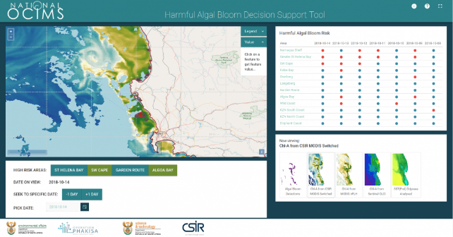Figure 13: A screenshot of the HAB DeST from the OCIMS website.

68

- Coastal Operations at Sea Decision Support Tool
The Coastal Operations at Sea (CoastOps) DeST provides a capability for monitoring and predicting ocean and sea state variables in the coastal ocean using state-of-the-art forecasts of winds, currents and waves, which are provided by numerical models that simulate and predict ocean and atmospheric conditions.
- Marine Spatial Planning Support Viewer
Marine Spatial Planning (MSP) Support Viewer DeST provides a consolidated view of data sources that can inform MSP and the development of Marine Area Plans (MAPs). The MSP Support Viewer DeST contains relevant and accessible spatial data from authoritative sources and use a federated data source approach for data ingestion.

- Integrated Vessel Tracking Decision Support Tool
The Integrated Vessel Tracking (IVT) DeST provides the capability of monitoring vessels movements based on both transponder information (such as Automatic Identification Systems) as well as vessels detected using Search and Rescue data, and provides notifications when vessels are within Marine Protected Areas (MPAs).
- Water Quality Decision Support Tool
The purpose of the Water Quality DeST is to provide support to coastal managers’ decision-making processes by providing a consolidated view of various remote-sensed and in-situ sources of water quality data.
- Coastal Flood Hazard Decision Support Tool
The Coastal Flood Hazard DeST identifies coastal areas at risk of flooding and aids in facilitating climate change adaptation. Based on the data available for South Africa, as one example the DeST can provide disaster managers, spatial planners and the general public a way of identifying coastal areas that are potentially at risk of flooding.
- Department of Forestry, Fisheries and the Environmental Coastal Viewer
Information regarding the Coastal Public Property (CPP) and Coastal Protection Zone (CPZ) can be found in this viewer. This can support decision making processes by focussing on access to the coast, protecting sensitive coastal ecosystems and protecting people, property and economic activities that may be affected by dynamic coastal processes.

3.11.2. South African National Biodiversity Institute (SANBI)

SANBI has developed an online portal where decision makers and other public and private entities can freely access spatial data that relates to biodiversity in South Africa. The Biodiversity Geographical Information System (BGIS) website houses all biodiversity related spatial data and their associated technical reports.

The following information and services are made available by the SANBI BGIS website and team:

69
- Freely downloadable biodiversity-related spatial datasets;
- Each spatial dataset is accompanied by metadata. Metadata describes the spatial datasets and provides the user an idea of its validity;
- An easy to use mapping platform that allows users to visualise important biodiversity features. The mapping platform allows users to add their own data, switch layers on and off, add annotations, and print maps;
- A pdf report listing all the biodiversity features in an area of interest; and
- The BGIS team offers free, quarterly BGIS training. The training focuses on how to efficiently use the website to make informed land-use decisions.

3.11.3. Formalised coastal education and awareness campaigns

The objective of awareness and education campaigns is to reduce the impacts on the coastal environment relating to prevalent coastal pressures such as land use, pollution (such as solid waste) and resource exploitation.

A few environmental education (EE) programmes are active in the Western Cape, with the WCDM and CM, actively participating in these programmes. Examples of coastal programmes that are implemented in partnership with government and non-profit organisations (NGOs) include:
- Working for the Coast programme, implemented by the DFFE and is aimed at ensuring access to pristine beaches and a well conserved coastline.
- International Coastal Clean-up, which is an initiative in partnership with volunteer organisations and individuals around the globe. It provides an opportunity to encourage people to remove waste and litter from beaches, estuaries and rivers, identify the sources of debris and change human behaviours regarding marine litter. In South Africa this initiative is managed by PlasticsSA and KZN Wildlife, and on one occasion over 3000 people collected over 7 tonnes of litter off 121km of the South African coastline.
- Youth Environmental Services Programme, the Government initiated the Youth Service Programme (YES) as a Presidential programme in 2003. Its aim was to respond to the multiple needs of young people which enable them to access new opportunities for employment, income generation, skills development and personal development while contributing to the reconstruction of South Africa. The Youth Environmental Service entails the involvement of unemployed young people in activities which provide environmental service that benefits the community whilst they are also provided with opportunities for personal development, accredited training and exit opportunities.
The DEA&DP, as the designated lead agent for coastal management in the Western Cape, promote and support environmental awareness and education amongst the people of the Western Cape through Environmental Calendar events and programmes, particularly the International Coastal Clean-up and National Marine Month activities. These initiatives are annual events and are aimed at raising environmental awareness in a broader sense and the WCDM work together with the DEA&DP to roll out these programmes within the region (WCSoCR, 2019).

The WCDM, with support from DEA&DP, promotes and implements the annual National Marine Week programme, which highlights the importance of oceans and the role they play in the life of all South Africans, as well as the Coastal Clean-up week. Typically the Environmental Calendar includes the following events, and the WCDM and the CM are encouraged to promote and become involved in these:

70
- World Recycling Day
- Earth Hour
- Earth Day
- World Biodiversity Day
- World Environment Day
- World Ocean Day
- International Coastal Clean-up Day
- Marine week
- International Day of Climate Action
- World Fisheries Day

3.11.4. National and Provincial training initiatives

A comprehensive understanding of the Integrated Coastal Management Act (ICMA) forms an integral aspect of coastal management for implementing agents and coastal officials. The DEA&DP have provided training on different aspects of the ICMA, including how ICMA integrates with other legislation (WCSoCR, 2019). The training that the DEA&DP have facilitate since 2013 include the following:

Year | Date | Type of training
2013 | 11 October | Western Cape Government Coastal Setback line Workshop
2013 | 20 November | DEA&DP Estuaries Workshop
2014 | 18 February | Estuarine Management Chairpersons Forum
2015 | 19 March | ICMA/SPLUMA
2015 | 26 May | ICMA- support workshop
2016 | 1-2 March | Western Cape Integrated Management Act Training
2016 | 14-15 March | Environmental Management Framework Workshop
2016 | 17 November | ICMA with focus on Environmental Governance
2017 | 1-2 March | ICMA with focus on Estuaries
2017 | 03 March | ICMA with focus on CML
2017 | 6-8 March | Estuary Management Course
2017 | 9 March | Worksop on Coastal Management Lines
2017 | 15 June | Marine Mammal Stranding Workshop
2020 | 12 March | Coastal access capacity building workshop
2022 | 14 March | Coastal capacity building
2024 | 2024 | Estuaries Water Quality Monitoring Training

Nelson Mandela University facilitates a three day “Management in Estuaries in South Africa” short course, with support from DFFE, on an annual basis. This course aims to capacitate government officials and private entities on estuarine management and the requirements of the national Estuarine Management Protocol.

3.11.5. Signage at beaches

One of the most simple and effective ways to provide information to the public is through the erection of education-based signage at public access points along the coastline. The LMs are proactive in erecting a variety of signage at key areas that prohibit illegal dumping as well as illegal ORV activities. It is also important that signage be erected at high risk public

71
areas, such as dangerous swimming beaches and public launch sites, which warns the public of dangerous conditions.

Through the WftC programmes, educational signage at beaches can be erected. The OCIMS Programme also has links to educational posters that follow coastal themes that are free and easy to access. These posters are available in English, isiXhosa and Afrikaans (https://www.ocims.gov.za/documents/gen-info/).

One of the issues that was raised during the initial stakeholder consultation was that members of the public do not know who to contact to report illegal or suspicious activities. It is suggested that signage be erected at key coastal access points that provide the contact details of the relevant officials (e.g. the Local FCO for fisheries transgressions, EMIs for ORV infringements, etc.).

3.11.6. Coastal related forums and committees

A number of environmental and coastal-related forums and committees exist within the WCDM that aim to keep up to date with environmental and coastal issues within the district. It is important that the CM are represented at these forums. However, many of these forums and committees are restricted to government and industrial organisations.
- In Saldanha Bay, an Air Quality forum has been developed that allows for members of the public to participate.
- The Estuary Advisory Forums allow for representatives of local community leaders and Rate Payers Associations to engage with the officials that are responsible for the management of these estuaries and the execution of the Implementation Plans.

3.11.7. Fisheries Community Development Workers

DFFE have community development workers to ensure that there is constant interaction and easily accessible relationships with local coastal communities. This function also aids in making sure that information about the operations and service deliver programmes of the department are easily cascaded to the coastal communities.

The roles and responsibilities of the community development workers include the following:
- Conducting community outreach programmes and events;
- Conduct situational analysis for each respective area;
- Establish community fishing forums;
- Establish database of all stakeholder and forums in their respective coastal areas;
- Act as a departmental representative/ link between the local coastal communities and the department, and
- Provide constant feedback on service delivery enquiries.

72

3.11.8. Public libraries

Public libraries are an underutilised resource when it comes to education and awareness. Each coastal town within the CM has a public library that can be used to allow members of the public access to environmental and coastal literature. Public libraries can also be used as a resource for the municipalities to directly engage with communities to discuss and educate people on coastal issues.

One of the prominent issues that came out of the stakeholder engagement sessions was that the communities were not aware of coastal policies, programmes or legislation, and they do not all have access to online resources. A database of coastal and environmental literature can be made available at public libraries with a summary of the key resources being made available in more than one language.

Based on the above as well as feed-back from stakeholders, the future needs in terms of awareness, education, training, capacity building and information are as follows:

- The WCDM and CM need to ensure that they are familiar with the OCIMS and what data can be obtained in terms of environmental monitoring and decision-making tools.
- The WCDM and CM must provide links on the webpages to key coastal legislation, policies and programmes as well as sources of scientific data (e.g. OCIMS and BGIS).
- WCDM and the CM must continue to engage with DFFE and DEA&DP with regards to upcoming training opportunities for officials. This must be done at the beginning of each year so provision can be made for training.
- The CM Environmental Officer must attend the Estuary Management Training course that is implements by NMU.
- Educational signage must be erected at all formalised coastal access points. The WftC programme must be used to support this.
- Signage must be erected at all coastal access points that provide the contact details of the relevant authorities that the public can report suspicious or illegal activities to.
- The WCDM and CM must ensure that they continue to participate in the relevant committees and forums.
- The WCDM and CM must engage with the Fisheries Control Officers in an attempt to assist the local communities with issues relating to the MLRA.
- The CM must ensure that the public libraries have access to all the latest relevant environmental and coastal policies, plans and programmes.
- A formalised Coastal Education Strategy must be developed that utilises municipal resources such as public libraries, schools and own halls. Open days and information sharing sessions by representatives from relevant coastal authorities and organisations must be included. The Two Oceans Aquarium and CapeNature can assist with the implementation of some coastal education activities that may form part of this strategy.
- The DM and CM need to support cultural education facilities. Support can be in the form of creating awareness of these initiative by creating a link on the municipality’s website or including them as part of their tourism plans.
- The WCDM, together with the CM, should consider hosting an aquaculture summit that highlights the aquaculture industry in the region as well as the opportunities for community benefaction.
- The CM must be available to support research institutions by providing data, if it is present, in a timeous manner. Other ways that the municipalities can support research is by engaging with communities so that field visits can be facilitated without suspicion.
- The CM should start to formalise an internship programme that allows undergraduate students the opportunity to obtain valuable work experience. Institutions such as the DPW, SETA and NRF can be approach to source funding.

73

ROLES AND RESPONSIBILITIES FOR COASTAL MANAGEMENT

  - Mandatory Roles and Responsibilities in terms of the ICMA

The ICMA is the central piece of legislation that defines the roles and responsibilities of various spheres of government, and other role players with regards to coastal management. While the roles and responsibilities of the National and Provincial government are important to consider at local government level, this chapter will only highlight roles and responsibilities pertaining to the CM.

The ICM Act definition of a municipality is as follows:

- a metropolitan, district or local municipality established in terms of the Local Government: Municipal Structures Act (Act No. 117 of 1998); or
- in relation to the implementation of a provision of this Act in an area which falls within both a local municipality and a district municipality, means -
- the district municipality; or
- the local municipality, if the district municipality, by agreement with the local municipality, has assigned the implementation of that provision in that area to the local municipality.

Responsibilities assigned to Municipalities are automatically assigned to metropolitan and district municipalities (WCDM). If capacity exists at a local government level, district municipalities can assign certain provisions.

However, the functions and powers of municipalities are assigned in terms of sections 156 and 229 of the Constitution of the Republic of South Africa Act (No. 108 of 1996). When two municipalities have the same fiscal powers and functions regarding the same area, an appropriate division of those powers and functions must be made in terms of national legislation, namely, the Municipal Structures Act (No. 117 of 1998). This Act assigns responsibility for the adjustment of the division of functions and powers, as well as the resolution of disputes arising between district and local municipalities to the MEC for local government. Any action initiated should be undertaken after consultation and via a notice in the Government Gazette. The Municipal Systems Act, (No. 32 of 2000) also provides a directive for the cooperation, support and assistance between district and local municipalities wherever possible.

Table 7: Government roles and responsibilities in coastal management in terms of the ICMA

ASPECT | RELATED SECTION/S IN THE ICMA | BRIEF DESCRIPTION OF ROLE AND RESPONSIBILITY | ASSISTANCE FROM OTHER ORGANS OF STATE
Access to coastal public property  74 | 18, 19, 20 | Ensuring that the public has equitable access to coastal public property by designating coastal access land, designate in by-laws strips of coastal access land to promote access to CPP along the coast, withdraw inappropriate coastal access land and follow an environmentally sensitive and socially responsible process in designating coastal access land. This is the responsibility of the CM. | DFFE, DEA&DP, WCDM
Coastal management line demarcation on zoning maps | 25 | The WCDM and the LMs must delineate coastal management lines in municipal zoning schemes maps and should participate in any provincial coastal management line determinations, but this is discretionary; alternatively can work with province to determine coastal management lines. Province will have to Gazette. | DEA&DP
Determining and adjusting coastal boundaries of coastal access land | 29 | The WCDM must ensure specified considerations are taken into account when determining or adjusting a coastal boundary of coastal access land. | DFFE, DEA&DP
Marking coastal boundaries zoning maps | 31 | The WCDM and CM must delineate coastal boundaries determined or adjusted in terms of S26 on zoning scheme maps
Municipal Coastal Management Programmes | 48, 49, 55 | The WCDM must prepare and adopt a municipal coastal management programme for managing the coastal zone or specific parts of the coastal zone in the municipality. | DFFE, DEA&DP
Consistency and alignment between Municipal Coastal Management Programmes and other statutory plans | 51, 52 | The WCDM and CM must ensure that any plan, policy or programme adopted by an organ of state that may affect coastal management is consistent and aligned with municipal coastal management programmes, which in turn is aligned with provincial coastal management programmes and the national coastal management programme. Ensure that IDPs (including its spatial development framework) is consistent with other statutory plans [See S52 (1) (a-f)] adopted by either a national or a provincial organ of state.
Consultation and public participation | 53 | The WCDM must ensure that adequate consultation and public participation precedes the exercising of a power by a municipality, which the ICMA requires to be exercised in accordance with section 53 of the ICMA. | DEA&DP
Implementation of land use legislation in the coastal protection zone  75 | 62 | In implementing any legislation that regulates the planning or development of land, in a manner that conforms to the principles of co-operative governance contained in Chapter 3 of the Constitution, apply that legislation in relation to land in the coastal protection zone in a way that gives effect to the purposes for which the protection zone is established, as set out in section 17. | DFFE, DEA&DP, Cape Nature

  - Collaborative Partnerships for Coastal Management

In order to effectively achieve integrated coastal management in the CM, cooperative governance must be promoted. This requires that methods and approaches be developed to ensure the optimal involvement of all coastal stakeholders in decision making processes that are highlighted in the CM CMP are achieved. The NCMP (2014) describes examples of collaborative partnerships that will be helpful in achieving the goals and objectives highlighted in the CM CMP. The following will be useful:

- Involvement of communities in coastal management by engaging with community leaders, ward councillors, rate payers associations, etc.;
- The improvement of partnerships between government (both Provincial and National), civil society (through effective public participation) and the private sector (local businesses, corporate companies, etc.);
- The strengthening of relationships between communities and conservation agencies (DEA&DP and Cape Nature);
- Improved conflict-resolution mechanisms;
- Improved communication between spheres of government and institutional structures;
- Improved co-ordination between sectors within the WCDM (e.g.: Community Services, Engineering Services, etc.);
- Encouraging sustainable development that adheres to the various pieces related to environmental and coastal management;
- Inclusion of public review into land use planning processes;
- Reduction of bureaucracy of development proposals;
- Elevating the priority of coastal management by incorporating goals, objectives and actions into the WCDM IDP; and
- Integration of coastal management principals into plans and strategies for all sectors of the WCDM (SDF, IDP, LED, etc.).

  - Development of bylaws

Section 11 of the Municipal Systems Act (Act No. 32 of 2000) clearly defines the executive and legislative authority that can be exercised by a municipality. Section 11(2) and (3) states the following:

76
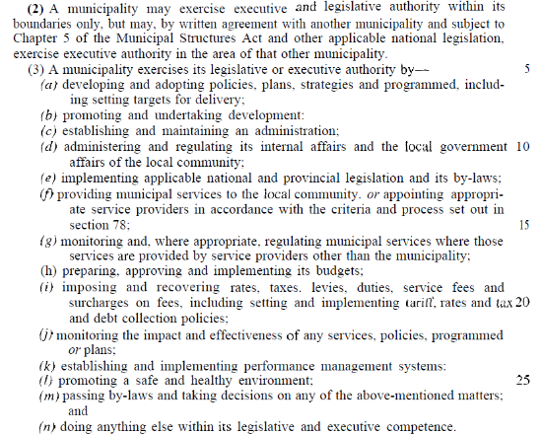

Bylaws can act as a tool to provide capacity for the CM to enforce laws within the area of their jurisdiction. The Municipal Systems Act (Act No 32 of 2000) Section 12 states that only a member of a municipal council may introduce a bylaw in the council after which it must be published in the Provincial Gazette.

CM developed a Coastal Management By-law that was promulgated in November 2022. This provides the CM the legislative support to implement coastal management along its coastline.

77

VISION AND PRIORITIES

  - The Cederberg Municipality Vision for the Coastline

South Africa’s Constitution specifies the following objectives for local government:
- To provide a democratic and accountable government for local communities;
- To ensure the provision of services to communities in a sustainable manner;
- To promote social and economic development;
- To promote a safe and healthy environment; and
- To encourage the involvement of communities and community organisations in the matters of local government.

The vision of the CM as expressed in its IDP and Budget process plan 2023/27 captures these objectives:

“Cederberg municipality, your future of good governance, service
excellence, opportunities and a better life”.

The vision for the first generation CMP for the CM has been carried through to the second and third generation CMP. The vision that was created for the first generation CMP still holds true and still bears relevance to the CM coastline.

We, the people of the Cederberg Municipality, celebrate the diversity, richness and uniqueness of our coast and its communities. The coastal environment will be effectively managed to ensure a balance between ecological integrity, sustainable livelihoods and cultural values.

The coast will be a safe, clean and healthy asset with equitable access and opportunities for all communities, now and in the future.

The guiding principles for coastal management within the CM, presented in Figure 16 below (NCMP, 2015), are closely aligned with the principals set out in this Western Cape CMP and the NCMP:

78

Figure 14: The guiding principles for coastal management in South Africa (NCMP, 2015)

79
  - The Cederberg Municipality’s Priorities for Coastal Management

The Situational Analysis (Chapter 3) describes the state of the CMs coastal ecosystems. The Situational Analysis along with contributions from the stakeholder engagement workshops held in each coastal LM contributed significantly to the assessment of the status of coastal management within the CM.

The CM does not have the resources or the capacity to address every coastal issue or challenge with which it is faced. It is also good coastal management practice to focus available resources on those issues that are deemed to be significant and require urgent response and to embark on a “cycle of improvement”.

Ten priorities for coastal management in the CM have been identified and are listed in order of importance based on the outcomes of the stakeholder engagement process thus far:

Priority 1: Cooperative governance and institutional arrangements

Goal: To promote the integrated and cooperative management of the coastline by bringing all relevant stakeholders together and creating the capacity within the municipalities to effective monitor and manage coastal activities.

Cooperative governance is important in the implementation of coastal management objectives and strategies within the WCDM and the CM. Effective cooperative governance requires:

- the participation of all stakeholders,
- coastal governance and co-responsibility,
- integrated, coordinated decision making,
- planning and development,
- the continued learning and practical implementation of programmes and processes, and
- ensuring compliance with international conventions, protocols and agreements.

It is important that the WCDM and the CM work closely with the National and Provincial spheres of government to ensure that the municipalities are sufficiently capacitated and financially resourced to implement coastal management strategies.

Priority 2: Facilitation of coastal access

Goal: To ensure that safe and equitable access to the coast for all people within the WCDM is facilitated and maintained by identifying areas that require the provision of new coastal access points, and by ensuring that existing coastal access points, and the public amenities associated with them, are in a state that conforms with the requirements set out in the ICMA.

The provision of public access to the coast is clearly addressed in the ICMA. Within the CM, public access to the coast is not fully compliant with the relevant provisions in the ICMA, due to either a lack of public access or amenities, a lack of awareness on the impact of illegal activities on the coastal zone, the poor condition of existing access roads to coastal areas, and the lack of open communication between local communities and authorities with regards to the provision of public access within the coastal zone. Other challenges facing the facilitation of coastal access in the CM includes the alienation of land for mining and gated residential estates.
80
There are various access points to the coast within CM which ensures tourism opportunities and economic benefits to communities. The provision and maintenance of public amenities falls within the mandate of the CM. However, the WCDM needs to provide assistance to the CM by assisting with the provision of resources to enable the CM to promote coastal tourism.

Priority 3: Coastal planning and development

Goal: To promote responsible coastal planning for the sustainable development of the WCDM coastal zone consistent with ICMA and other legislation and policy requirements, namely:
- Coastal Protection Zone
- Coastal Management Lines
- Coastal Access
- Climate change risks
- Cape West Coast Biosphere Reserve
- Western Cape Biodiversity Spatial Plan

This can be achieved by incorporating appropriate spatial principles into the CM SDF, defining and establishing urban edges for all urban nodes in the coastal zone and ensuring that climate change adaptation and mitigation measure are included in the planning processed.

Marine and coastal resources are vulnerable to a variety of impacts from human activities, such as coastal urban and rural sprawl, uncontrolled and unmonitored development in coastal areas, and development that may pose a threat to eco-tourism through environment degradation.

There will inevitably be impacts due to the increasing development along the CM coastline. However, in order to preserve the coastline and prevent degradation, it is necessary to incorporate all existing guidelines and frameworks into town and regional planning schemes, and broader spatial planning tools such as SDFs, for all development along the coastal zone.

Priority 4: Compliance, monitoring and enforcement

Goal: To capacitate the municipalities with regards to monitoring and enforcing coastal management objectives and to encourage other organs of state who have a legal mandate to enforce coastal and marine legislation to become more visible around areas that are known to be hotspots for illegal activities in order to ensure the protection of marine and coastal resources for exploitation and degradation.

The coastal and marine environments are sensitive and are prone to exploitation and degradation as a result of anthropogenic activities. Various legislation has been developed to protect these coastal and marine resources and need to be effectively implemented and enforced in order to preserve the integrity of these systems.

Illegal activities within the CM need to be monitored and the relevant coastal and marine legislation needs to be enforced. There are a number of structures that make provision for enabling organs of state to respond to these illegal activities, and the officials who have been mandated to enforce certain legislation need to be more visible in areas that are known to be hotspots for illegal activities. The municipalities also need to build their own capacity in terms of being able to ensure compliance with coastal management objectives.

81

Priority 5: Estuary management:

Goal: The implementation of the estuarine management plans for the Jakkalsvlei, Wadrif and Verlorenvlei estuaries in accordance with the National Estuarine Management Protocol.

Estuaries are sensitive unique environments and are susceptible to pollution and degradation from sources upstream and the surrounding areas. The CM does not have a large number of estuaries along its coastline and all the estuaries have estuarine management plans. It is important that the implementation strategies outlined in these EMPs are actioned in order to preserve their ecological integrity.

Priority 6: Natural resource management:

Goal: To manage the terrestrial and marine environment in a holistic and coordinated manner where the municipalities acknowledge and support the goals and objectives of the protected areas and conservancies located within the region in order, to protect and preserve the unique biodiversity that characterises the CM.

The marine environment includes inshore and offshore reefs, sandy beaches and rocky shores. This area is an extremely valuable asset and resource due to its aesthetic value, ecological and biological diversity and economic potential. However, the integrity of marine resources is vulnerable to a variety of impacts largely resulting from varying levels of human induced pressure. Numerous plant and animal populations (such as abalone, limpets, mussels and lobster and other shellfish, seaweed, bait species, etc.) along the CM coastline are subject to varying degrees of exploitation for subsistence and non-subsistence purposes, both permitted and un-permitted. Certain coastal communities along the CM coastline are dependent on harvesting various marine organisms either for food or to generate an income. As described in Section 3.7.4. sand mining and heavy mineral mining takes place in certain areas. Both mining and the harvesting of resources seem to continue unchecked. The DMPR is responsible for checking environmental compliance in the mining sector, and DFFE is responsible for monitoring marine living resource use. The unsustainable use of these resources results in over exploitation and degradation of the marine and coastal zones. Both the WCDM and CM need to engage with national departments to improve natural resource management along the West Coast.

Priority 7: Heritage resource management:

Goal: To appreciate and conserve the rich heritage and cultural resources that are found within the CM.

The CM is home to some of the oldest population groups in Southern Africa and as a result, some of the most valuable heritage and cultural assets. These assets highlight the history of the development of the South African people. It is important that these cultural groups, and the heritage and cultural assets that are associated with these groups, are acknowledged and that the cultural and heritage assets are formally protected to ensure that future generations can better understand and appreciate the rich and diverse heritage of South Africa.

82
Priority 8: Pollution control and management

Goal: To better manage and monitor effluent generating infrastructure and facilities to prevent pollution of the coastal zone as well as ensuring transparency through the publishing of monitoring data.

To achieve this goal the community needs to become custodians of their environment by supporting the authority’s’ objectives regarding waste management. This can be achieved by reporting pollution events as well as reducing household pollution through adopting a reduce-reuse-recycle culture.

Existing waste management policies and plans need to be updated and better implemented to ensure that the municipalities fulfil their required mandates in terms of waste management; and the municipalities need to continue to support organisations that undertake continual monitoring of environmental conditions within the CM.

The CM has a number of processing facilities along the coastline that discharge into the coastal environment. It is important that all discharge and other pollution generating activities within the CM are properly authorised and that they remain compliant with their authorisation conditions.

There are programmes that are being implemented by National government that afford an opportunity for the municipalities to capacitate themselves on waste management, thereby improving waste management along the coastline. These programmes are effectively utilised by the LMs. The most relevant of these programmes is the Working for the Coast Programme that focusses on cleaning the coastline and maintaining and developing new coastal infrastructure.

Priority 9: Socio-economic development

Goal: To ensure direct involvement with the Western Cape Small Harbours Spatial and Economic Development Framework in order to promote community development. The Municipalities must also ensure that all projects identified in the IDP and SDF that relate to development of coastal areas are implemented within the IDP period.

Goal: To assist communities to benefit from the growing aquaculture industry by engaging with aquaculture operations with regards to community benefaction programmes.

Goal: To assist communities to benefit from the Small-Scale Fisheries Policy through engagement with DFFE in order to facilitate the fair and transparent allocation of fishing rights. DFFE also need to support communities in applying for fisheries permits as many community members cannot travel to Cape Town.

Goal: To promote and support renewable energy projects that are being proposed in the WCDM area, provided that environmental sustainability is achieved.

The CM coastal economy focusses harbours, fisheries and it is important that the further development of these industries is achieved in an environmentally sustainable manner. However, it is even more important to ensure that the coastal communities benefit from these activities, and the municipalities need to encourage private operators to support community benefaction objectives. To assist with this, the CM should develop a list of community benefaction objectives and targets that the private sector is expected to meet.
83
Many coastal communities rely on the fisheries industry. Although the municipalities cannot directly control the issuing of rights and permits, they have a responsibility to support community development. Close partnership with DFFE is essential in ensuring the sustainable livelihood of coastal communities that rely on marine resources, and DFFE need to be able to support the more isolated communities who cannot travel long distances to secure their permits.

Renewable energy is a rapidly growing sector in South Africa, and a number of renewable energy projects are being proposed in the CM. It is important that the WCDM and the LMs participate in the development of the sector, but they must ensure that the renewable energy projects do not come into conflict with the Municipality’s environmental and biodiversity conservation programmes. Active involvement in the EIA process by both the WCDM and CM is required to ensure this.

Priority 10: Awareness, education, training, capacity building and information

Goal: Instil a sense of custodianship of the coast amongst all coastal communities through education, training and awareness of coastal conservation and management by creating a centralised, publicly accessible database of all municipal plans relevant to coastal management, coastal bylaws and coastal legislation and regulations. Update and maintain this coastal stakeholder database and develop a coastal education and awareness programme.

Goal: To ensure that all municipalities are aware of and have access to the new and updated environmental monitoring and decision-making tools; and that municipal planning officials are actively using these tools to ensure that town planning process are being undertaken in an environmentally responsible and informed manner.

Goal: To ensure that all municipal officials are adequately capacitated to manage environmental and coastal aspects through ensuring that all training programmes that are offered by National and Provincial government, as well as private organisations are utilised and attended.

Goal: To encourage education and skills development amongst graduates through the implementation of internship programmes; and to support research institutions be facilitating access to municipal data and assisting with field visits.

The CM coastline has unique biodiversity and has many beaches and rocky shore environments that are in good condition. It is important to conserve and effectively manage this natural heritage through awareness and education of the coastline. This requires the coordination and cooperation of the communities, authorities and private sector.

Municipal officials also need to be able to make informed and environmentally sound decisions with regards to spatial and town planning activities. A wide variety of data is publicly available and there is easy access to up-to-date environmental planning tools that can assist decision-makers. It is important that environmental management officials are adequately capacitated to understand the management aspects and legislative tools that need to be utilised to effectively fulfil their mandates. National and Provincial government understand the need to provide training to municipal officials regarding environmental management, and offer training programmes on an annual basis. The municipalities need to ensure that they are aware of these programmes and need to attend where possible.

84

In order to secure capacity in the future, it is strongly recommended that the Municipalities utilise internship programmes where graduates are afforded the opportunity to gain valuable work experience within the environmental management context. Engagement
with universities and funding organisations (NRF, DOPW, SETA) needs to be undertaken to facilitate this initiative. Municipalities must also assist research institutions in their research objectives by facilitating access to data and potential access to resources.

85

COASTAL MANAGEMENT OBJECTIVES AND ACTIONS

The vision for the CM coastline, along with the ten priority objectives identified in the previous chapter (Chapter 5) provides the focus for coastal management for the CM. In order to address the ten objectives and to promote the implementation of the CM CMP, specific management strategies and actions are required.

This chapter addresses the CMs coastal management priorities, with respect to the ten coastal management objectives identified, with focus being drawn on the municipal mandate in terms of the ICMA, while ensuring alignment with the national and provincial management objectives as well.

Specific strategies and actions have been developed for the WCDM and the CM to achieve the CMs CMP objectives. These strategies and actions have been developed based on the Situational Analysis and stakeholder consultation.

86

  - Coastal Management Objective 1: Improve Cooperative Governance and Clarify Institutional Arrangements

PROPOSED IMPLEMENTATION ACTION | OUTPUT INDICATOR | TIMEFRAME | RESPONSIBLE AUTHORITIES
  - Coastal Management Strategy: Clarification of institutional arrangements for coastal management and the facilitation of the generation of capacity
- The Cederberg LM must formally appoint an environmental officer. | Formal environmental officer appointed. | 2019/2020 | WCDM  Cederberg LM
- Develop clear mandates for LM and DM environmental officers and adopt. | Mandate adopted by Council.  Adopted mandate circulated to all environmental officers. | 2020 | WCDM &  LM
  - Coastal Management Strategy: The continued implementation and update the Coastal Management Programme
- Update the LM CMP every five years. | Update of LM CMP commenced.  Update of LM CMP finalised. | By June 2024  By June 2025 | LM
- Ensure that LM participates in the CMP development by providing comment within the stipulated timeframes and attending stakeholder workshops. | Record of comment received on all drafts of the CMP.  Record of attendance to all relevant stakeholder sessions (attendance registers). | At time of CMP update  At time of CMP update | WCDM &  LM
- Report on status of implementation of the CMP at the WCDM MCC meetings. | CMP update added as permanent item on the WCDM MCC agenda.  Meeting minutes recording update report.  Produce an annual report based on the quarterly inputs on the implementation of the WCDM and submit to DEA&DP. | Quarterly | WCDM &  LM
  - Coastal Management Strategy: The promotion of cooperative governance through engagement with all relevant coastal stakeholders
- Organise and facilitate WCDM Municipal Coastal Committee (MCC) meetings every three months.  87 | WCDM Coastal Committee meetings held every three months (minutes of meetings).  Attendance registers indicating participants. | Quarterly | WCDM &  LM
- WCDM to ensure attendance at all PCC meetings to escalate key coastal issues that require assistance from the province or National. | WCDM represented at PCC meetings (attendance register).  WCDM issues raised if necessary (minutes of meetings). | Quarterly | WCDM  DEA&DP

88
  - Coastal Management Objective 2: The Facilitation of Coastal Access

PROPOSED IMPLEMENTATION ACTION | OUTPUT INDICATOR | TIMEFRAME | RESPONSIBLE AUTHORITIES
  - Coastal Management Strategy: The implementation of the West Coast District Municipality Coastal Access Audit
- Incorporate areas identified in the Coastal Access Audit to be addressed in municipal zoning schemes. | Coastal access priority areas from the Coastal Access Audit incorporated into municipal zoning schemes. | 2024 | LM
- Status of implementation of WCDM Coastal Access Audit recommendations reported to the WCDM MCC. | Feedback recorded in MCC meeting minutes. | Continual | DEA&DP  WCDM  LM
- The LM must develop and obtain approval of a coastal access bylaw. | Coastal Management By-law was promulgated. | 2022 | WCDM  LM
  - Coastal Management Strategy: Engagement with the Working for the Coast Infrastructure Programmes
- LMs to submit proposals for upgrading coastal access infrastructure to the WftC Programme for every funding cycle (2-years). | Proposal submitted to WftC. | 2022  2024 | WCDM  LM
  - Coastal Management Strategy: Addressing Public Coastal Access Issues through Town Planning and Resource Use Permits
- The Impact of coastal access related to private township and resort developments needs to be assessed before the municipality approves any future development in the coastal zone. This can be done by identifying nearby formal coastal access points and determining whether sufficient coastal access is already available. If not, the following should take place:  - A request for servitudes to be put in place;  - Request that access be incorporated as part of the title deeds; or  - Request that the developments oversee the maintenance of certain access areas.  89  These can also be incorporated as mitigation measures in the EIA not only comment wise. | Environmental Authorisations for private developments carefully consider coastal access issues, and comments on the EA or BA is provided. | Ongoing | WCDM  LM
- The LM must assess the impact of the coastal access point before approving its development. Determine if access infrastructure triggers an EIA or BA in terms of NEMA EIA regulations and appoint service provider to undertake the study to obtain environmental approval. | Suitable coastal access included in town planning approvals. | Ongoing | WCDM  LM
- Engage with DFFE to ensure that DFFE are aware of the location of formal coastal access points to prevent permits being issued for sections of beach that do not have access points in order to limit illegal access and ecological impacts associated with this. | Coastal access maps provided to DFFE. | 2020 | LM  DFFE
  - Coastal Management Strategy: The facilitation of the effective management of Public Launch Sites
- The LM must undertake a municipal capacity assessment to determine whether the LM has the capacity and resources to manage its designated Public Launch Sites. | Municipal Capacity Assessment for the Management of Public Launch Sites completed | 2020 | WCDM  LM
- The LM must appoint a service provider to management the Public Launch Sites that the capacity assessment shows requires  - the delegation of management responsibilities. | Service Level Agreements signed.  Public allocation approved. | 2021 | WCDM  LM  DEA&DP
- The LM must undertake a “State of Public Launch Sites” assessment where key infrastructure upgrade requirements must be identified and implemented. | State of Public Launch Sites completed  Infrastructure upgrades implemented | 2020  2024 | WCDM  LM
- The LMs must develop and obtain approval of Operational Management Plans for their designated Public Launch Sites. | Operational Management Plans still in process for approval by DEA&DP | Ongoing | WCDM  LM  DEA&DP
  - Coastal Management Strategy: Managing recreational and commercial events on beaches
90  - A Standardised policy for the management of  - recreational and commercial events (including sporting events) needs to be developed and adopted. | “Policy for Recreational and Commercial Events of Beaches” adopted. | 2020 | WCDM  LM
  - Coastal Management Strategy: Ensuring public safety and security
- Periodic updating of Disaster Management Plan with the incorporation of ICMA principals, findings and new legal requirements and improve the detection and response system. | Disaster Management Plans revised | Ongoing | WCDM
- Increase patrols of coastal parking areas and expand Sector Policing approach. | Increased patrols to coastal parking areas and decrease in reported crime at these sites.  Operational procedure revised to sector approach. | Ongoing | SAPS

91
  - Coastal Management Objective 3: To Ensure that Coastal Planning and Development is Conducted in a Manner that ensures the Protection and Rehabilitation of the Coastal Zone

PROPOSED IMPLEMENTATION ACTION | OUTPUT INDICATOR | TIMEFRAME | RESPONSIBLE AUTHORITIES
  - Coastal Management Strategy: The incorporation of biodiversity, environmental and climate change policies into town planning processes
- Update IDPs and SDFs to incorporate all updated coastal and environmental spatial plans, management legislation (based on boundaries in terms of ICMA), policies and plans. | Revised IDPs and SDFs | Ongoing | WCDM  LM
- Consider climate change risks and the Coastal Management Lines when reviewing coastal development applications in order to prevent damage to coastal infrastructure. | WCDM CMP in process of being updated. | Ongoing | WCDM
- Coastal Management Lines must be incorporated into the SDFs. | CMLs indicated in SDF | Ongoing | WCDM  LM
  - Coastal Management Strategy: Addressing coastal erosion within the coastal zone
- Identify, prioritise, estimate costs, and rehabilitate areas in estuaries that are experiencing or are prone to erosion, as per the Estuarine Management Plans. | Priority areas needing rehabilitation identified.  Degradation profiles compiled.  Rehabilitation programme developed.  Priority degraded areas restored. | 2024 | Western Cape Department of Transport: Public Works (WC DoT&PW)  LM  RMA
  - Coastal Management Strategy: To address the high percentage of vacant plots and the low occupancy levels of residential dwellings.
- Urban edges to be illustrated in SDFs to promote nodal development and appropriate densities beyond urban edges. SDF and other planning instruments to ensure infill development of the high percentage of vacant plots  92  - within urban areas, as well as including zones for mixed-cost housing. | Revised SDFs. | Ongoing | LM

93
  - Coastal Management Objective 4: To Enhance Compliance Monitoring and Enforcement Efforts in the District

PROPOSED IMPLEMENTATION ACTION | OUTPUT INDICATOR | TIMEFRAME | RESPONSIBLE AUTHORITIES
  - Coastal Management Strategy: Developing Local Authority Environmental Management Inspectorate and Marine Conservation Capacity
- The LM must appoint one Grade 2 EMI within to enforce the legislative requirements in terms of NEMA. | One official identified for the LM.  Budget allocated within the LM to send the identified official on the training programme.  Training and function included in an official performance agreement. | 2023 | LM  DEA&DP
- At least one Honorary Marine Conservation Officer must be appointed in terms of Section 9 of the MLRA in the LM. CapeNature officials may also be appointed as Honorary Marine Conservation Officers. | One official identified in the LM.  Budget allocated within the LM to send the identified official on the training programme.  Training and function included in an official performance agreement. | In process | DFFE  CapeNature  LM
  - Coastal Management Strategy: Facilitating and encouraging public reporting of illegal activities
- The LMs must develop and erect signs at all coastal access points that provide the contact details of the local SAPS unit, Fisheries Control Officer, the Local EMI as well and the Local Environmental Officer. | Funding received from WftC.  Signage design approved.  Signage printed  Information signs erected at all coastal access points. | 2020 | LM  WCDM
- Contact details of the local SAPS unit, Fisheries Control Officer, the Local EMI as well and the Local Environmental Officer must be made available on all Municipal Websites. | Contact details of relevant compliance officials indicated on the Municipal website. | 2019 | WCDM  LM
- Compliance officials need to be more visible in areas that are known to be hotspots for illegal activities, including poaching and illegal ORV driving.  94 | Increased patrols by local compliance officials at known hotspots for illegal activities.  A decrease in report of illegal activities. | Ongoing | LM  WCDM  DEA&DP  DFFE
  - Coastal Management Strategy: Facilitating the development and enforcement of Municipal by-laws
- Enforcement of existing municipal by-laws need to be improved, particularly with regards to water-sports. Local Authority officials need to act of reports received on transgressions. | Records of transgressions.  Decrease in transgressions against municipal by-laws. | Ongoing | LM
- A Coastal Management By-law must be developed to assist the LM in the implementation of the CMP. This by-law must be adopted by Council and enforced by the law enforcement team, EMI, Honorary Marine Conservation Officers, Fisheries Control Officers and SAPS. | Coastal Management By-law adopted. Revised By-law promulgated. | 2020 & 2022  Ongoing | LM
  - Coastal Management Strategy: Addressing the increase in illegal Off-Road Vehicle activity.
- The LM must identify sites and then erect physical barriers to prevent illegal access to the coastal zone by ORVs. The Local Municipality, who is mandated to maintain beaches, must assess the location of illegal ORV access points as well as the extent of damage. This high priority access points must be physically barricaded. | Illegal ORV audit finalised.  Budget allocated for the installation of physical barriers.  Physical barriers at illegal ORV access points installed. | 2021  Ongoing | LM  WCDM  DFFE
- Signs must be erected at known illegal ORV access points with the contact details of the DEA&DP official responsible for enforcing ICMA in the WCDM area. | Funding received from WftC  Signs erected at illegal ORV access points. | 2020  2024 | LM

95
  - Coastal Management Objective 5: To Ensure Effective Management of Estuarine Resources in the WCDM

PROPOSED IMPLEMENTATION STRATEGY | OUTPUT INDICATOR | TIMEFRAME | RESPONSIBLE AUTHORITIES
  - Coastal Management Strategy: Facilitating the designation of Responsible Managing Authorities (RMA)
- A formal MoU/IP between DEA&DP, CapeNature, WCDM and needs to be signed identifying the designated RMA for the Jakkals and Verlorenvlei estuaries. | RMA identified  Signed MoU for implementation of the EMP | In process | DEA&DP  WCDM  CAPENATURE
- A formal MoU/IP between DEA&DP, CapeNature, WCDM and needs to be signed identifying the designated RMA for the Wadrift estuary. | RMA identified  Signed MoU for implementation of the EMP | In process | DEA&DP  CapeNature  WCDM
  - Coastal Management Strategy: Supporting the development of Estuarine Management Plans for smaller estuaries in the WCDM
- The LM, together with the WCDM will implement actions and engage with relevant authorities on the management of the smaller and development of the EMPs, where relevant. | Proof of correspondence.  Minutes of meetings. | 2020 | WCDM  LM  DEA&DP
  - Coastal Management Strategy: Facilitating the implementation of Estuarine Management Plans in the District
- The LM must support, and where relevant, undertake the implementation of the actions in the EMP for the Jakkalsvlei estuary and the LM must form part of the EAF. | All actions in EMP implemented.  WCDM and LM attendance at EAF meetings (attendance registers). | Ongoing | RMA  WCDM  LM
- The LM must support, and where relevant, undertake the implementation of the actions in the EMP for the Wadrift estuary and the LM must form part of the EAF. | All actions in EMP implemented.  WCDM and LM attendance at EAF meetings (attendance registers). | Ongoing | RMA  WCDM  LM
96  - The LM must support, and where relevant, undertake the implementation of the actions in the EMP for the Verlorenvlei estuary and the LM must form part of the EAF. | All actions in EMP implemented.  WCDM and LM attendance at EAF meetings (attendance registers). | Ongoing | RMA  WCDM  LM
- The status of the Implementation of the EMPs must be reported at the EAFs as well as the WCDM Coastal Committee. | Update of implementation of EMPs recorded in relevant EAFs meeting minutes.  Update of status of implementation of the EMPs is a permanent item on the WCDM Coastal Committee Agenda.  Update of implementation of EMPs recorded in WCDM Coastal Committee meeting minutes.  Final EMPs can be viewed on the following link: https://www.westerncape.gov.za/eadp/about-us/meet-chief-directorates/environmental-sustainability/biodiversity-and-coastal-management. | Quarterly | RMA  WCDM  WCDM

97
  - Coastal Management Objective 6: The Protection, Management and Sustainable Use of Natural Resources

PROPOSED IMPLEMENTATION ACTION | OUTPUT INDICATOR | TIMEFRAME | RESPONSIBLE AUTHORITIES
  - Coastal Management Strategy: The effective control of invasive alien plants
- WCDM and LMs to develop a long-term alien clearing plan for properties under their ownership, in conjunction with Working for Water. | Budget/funding approved, and development of plans included in IDPs.  Appointment of service providers.  Finalisation of plans. | 2020  2020  2021 | WCDM  LM  WfW
- WCDM and LMs to implement long-term alien clearing plans for properties under their ownership. | Budget/funding approved, and development of plans included in IDPs.  Appointment of service providers.  Commencement of alien clearing programme.  Number of hectares cleared. | 2022  2022  2022  Ongoing | WCDM  LM  WfW
  - Coastal Management Strategy: Cooperative management of Protected Areas
- The WCDM and LMs must ensure that the objectives of the Protected Areas and Conservancies in the area are incorporated into the IDP and SDFs. | Updated IDPs and SDFs | 2022 | WCDM  LM
  - Coastal Management Strategy: Monitoring mining activities in the coastal zone
- Enforce rehabilitation requirements of Mining and Mine Prospecting Licenses and Permits | Written instructions to mine operators.  Approved rehabilitation Plans.  Completion of rehabilitation and formal closure of mines. | Ongoing | DMRE  DFFE  DEA&DP
- The SANBI Mining Guidelines must form part of the decision-making process when mining applications are made. | No mining activities in legal protected and highest biodiversity important areas. | Ongoing | DMRE  DFFE  DEA&DP
98  - The SANBI Mining Guidelines must be incorporated into the municipal IDPs and SDFs to ensure that mining plans are not considered in environmentally sensitive areas. | Update IDPs and SDFs. | 2022  Ongoing | WCDM  LM
- The WCDM and LMs must be aware of offshore mining, oil and gas prospecting activities as these activities could result in the degradation of the coastal zone due to oil spills and other contaminants affecting beaches. These offshore mining areas must be included in the municipal IDPs and SDFs. | Update IDPs and SDFs | Ongoing | WCDM  LM
  - Coastal Management Strategy: Facilitating the coordinated management of marine living resources
- A Marine Mammal Stranding Policy and Protocol for the West Coast must be developed in order to effectively manage marine mammal stranding events. The roles and responsibilities of the various stakeholders must be clearly defined in the policy and a clear response plan must be developed. The Marine Mammal Stranding policy must also indicate that the LMs are responsible for removing mortalities off beaches and disposing of them in an appropriate manner. | Adopted Marine Mammal Stranding Policy and Protocol. | 2020 | DFFE: Oceans and Coasts  SANParks  DEA&DP  CapeNature  WCDM  LM  Two Oceans Aquarium  SPCA
- The WCDM HAB Contingency Plan must be updated to incorporate information from the OCIMS as well as to clearly  99  define the roles and responsibilities of the DM and LM in terms of managing mortalities that may wash up in the coastal zone. | Updated HAB Contingency Plan | 2020 | WCDM  LM
- The Local Authorities must assist members of the public with reporting illegal activities in terms of the MLRA by referring the informant to the local FCO. | Illegal activities referred to the FCOs | Ongoing | DFFE  WCDM  LM

100
  - Coastal Management Objective 7: Managing Heritage Resources within the District

PROPOSED IMPLEMENTATION ACTION | OUTPUT INDICATOR | TIMEFRAME | RESPONSIBLE AUTHORITIES
  - Coastal Management Strategy: Acknowledging Khoisan communities and their needs
- The history of the Khoisan communities in the LM needs to be incorporated into the tourism and social development section of municipal IDPs with emphasis being made on providing opportunities to develop these communities. | Update of IDPs | 2023 | WCDM  LM
- The LM is required to develop and maintain a heritage register in terms of the NHRA. Khoisan heritage and cultural sites of importance must be identified and incorporated into the Municipality’s heritage register. | Update heritage register. | Ongoing | WCDM  LM
- The heritage register must be made available to other organs of state and public via online GIS, coupled with an awareness campaign. It is suggested that the GIS data for coastal heritage and cultural assets be incorporated into the DFFE Coastal Viewer platform. | Coastal heritage and cultural assets present on DFFE Coastal Viewer. | Ongoing | DFFE  SAHRA  WCHRA  LM
- Comprehensive stakeholder engagement with communities and traditional authorities to be undertaken when name changes of heritage resources taken place. | Attendance registers.  Meeting minutes | 2019 | WCHRA  LM
  - Coastal Management Strategy: Facilitating the conservation of Heritage Resources
- The LM must identify Heritage Resources that require formal protection under the  101  NHRA. | Formal protection of one heritage resource per year | Annually | WCHRA  LM
- Heritage Conservation Management Plans must be developed for all Provincial Heritage sites in the LM with assistance from the WCDM. | 2 plans to be completed per annum | Every 2 years | WCHRA  LM  WCDM

102
  - Coastal Management Objective 8: The Effective Management and Control of Pollution in the Coastal Zone

PROPOSED IMPLEMENTATION ACTION | OUTPUT INDICATOR | TIMEFRAME | RESPONSIBLE AUTHORITIES
  - Coastal Management Strategy: Managing the discharge of effluent, stormwater and other industrial-based pollutants into coastal waters
- A Coastal Waters Discharge Audit of coastal outfalls is underway. Thereafter DFFE O+C will decide how to move forward with authorising discharges in terms of the new Coastal Waters Discharge Regulations. | Proof of engagement with DFFE regarding the Coastal Waters Discharge Audit. | 2020  2021 | DFFE: Oceans and Coasts
- Facilities that are discharging into the coastal waters need to be continuously monitored for compliance with the CWDP conditions and the Water Quality Guidelines for Discharge into Coastal Waters. | Proof of requests from the WCDM for access to reports on results of monitoring of discharges. | Annual  Annual | DFFE: Oceans and Coasts
- Stormwater management by-laws must be revised and implemented to control the release of commercial and industrial discharges into the municipal stormwater systems. | Updated by-law | 2024  Ongoing | WCDM  LM
- Municipalities need to limit the number of septic tanks located in the coastal zone and catchment areas by requesting that conservancy tanks be installed and maintained, if no municipal sewerage infrastructure is available, and encourage existing septic tank users to convert septic tanks systems to conservancy tanks systems. | No new developments with septic tanks to be approved.  Increase in conservancy tanks installed on existing developments. | 2024  Ongoing | LM
- All dredging activities in ports and harbours must have the appropriate authorisations in place in terms of NEMA  103  prior to dredging activities taking place. | Proof of request for authorisations. | Periodically | LM,  TNPA,  DPW,  DFFE
- The West Coast Oil Spill Contingency Plan must be implemented when required and all relevant authorities must be made aware of their responsibilities. The LM must request that workshops be conducted to provide training for all required authorities on the implementation of the Contingency Plan in the event of an oil spill | Proof of request to attend workshops and training.  Incident reports detailing process undertaken to respond to oil spill.  Attendance registers from workshop. | Periodically  Periodically  Every 2 years | SAMSA  DFFE: Oceans and Coasts  LM  WCDM
  - Coastal Management Strategy: Continue to plan, install, alter, operate, maintain, repair, replace, protect and monitor municipal WWTWs in coastal towns
- Municipal WWTWs to test and report on treated effluent quality (i.e. continue with Green Drop monitoring-type programme) and publish results in an annual report that is publicly accessible on the municipality’s website. | Monitoring reports published on website | Annual | LM
  - Coastal Management Strategy: To promote the effective management of Air Quality
- Finalise the updated Air Quality Management Plan and implement the management strategies outlined in the Plan. | Finalised Air Quality Management Plan.  Strategies implemented. | 2019  2022  Ongoing | WCDM  LM
- Tribal Authorities must form part of existing Air Quality forums where public attendance is encouraged. | Tribal Authorities present at meetings (Attendance registers) | 2019 | WCDM  LM
  - Coastal Management Strategy: To ensure the effective management of solid waste in the coastal zone
- The LM must ensure that beach cleaning activities take place on a regular basis to ensure the removal of litter. This can be  104  done through using the WftC resources as  well as installing new rubbish bins and  increasing rubbish collections at coastal  access points. | No litter on beaches.  At least one new rubbish bin at coastal access sites.  Rubbish bins cleaned. | Ongoing  2020  Once a week | LM  WftC  WCDM
- The LM must remove seaweed (on selected beaches), animal mortalities and other organic matter, particularly after storm surges and HAB incidents. | No organic waste on beaches one week after storm surges or HAB incidents. | Ongoing | LM  WCDM
- The WCDM and other relevant authorities must ensure that food processing facilities are regularly audited to ensure that solid and organic waste is properly managed and disposed of. Trucks that are transporting organic waste must be covered to prevent birds from feeding on the waste and any organic waste that has accumulated at the food processing facility must be cleaned and removed before birds can feed on it. | No waste outside of food processing factories.  Reduced number of birds feeding on organic waste at food processing factories. | Ongoing | WCDM
- Recycling programmes must be initiated in all coastal towns in order to reduce the amount of solid waste ending up in dustbins and landfill sites.  105 | Recycling drop-off points in each coastal town.  Recycling material collected from recycling points. | 2019  Once a week | LM
  - Coastal Management Strategy: Encouraging the Reinstatement of the Blue Flag Beach Programme
- At least an additional two beaches to achieve Blue Flag Status | One beaches additional beaches with Blue Flag status. | Ongoing | LM

106
  - Coastal Management Objective 9: Ensuring the Socio-Economic Development of Coastal Communities

PROPOSED IMPLEMENTATION ACTION | OUTPUT INDICATOR | TIMEFRAME | RESPONSIBLE AUTHORITIES
  - Coastal Management Strategy: Promotion of the Small Harbours: Spatial and Economic Development Framework
- The LM must engage with DEA&DP with regards to the small harbours that have been identified and incorporate the SDF plans for these harbours into their IDPs, SDFs and LED plans. | Update of IDPs, SDFs and LED plans | 2022  Ongoing | WCDM  LM
  - Coastal Management Strategy: Development of marine aquaculture within the District
- The DM and LMs must engage with DFFE to continue to be informed of aquaculture development plans that must be incorporated into the IDPs, SDFs and LED plans. | Updated IDPs, SDFs and LED plans. | 2022  Ongoing | WCDM  LM
- A feasibility study must be conducted to determine the potential for development of a community-driven aquaculture project in the LM, either looking at a new site or utilising a site within the new ADZ in Saldanha Bay. | Feasibility study completed. | 2021 | WCDM  LM  WC Department of Economic Development and Tourism (DED&T)
- The LM must engage with the relevant authorities with regards to hosting an aquaculture summit that focuses on community development and opportunities for previously disadvantaged communities in aquaculture. The summit should include existing industry partners that could provide assistance to communities to develop capacity in the aquaculture industry in the WCDM region.  107 | Proof of WCDM engagement with relevant authorities  Aquaculture summit held. | 2020 | DFFE  DED&T  WCDM  LM
  - Coastal Management Strategy: Supporting the Small-Scale Fisheries Industry
- The WCDM and the LM must engage with DFFE to push that the Small-Scale Fisheries Policy be finalised and Gazetted with rights being issued to communities in the WCDM in a fair and transparent manner. | Proof of WCDM communication with DFFE.  Rights issued to communities in the WCDM. | 2020 | WCDM  LM  DFFE
- The WCDM must engage with DFFE to try to encourage the DFFE Regional offices to provide more support to communities through assisting them with MLRA permits and rights. The WCDM must facilitate a discussion between DFFE and the LM to determine a way forward in assisting coastal communities who cannot travel to Cape Town. | Proof of WCDM correspondence with DFFE  Minutes from a workshop held with the WCDM, LMs and DFFE to discuss supporting communities. | 2020 | WCDM  LM  DFFE
  - Coastal Management Strategy: The facilitation of coastal tourism development
- The LM must update their Local Tourism Strategies to incorporate the development of coastal towns as tourism destinations with emphasis on community driven tourism initiatives (e.g.! Khwa ttu Project). Development must include upgrading and supporting tourism offices as well as advertising coastal town on municipal websites. | Local Tourism Strategies updated.  Coastal tourism facilities advertised on websites. | 2020  2020 | WCDM  LM
- The LM must participate in the WESSA Tourism Green Coast project by identifying one beach in the LM that meets the criteria for the project.  108 | One beach in the LM that has received Tourism Green Coast status. | 2020 | WCDM  LM
  - Coastal Management Strategy: Preparing for the growth of the renewable energy sector
- The LM must update their IDPs and SDF with potential and existing renewable energy projects in the district and must include the REDZ and Strategic Transmission Corridors. | Update IDPs and SDFs. | 2022  Ongoing | LM  WCDM

109
  - Coastal Management Objective 10: Developing and Facilitating Awareness, Education, Training, Capacity Building and Information Gathering in the District

PROPOSED IMPLEMENTATION ACTION | OUTPUT INDICATOR | TIMEFRAME | RESPONSIBLE AUTHORITIES
  - Coastal Management Strategy: Facilitate the training of municipal officials on coastal management and informed decision making
10.1.1 The LM must assist the WCDM in conducting a survey within the LM to understand what the specific needs are in terms of training required to carry out coastal management functions. | Survey conducted. | 2020 | LM  WCDM
10.1.2 The WCDM, together with the LM, must engage with DEA&DP to facilitate a short training course that identifies all the online tools available to assist municipalities to make informed decision with regards to town planning and coastal monitoring. These online resources include the OCIMS and BGIS. | Attendance at training course (Attendance register) | 2020 | LM  WCDM  DEA&DP
- The WCDM and LMs must continue to engage with DEA&DP and DFFE to ensure that all upcoming training course for officials are added to the municipal calendar and that at least one municipal official attends the courses. | DEA&DP and DFFE courses indicated on Municipal calendar.  At least one municipal official in attendance (attendance register). | Annual  Annual | DFFE  DEA&DP  WCDM  LM
- At least one LM official or representative from the relevant RMAs must attend the Estuary Management training course facilitated by Nelson Mandela University (NMU).  110 | LM or RMA official attendance at Estuary Management course. | Periodically | LM  WCDM
  - Coastal Management Strategy: Facilitating Public Awareness and Access to Information
10.2.1 Educational signage highlighting the importance of the coastal environment (can be downloaded from the OCMIS webpage) must be erected at all formalised public access points. | Educational signage at all formalised coastal access points | 2024 | WftC  LM
- The municipalities must have links on their webpages to the major publicly accessible coastal and biodiversity information websites (e.g. OCMIS and BGIS) as well as the main updated coastal and environmental management programmes (CMP, AQMP, Disaster Management Plan, etc.). | Links on municipal webpages. | 2020  Ongoing | WCDM  LM
- All public libraries must have updated copies of the relevant coastal planning documents (e.g. updated CMPs). | Update copies of coastal planning documents in libraries. | 2020  Ongoing | WCDM  LM
- A formalised Coastal Education Strategy must be developed that utilised municipal resources such as public libraries, schools and town halls. Open days and information sharing sessions by representatives from relevant coastal authorities and organisations must be included. The Two Oceans Aquarium, CapeNature and other partners such as the CWCBR and !KwaThu can assist with the implementation of some coastal education activities that may form part of this strategy.  111 | Coastal Education Strategy completed.  Initiation of the implementation of the Coastal Education Strategy. | 2021  2022 | LM  WCDM  DEA&DP
  - Coastal Management Strategy: Supporting Existing Education and Awareness Projects
- Existing education and awareness initiatives, such the !Khwa ttu Project, must be supported by the municipalities. Support can be in the form of creating awareness of these initiative by creating a link on the municipality’s website or including them as part of their tourism plans. | Existing projects advertised on municipal websites.  Existing projects incorporated into Tourism Development Strategies. | 2020  Ongoing | LM  WCDM
- The LM must continue to actively engage with and participate in existing environmental management-based forums and committees (Air quality, Coastal, EAFs, water quality trusts, etc.) | Attendance at meetings (attendance registers) | Ongoing | LM  WCDM

112

IMPLEMENTATION AND REVIEW

Implementation of this CM CMP is driven by the Municipality’s commitment to the requirements of the various relevant national and provincial drivers (The National Development Plan, NCMP, Operation Phakisa, Western Cape Coastal Management Programme), as well as the CMs strategic objective of ‘ensuring environmental integrity for the West Coast”. These, together with the outcomes of the stakeholder engagement process, form the basis for the CM CMP priority areas which will enable quantifiable and measurable outcomes.

Monitoring the success of the implementation of this CM CMP is important and the five-year programme is proposed to be continually reviewed by the West Coast District Coastal Committee. Indicators identified will be used to measure the success of the proposed strategies. Indicators, and the means of collecting information about them, are anticipated to be refined over time. The recently completed Western Cape State of Coast report will be a useful guide for developing district and local level indicators. The implementation and monitoring of the estuarine management plans will also play an important role in the monitoring of the success of the CM CMP as many of the priority actions are linked.

Following the adoption of the updated CM CMP by the MEC and Council, the next substantive amendment is required to occur five years after publication of this updated CM CMP, in compliance with the requirements of the ICM Act. Review of the progress of implementation will be on-going and interim amendments to the programme may be required and undertaken in consultation with the West Coast District Coastal Committee.

CONCLUSION

Managing the complex and sensitive environments that make up the coastal zone is a challenge that requires strategic and practical coastal management objective setting, followed by the development of definitive and implementable goals, with on-going monitoring of indicators to ensure effective implementation.

This CM CMP is intended to function as an integrated coastal planning tool to manage the diverse range of activities that occur in the coastal zone, without compromising environmental integrity or economic development. Effective implementation of the priority strategies contained in this CM CMP should make a significant contribution towards the achievement of ICM along the West Coast as well as the Western Cape as a whole.

113

References

Aurecon. (2014). Towards Day-to-day Adaptation: A Policy Framework for Climate Change Response and Adaptation in the West Coast District. Cape Town.

Aurecon. (2017c). Proclaimed Fishing Harbours: Site Specific Maintenance Management Plan for Lamberts Bay Harbour. Report No. 11631.

Branch, GM; Hauck, M; Siqwana-Ndulo, H and Dye, AH. (2002). Defining fishers in the South African context: subsistence, artisanal and small-scale commercial sectors. South African Journal of Marine Science. 24(1): 475-487.

CapeNature. (2019). Lambert’s Bay Bird Island Nature Reserve. https://www.capenature.co.za/reserves/bird-island-nature-reserve/. Accessed: 28 March 2019.

Cederberg Municipality. (2023). IDP and Budget Process plan 2023 -2027.

Cederberg Municipality. Final Integrated Development Plan. May 2024. 2024/2025.

Cederberg Municipality. (2023). Spatial Development Framework: Spatial Vision, Guidelines and Proposals for 2023 - 2027.

Celliers, Louis & Lück-Vogel, Melanie. (2014). A National Coastal Access Strategy for South Africa - Strategy 2 to the Implementation of the ICM Act.

DAFF. (2016). Status of the South African marine fishery resources 2016. Department of Agriculture, Forestry and Fisheries, Branch: Fisheries.

DEA&DP (2011). Phase 3 Report: West Coast District Municipality Sea Level Rise & Flood Hazard Risk Assessment. DEA&DP, Western Cape.

DEA&DT (2014). Coastal Management/Set Back lines for the West Coast District Municipality. Final Report. DEA&DP, Western Cape.

Department of Environmental Affairs and Development Planning. (2016). Western Cape Coastal Management Programme.

Department of Environmental Affairs and Development Planning. (2022 – 2027)
Western Cape Provincial Coastal Management Programme.

Department of Environmental Affairs and Development Planning. (2019). Western Cape State of the Coast Report.

Department of Environmental Affairs and Development Planning. (2018). Provincial Coastal Access Strategy and Plan: Summary Draft.

Department of Environmental Affairs. (2013). National Estuarine Management Protocol.

Department of Environmental Affairs. (2014). The National Coastal Management Programme of South Africa. Cape Town.

114
Department of Environmental Affairs. (2016). https://www.environment.gov.za/mediarelease/cabinetapproves_representativenetworkofMPAs. Accessed: 22 March 2019.

Department of Environmental Affairs. (2018). Keeping South Africa’s oceans clean is everyone’s responsibility. https://www.environment.gov.za/mediarelease/2018world_ocenasday. Accessed: 26 March 2019.

Department of Environmental Affairs. (2018). Operation Phakisa - Ocean Economy. https://www.environment.gov.za/projectsprogrammes/operationphakisa/oceanseconomy. Accessed: 26 March 2019.

Department of Environmental Affairs. Environmental Management Inspectorate. Retrieved from https://www.environment.gov.za/sites/default/files/legislations/emi_ranking_system.pdf. Accessed: 18 March 2019.

Energy-pedia news. (2017). Upstream oil and gas news for exploration and production professionals. https://www.energy-pedia.com/news/south-africa/bhp-set-to-drill-offshore-south-africa. Accessed: 25 March 2019.

Harris, JM; Branch, GM; Clark, BM; Cockcroft, AC; Coetzee, C; Dye, AH; Hauck, M; Johnson, A; Kati-Kati, L; Maseko, Z; Salo, K; Sauer, WHH; Siqwana-Ndulo, N and Sowman, M. (2002). Recommendations for the management of subsistence fisheries in South Africa. South African Journal of Marine Science. 24(1): 503-523.

Integrated second generation of the West coast district municipality inclusive of the five local municipalities Air quality management plan 2019-2024

Pence, GQK. (10`7). The Western Cape Biodiversity Spatial Plan: Technical Report. Unpublished report. Western Cape Nature Conservation Board (CapeNature). Cape Town, South Africa.

PRDW. (2017). Professional Consultancy Services for Coastal Engineering Infrastructure Activities – Proclaimed Fishing Harbours Western Cape: Project Descriptions. Report No. S2042-2-TS-EN-001.

SAAMBER. (2018). Marine Protected Areas Map. www.saambr.org.za/marine-protected-areas-mpas/. Accessed: 27 March 2019.

SAHRIS. (2019). Declared sites. https://sahris.sahra.org.za/declaredsites. Accessed: 15 March 2019. South African Heritage Resources Agency Information System.

SAOGA. (2017). Upstream Oil & Gas in South Africa. https://www.saoga.org.za/oil-gas-hubs/upstream-oil-gas-south-africa. Accessed: 25 March 2019. South African Oil and Gas Alliance.

SAWestCoast.com. (2014). South Africa West Coast History: The Forgotten People of the West Coast: Who were the GuriQua?. http://www.sawestcoast.com/history.html. Accessed: 15 March 2019.

115
Sink, K; Harris J and Lombard. A. (2004). Appendix 1: South African marine bioregions, IN: South African National Spatial Biodiversity Assessment 2004: Technical Report Vol. 4 Marine Component. Draft, October 2004.

Statistics South Africa. Provincial GDP data for 2016.

Tunley, K.L., Clark, B.M., Louw, A., Tunwell, L., and Sterley, J. 2010. Review of the Status of Boat-Launching Sites in the Western Cape. Volume 1: West Coast District. Unpublished report prepared for Department of Environmental Affairs and Development Planning, Western Cape Government.

Turner, AA. (2017). Western Cape Province State of Biodiversity 2012. CapeNature Scientific Services. Stellenbosch.

Turpie, J.K., Wilson, G. & Van Niekerk, L. (2012). National Biodiversity Assessment 2011: National Estuary Biodiversity Plan for South Africa. Anchor Environmental Consultants, Cape Town. Report produced for the Council for Scientific and Industrial Research and the South African National Biodiversity Institute. Available at: http://bgis.sanbi.org/nba/project.asp.

UNOPS (United Nations Office for Project Services). (2011). Draft Cost/benefit assessment of marine and coastal resources in the Western Indian Ocean: Mozambique and South Africa. Produced for the Agulhas and Somali Current Large Marine Ecosystems Project. Jane Turpie & Gwyn Wilson, Anchor Environmental Consultants, South Africa. June 2011.

WCG. (2014). Coastal Set-back Lines for the West Coast District: Final Project Report. For the Western Cape Government, Department of Environmental Affairs & Development Planning. Pp 50.

WESSA. 2018. http://wessa.org.za/what-we-do/ecotourism/blue-flag-sa/. Accessed 13 March 2019.

West Coast District Municipality. (2014). West Coast District Spatial Development Framework.
West Coast District Municipality. (2017). Integrated Development Plan 2017-21:Draft V1.

West Coast Way. (2017). Cape West Coast to be revolutionized through Biodiversity Corridor and Tourism Development. https://www.westcoastway.co.za/cape-west-coast-revolutionized-biodiversity-corridor-tourism-development/. Accessed: 28 March 28 March 2019.

Western Cape Government (2022) The 2022 Socio-Ecnomic Profile Cederberg Municipality.

Western Cape State of the Coast Report (2019) (WCSoCR).

WWF-SA. (2015). South African Linefish Procurement Guidelines. http://wwfsassi.co.za/wp-content/uploads/2015/05/South-African-Linefish-Procurement-Guidelines.pdf. Date accessed – 07/12/2017.

116

APPENDIX A: MUNICIPAL DEMARCATION BOARD MAP

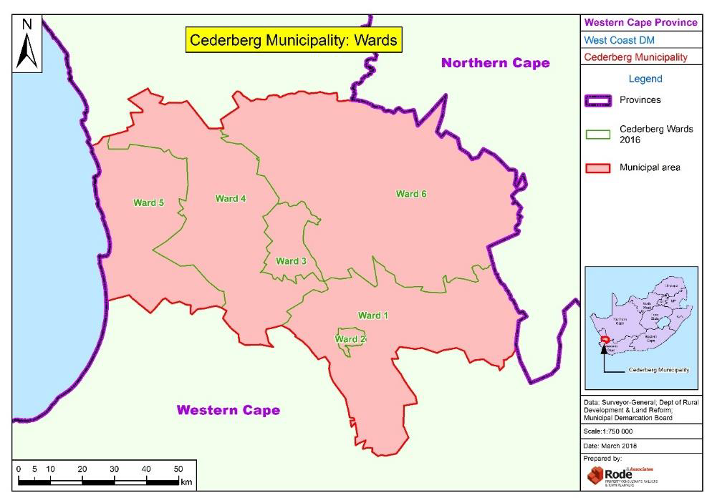

117

APPENDIX B: DECLARED PROVINCIAL HERITAGE SITES ALONG THE CM COASTLINE (SAHRIS, 2019).

LM | Site ID | Site Reference | Full Site Name | Site Type | Archive Status | Declaration Type | Gazette No | Gazette Date
Cederberg | 3387 | BPT PHS | Baboon Point Provincial Heritage Site | Rock Art, Deposit, Artefacts, Shell Midden, Cultural Landscape, Building, Palaeontological, Natural |  | Provincial Heritage Site | 6621 | 09/04/2009
Cederberg | 3494 | MPM PHS | Mussel Point Midden | Shell Midden |  | Provincial Heritage Site | 6621 | 09/04/2009
Cederberg | 108260 | The Verlorenvlei Heritage Settlement (Smit Section) | The Verlorenvlei Heritage Settlement (Smit Section) | Cultural Landscape |  | Provincial Heritage Site | 7310 | 23/09/2014

118

Critical Biodiversity Areas (CBA) are areas that are required to meet biodiversity targets for species, ecosystems or ecological processes and infrastructure. CBAs are areas of high biodiversity and ecological value and need to be kept in a natural or near-natural state, with no further loss of habitat or species.
Ecological Support Areas (ESA) are Areas that are not essential for meeting biodiversity targets, but that play an important role in supporting the functioning of PAs or CBAs, and are often vital for delivering ecosystem services. ESAs need to be maintained in at least a functional and often natural state, in order to support the purpose for which they were identified, but some limited habitat loss may be acceptable

